|  |
| --- |
| **Concordia University**  **Department of Computer Science**  **and Software Engineering** |

|  |
| --- |
| **Touch For Food** |

|  |
| --- |
| **Test Cases & Reports** |

|  |
| --- |
| **SOEN 490**  **Capstone Project**  **Fall 2012 – Winter 2013** |

|  |  |
| --- | --- |
| **CloudNine** |  |
| Josh Hum (Team Leader) | 9583157 |
| Katrina Anderson | 9106251 |
| Cristian Asenjo | 9280014 |
| Christian Daher | 9599673 |
| Cynthia Donato | 9353852 |
| Mikhail Levkovsky | 9583165 |
| Patrick Modafferi | 9401377 |
| Ryan Nasr | 9605614 |
| Matthew Tam | 9675701 |

**Table of Contents**

1 Test Cases 7

1.1 User Interface Test Cases 7

2 Iteration 2 Test Results 32

2.1 Unit Tests 32

2.2 Defects 33

3 Iteration 3 Test Results 34

3.1 Unit Tests 34

3.2 Defects 36

4 Iteration 4 Test Results 37

4.1 Unit Tests 37

4.2 Defects 39

5 Iteration 5 Test Results 41

5.1 Unit Tests 41

5.2 Defects 43

6 Iteration 6 Test Results 45

6.1 Units Tests 45

6.2 Defects 48

6.3 User Interface Tests & Results 49

7 Iteration 7 Test Results 51

7.1 Units Tests 51

7.2 Defects 54

7.3 User Interface Tests & Results 56

8 Iteration 8 Test Results 58

8.1 Units Tests 58

8.2 Defects 62

8.3 User Interface Tests & Results 65

9 Iteration 9 Test Results 68

9.1 Unit Tests 68

9.2 Defects 75

9.3 User Interface Tests & Results 83

10 Iteration 10 Test Results 88

11 Iteration 11 Test Results 88

11.1 Unit Tests 88

11.2 Defects 94

11.3 User Interface Tests & Results 97

Appendix A References 103

Appendix B Glossary 104

**List of Figures**

Figure 2‑1 Iteration 2 Unit Test Results 32

Figure 2‑2 Iteration 2 Unit Test Coverage Results 32

Figure 2‑3 Iteration 2 Defect Breakdown vs. Sprint & Number of Defects vs. Criticality 34

Figure 3‑1 Iteration 3 Unit Test Results 34

Figure 3‑2 Iteration 3 Unit Test Coverage Results 35

Figure 3‑3 Iteration 3 Defect Breakdown vs. Sprint & Number of Defects vs. Criticality 37

Figure 4‑1 Iteration 4 Unit Test Results 37

Figure 4‑2 Iteration 4 Code Coverage Results 38

Figure 4‑3 Iteration 4 Defect Breakdown vs. Sprint & Number of Defects vs. Criticality 40

Figure 5‑1 Iteration 5 Unit Test Results 41

Figure 5‑2 Iteration 5 Code Coverage Results 42

Figure 5‑3Iteration 5 Defect Breakdown vs. Sprint & Number of Defects vs. Criticality 44

Figure 6‑1 Iteration 6 Unit Test Results 46

Figure 6‑2 Iteration 6 Code Coverage Results 47

Figure 6‑3 Iteration 6 Defect Breakdown vs. Sprint & Number of Defects vs. Criticality 49

Figure 7‑1 Iteration 7 Unit Test Results 52

Figure 7‑2 Iteration 7 Code Coverage Results 53

Figure 7‑3 Iteration 7 Defect Breakdown vs. Sprint & Number of Defects vs. Criticality 55

Figure 8‑1 Iteration 8 Unit Test Results 60

Figure 8‑2 Iteration 8 Code Coverage Results 61

Figure 8‑3 Iteration 8 Defect Breakdown vs. Sprint 63

Figure 8‑4 Number of Defects vs. Criticality 64

Figure 9‑9‑1 Number of Defects vs. Criticality 83

Figure 11‑1 Iteration 11 Unit Test Results 92

Figure 11‑2 Iteration 11 Code Coverage Results 93

Figure 11‑3 Iteration 10/11 Defect Breakdown vs. Sprint 96

Figure 11‑4 Number of Defects vs. Criticality 97

**List of Tables**

Table 2‑1 Iteration 2 List of Defects 33

Table 3‑1 Iteration 3 List of Defects 36

Table 4‑1 Iteration 4 List of Defects 39

Table 5‑1 Iteration 5 List of Defects 43

Table 6‑1 Iteration 6 List of Defects 48

Table 6‑2 Iteration 6 UI Test Results 49

Table 7‑1 Iteration 7 List of Defects 54

Table 7‑2 Iteration 7 UI Test Results 56

Table 8‑1 Iteration 8 List of Defects 62

Table 8‑2 Iteration 8 UI Test Results 65

Table 11‑1 Iterations 10 and 11 List of Defects 94

Table 11‑2 Iteration 10/11 UI Test Results 97

|  |
| --- |
| **Touch For Food** |

|  |
| --- |
| **Test Report** |

|  |
| --- |
| **Version 11.26** |

**Revision History**

|  |  |  |  |
| --- | --- | --- | --- |
| **Date** | **Rev.** | **Description** | **Author(s)** |
| 2013-01-11 | 5.0 | Document Creation | Katrina Anderson |
| 2013-01-13 | 5.1 | Added unit test statistics for sprints 2-4 and added list of figures. | Katrina Anderson |
| 2013-01-14 | 5.2 | Added defect information for sprints 2-4 and added list of tables. | Katrina Anderson |
| 2013-01-15 | 5.3 | Added unit test and defect information for sprint 5 | Katrina Anderson |
| 2013-01-17 | 5.4 | Updated table and stats | Katrina Anderson |
| 2013-01-19 | 6.5 | Added TC25.1 | Cynthia Donato |
| 2013-01-19 | 6.6 | Added TC40.1-TC40.4 | Katrina Anderson |
| 2013-01-23 | 6.7 | Added TC26.1-TC26.6 | Christian Daher |
| 2013-01-24 | 6.8 | Added TC27.1-27.3 | Mikhail Levkovsky |
| 2013-01-26 | 6.9 | Added TC192.1-192.8 | Cristian Asenjo |
| 2013-01-27 | 6.10 | Added TC29.1-TC29.6 | Ryan Nasr |
| 2013-01-29 | 6.11 | Fixed a few numbering typos in UI Test Cases | Matthew Tam |
| 2013-01-29 | 6.12 | Added User Interface Test & Results for sprint 6 | Matthew Tam |
| 2013-02-03 | 7.13 | Added unit test and defect information for sprint 6 | Josh Hum |
| 2013-02-06 | 7.14 | Added User Interface TC34 and TC42 | Katrina Anderson |
| 2013-02-07 | 7.15 | Updated user interface tests to reflect system changes. | Katrina Anderson |
| 2013-02-10 | 7.16 | Added Test Report For Iteration 7 | Katrina Anderson |
| 2013-02-12 | 7.17 | Reviewed Document | Josh Hum |
| 2013-02-18 | 8.18 | Added new test cases | Josh Hum |
| 2013-02-21 | 8.19 | Added test cases for Review and User History | Patrick Modafferi |
| 2013-02-24 | 8.20 | Added Test Report for Iteration 8 | Josh Hum |
| 2013-03-10 | 9.21 | Updated test cases | Cynthia Donato |
| 2013-03-11 | 9.22 | Updated test cases | Cynthia Donato |
| 2013-03-11 | 9.23 | Added TC36.1 and TC36.2 | Cynthia Donato |
| 2013-03-27 | 11.24 | Reviewed whole document | Patrick Modafferi |
| 2013-03-30 | 11.25 | Updated test cases | Josh Hum |
| 2013-04-03 | 11.26 | Updated test cases | Mikhail Levkovsky |
| 2013-04-05 | 11.27 | Added sprint 11 test report | Josh Hum |

# Test Cases

## User Interface Test Cases

### TC25.1 Create Order

**Test Case ID:** TC25.1

**Title:** Test Create Order

**Requirement:** CAP-25

**Type:** UI

**Preconditions:**

1. The user is a member of TFF and is signed into the system.
2. The user is assigned the role of Customer.
3. The user is currently on the menu page of restaurant R1.

**Description:**

1. The user selects the “Order” button of a menu item.
2. The user selects the option “None” for sides and selects the “Add to Order” button.
3. The user navigates to the “My Order” section of TFF.
4. The user presses the “Finalize” button to place the order.

**Expected Results:**

1. The system displays a dialog showing options for side items.
2. The system displays a green box indicating that the item was added to the order.
3. The system displays the complete order. The order status is displayed as “OPEN”.
4. The system displays the order with the status of “PLACED”. The “Edit Order” and “View Order Status” buttons are visible.

### TC26.1 Test View Menu (Customer)

**Test Case ID:** TC26.1

**Title:** Test View Menu (Customer)

**Requirement:** CAP-26 View Menu

**Type:** UI

**Preconditions:**

1. The user is a member of TFF and is signed into the system.
2. The user is assigned the role of Customer.
3. The menu M1 has been created.
4. The menu item I1 has been created.

**Description:**

1. The user selects the “Menus” option.
2. The user selects a menu M1.
3. The user selects a menu item I1.

**Expected Results:**

1. The system displays a list of menus for the restaurant the user is signed into.
2. The system displays various categories. Each category has at least one food item listed under it and all food items are displayed with a title, description, price and option to order.
3. The system enlarges the description for I1. The description includes title, description, price, photo and recent ratings.

### TC26.2 Test View Menu (Restaurant)

**Test Case ID:** TC26.2

**Title:** Test View Menu (Restaurant)

**Requirement:** CAP-26 View Menu

**Type:** UI

**Preconditions:**

1. The user is a member of TFF and is signed into the system.
2. The user is assigned the role of Restaurant.
3. The menu M1 has been created.
4. The category C1 has been created.
5. The menu item I1 has been created.

**Description:**

1. The user selects the “Menus” option.
2. The user selects a menu M1.
3. The user selects a category C1.
4. The user selects a menu item I1.

**Expected Results:**

1. The system displays a list of menus for the restaurants associated to the user.
2. The system displays a list of categories associated to the menu and a list of categories available to be associated to the menu.
3. The system displays a list of items associated to the menu and list of items available to be associated to the menu.
4. The system enlarges the description for I1. The description includes title, description, price, photo and recent ratings.

### TC26.3 Test View Menu (Administrator)

**Test Case ID:** TC26.3

**Title:** Test View Menu (Administrator)

**Requirement:** CAP-26 View Menu

**Type:** UI

**Preconditions:**

1. The user is a member of TFF and is signed into the system.
2. The user is assigned the role of Administrator.
3. The menu M1 has been created.
4. The menu item I1 has been created.

**Description:**

1. The user selects the “Menus” option.
2. The user selects a menu M1.
3. The user selects a menu item I1.

**Expected Results:**

1. The system displays a list of menus for all restaurants.
2. The system displays various categories. Each category has at least one food item listed under it and all food items are displayed with a title, description, price and option to order.
3. The system enlarges the description for I1. The description includes title, description, price, photo and recent ratings.

### TC26.4 Test Search Menu (Customer)

**Test Case ID:** TC26.4

**Title:** Test Search Menu (Customer)

**Requirement:** CAP-26 View Menu

**Type:** UI

**Preconditions:**

1. The user is a member of TFF and is signed into the system.
2. The user is assigned the role of Customer.
3. The menu M1 has been created, is active, and not deleted.
4. The menu item MI1 has been created, is active and not deleted.
5. The menu item MI2 has been created, is active and not deleted.
6. The user has tapped into a table at the restaurant to which the menu M1 belongs.

**Description:**

1. The user searches for MI.

**Expected Results:**

1. The system displays a list of results. TheMI1 menu item along with the menu name M1 is first followed by MI2 along with the menu name MI.

### TC26.5 Test Search Menu (Restaurant)

**Test Case ID:** TC26.5

**Title:** Test Search Menu (Restaurant)

**Requirement:** CAP-26 View Menu

**Type:** UI

**Preconditions:**

1. The user is a member of TFF and is signed into the system.
2. The user is assigned the role of Customer.
3. The menu M1 has been created, is active, and not deleted.
4. The menu item MI1 has been created, is active and not deleted.
5. The menu item MI2 has been created, is active and not deleted.

**Description:**

1. The user searches for MI.

**Expected Results:**

1. The system displays a list of results. TheMI1 menu item along with the menu name M1 is first followed by MI2 along with the menu name MI.

### ~~TC26.6 Test Search Menu (Administrator)~~

This test case is no longer applicable beginning in sprint 10.

**~~Test Case ID:~~** ~~TC26.6~~

**~~Title:~~** ~~Test Search Menu (Administrator)~~

**~~Requirement:~~** ~~CAP-26 View Menu~~

**~~Type:~~** ~~UI~~

**~~Preconditions:~~**

1. ~~The user is a member of TFF and is signed into the system.~~
2. ~~The user is assigned the role of Administrator.~~
3. ~~The restaurant R1 has been created.~~
4. ~~The restaurant R2 has been created.~~
5. ~~The menu M has been created for R1, is active, and not deleted.~~
6. ~~The menu item MI1 has been created for R1, is active and not deleted.~~
7. ~~The menu item MI2 has been created for R1, is active and not deleted.~~
8. ~~The menu MI2 has been created for R2, is active, and not deleted.~~
9. ~~The menu item M4 has been created for R2, is active and not deleted.~~
10. ~~The menu item M5 has been created for R2, is active and not deleted.~~

**~~Description:~~**

1. ~~The user searches for MI1.~~

**~~Expected Results:~~**

1. ~~The system displays a list of results. The MI1 menu item along with the menu name M is first followed by M4 along with the menu name M2. Lastly, MI2 is displayed along with the menu name M.~~

### TC27.1 Test Menu Editor Main Page

**Test Case ID:** TC27.1

**Title:** Test Menu Editor Main Page

**Requirement:** CAP-27 Manage Menu

**Type:** UI

**Preconditions:**

1. The user is a member of TFF and is signed into the system.
2. The user is assigned the role of Restaurant or Administrator.

**Description:**

1. The user clicks on “Menus” link at the top of the page.

**Expected Results:**

1. The system displays a page where there is an option to create a new menu and all the current menus are displayed.

### TC27.2 Test Category Management Page

**Test Case ID:** TC27.2

**Title:** Test Category Management Page

**Requirement:** CAP-27 Manage Menu

**Type:** UI

**Preconditions:**

1. The user is a member of TFF and is signed into the system.
2. The user is assigned the role of Restaurant or Administrator.
3. The menu M1 has been created (TC27.5)
4. The user has navigated to the menu M1 page.

**Description:**

1. The user clicks on “New Category”
2. The user fills in the form as follows and selects “Create”

Name: C1

**Expected Results:**

1. The system presents a form for the new category
2. The system displays a list of categories with category C1 present in the section “On the Menu”

### TC27.3 Test Item Management Page

**Test Case ID:** TC27.3

**Title:** Test Item Management Page

**Requirement:** CAP-27 Manage Menu

**Type:** UI

**Preconditions:**

1. The user is a member of TFF and is signed into the system.
2. The user is assigned the role of Restaurant or Administrator.
3. The category C1 has been created (TC27.2)
4. The user has navigated to the category C1 page.

**Description:**

1. The user clicks on the “New Item” link.
2. The user fills in the form as follows and selects “Create”

Name: I1

Description: Yummy!

Price: 9.99

1. The user selects edit I1.
2. The user changes the fields as follows and presses “Save”

Name: I1

Description: Yummy In My Tummy!

Price: 99.99

**Expected Results:**

1. The system presents a form for the new item containing fields for name, description (optional), meta data (optional), a category and an image url (optional).
2. The system displays a list of items with the newly added item present
3. The system displays a form filled out with the item’s values
4. The system displays a list of items with the newly edited item present.

### TC27.4 Test Menu Edit

**Test Case ID:** TC27.4

**Title:** Test Menu Edit

**Requirement:** CAP-27 Manage Menu

**Type:** UI

**Preconditions:**

1. The user is a member of TFF and is signed into the system.
2. The user is assigned the role of Restaurant or Administrator.
3. The menu M1 has been created (TC27.5)
4. The category C1 has been created (TC27.3)
5. The user has navigated to the “M1” page.

**Description:**

1. The user presses on the “+” next to C1 on the “Available Categories” list.
2. The user presses “-” next to C1 on the “On the Menu” list
3. The user presses “Ok”

**Expected Results:**

1. The system displays C1 on the “On the Menu” list.
2. The system prompts “Are you sure you want to delete?”
3. The system displays C1 on the “Available Categories” list.

### TC27.5 Test Create Menu

**Test Case ID:** TC27.5

**Title:** Test Category Management Page

**Requirement:** CAP-27 Manage Menu

**Type:** UI

**Preconditions:**

1. The user is a member of TFF and is signed into the system.
2. The user is assigned the role of Restaurant or Administrator.
3. The restaurant R1 has been created.

**Description:**

1. The user clicks on “Menus” link at the top of the page.
2. The user clicks on “Create New Menu”
3. The user fills in the form as follows and selects “Create”

Menu Name: M1

**Expected Results:**

1. The system displays a page where there will be an option to create a new menu.
2. The system displays a form to the user to put in the menu name.
3. The system displays a page with an empty box entitled “On the Menu” and a second box filled with available categories and the option to create more categories.

### TC29.1 Test Cancel Order

**Test Case ID:** TC29.1

**Title:** Test Cancel Order

**Requirement:** CAP-29 Manage Order

**Type:** UI

**Preconditions:**

1. The user is a member of TFF and is signed into the system.
2. The user is assigned the role of Restaurant or Administrator.
3. The order O1 has been created.

**Description:**

1. The user navigates to the “Orders” page
2. The user clicks ‘Cancel’ on the order O1.
3. The user confirms the cancellation of O1.

**Expected Results:**

1. The system displays a list of orders. The status of O1 is set to “PLACED”
2. The system displays a confirmation message.
3. The system displays a list of orders. O1 is no longer in the list.

### TC29.2 Test Decline Order Item

**Test Case ID:** TC29.2

**Title:** Test Decline Order Item

**Requirement:** CAP-29 Manage Order

**Type:** UI

**Preconditions:**

1. The user is a member of TFF and is signed into the system.
2. The user is assigned the role of Restaurant or Administrator.
3. The order O1 has been created.
4. The order O1 contains and item I1

**Description:**

1. The user navigates to the “Manage Order” page
2. The user clicks ‘Decline’ on the order O1 for the item I1.
3. The user confirms the declination of O1.

**Expected Results:**

1. The system displays a list of orders. The status of O1 is set to “PLACED”
2. The system displays a confirmation message.
3. The system displays a list of orders where I1 in O1 is set to “REJECTED”. All other order items are unaffected.

### TC29.3 Test Accept Order Item

**Test Case ID:** TC29.3

**Title:** Test Accept Order Item

**Requirement:** CAP-29 Manage Order

**Type:** UI

**Preconditions:**

1. The user is a member of TFF and is signed into the system.
2. The user is assigned the role of Restaurant or Administrator.
3. The order O1 has been created.
4. The order item I1 has been created.

**Description:**

1. The user navigates to the “Manage Order” page
2. The user clicks ‘Accept’ on the item I1 in the order O1.

**Expected Results:**

1. The system displays a list of orders. The status of O1 is set to “PLACED”
2. The system displays a list of orders. O1 is set to “PROCESSING”. All other order items are unaffected.

### TC34.1 Test Create Service Request (Administrator)

**Test Case ID:** TC34.1

**Title:** Test Create Service Request (Administrator)

**Requirement:** CAP-34 Call Waiter

**Type:** UI

**Preconditions:**

1. The user is a member of TFF and is signed into the system.
2. The user is assigned the role of Administrator.
3. An open request for service at T1 doesn’t exist.

**Description:**

1. The user selects the “Service Request” link from the main menu.
2. The user selects the “Create New” link.
3. The user fills in the form as follows and selects “Create”

Table: T1

Comment: “Water Please!”

1. The user selects the “Create New” link.
2. The user fills in the form as follows and selects “Create”

Table: T1

Comment: “Water Please!”

**Expected Results:**

1. The system displays a list of all service requests (for all restaurants with all statuses).
2. The system displays the service request creation form.
3. The system displays a list of all service requests (for all restaurants with all statuses), including the new request for table 1.
4. The system displays the service request creation form.
5. The system displays an error message indicating that a request for table 1 is already open.

### TC34.2 Test Create Service Request (Restaurant)

**Test Case ID:** TC34.2

**Title:** Test Create Service Request (Restaurant)

**Requirement:** CAP-34 Call Waiter

**Type:** UI

**Preconditions:**

1. The user is a member of TFF and is signed into the system.
2. The user is assigned the role of Restaurant.
3. An open request for service at T1 doesn’t exist.

**Description:**

1. The user selects the “Service Request” link from the main menu.
2. The user selects the “Create New” link.
3. The user fills in the form as follows and selects “Create”

Table: T1

Comment: “Water Please!”

1. The user selects the “Create New” link.
2. The user fills in the form as follows and selects “Create”

Table: T1

Comment: “Water Please!”

**Expected Results:**

1. The system displays a list of open service requests for the user’s restaurant.
2. The system displays the service request creation form.
3. The system displays a list of open service requests for the user’s restaurant, including the new request for table 1.
4. The system displays the service request creation form.
5. The system displays an error message indicating that a request for table 1 is already open.

### TC34.3 Test Call Waiter (Customer)

**Test Case ID:** TC34.3

**Title:** Test Call Waiter (Customer)

**Requirement:** CAP-34 Call Waiter

**Type:** UI

**Preconditions:**

1. The user is a member of TFF and is signed into the system.
2. The user is assigned the role of Customer.
3. An open request for service at the user’s table doesn’t exist.

**Description:**

1. The user selects the “Call Waiter” link from the main menu.
2. The user fills in the form as follows and selects “Call Waiter!”

Comment: “Water Please!”

1. The user selects the “Call Waiter” link from the main menu

**Expected Results:**

1. The system displays the call waiter form.
2. The system displays the TFF home page.
3. The system displays an error message indicating that a request for the user’s table is already open.

### TC34.4 Test Edit Service Request (Restaurant)

**Test Case ID:** TC34.4

**Title:** Test Edit Service Request (Restaurant)

**Requirement:** CAP-34 Call Waiter

**Type:** UI

**Preconditions:**

1. The user is a member of TFF and is signed into the system.
2. The user is assigned the role of Restaurant.
3. An open request for service at Table 1 already exists (TC34.1).
4. An open request for service at Table 2 doesn’t exist.

**Description:**

1. The user selects the “Service Request” link from the main menu.
2. The user selects the “Edit” link on the service request for table 1.
3. The user changes the form as follows and selects “Save”

Table: Table 2

Comment: “Water Please! Please!”

**Expected Results:**

1. The system displays a list of open service requests for the user’s restaurant.
2. The system displays the service request edit form.
3. The system displays a list of open service requests for the user’s restaurant. Table 1 no longer has an open request; instead Table 2 has a request with the comment “Water Please! Please!”.

### TC34.5 Test Edit Service Request (Administrator)

**Test Case ID:** TC34.5

**Title:** Test Edit Service Request (Administrator)

**Requirement:** CAP-34 Call Waiter

**Type:** UI

**Preconditions:**

1. The user is a member of TFF and is signed into the system.
2. The user is assigned the role of Administrator.
3. An open request for service at Table 1 already exists (TC34.1).
4. An open request for service at Table 2 doesn’t exist.

**Description:**

1. The user selects the “Service Request” link from the main menu.
2. The user selects the “Edit” link on the service request for table 1.
3. The user changes the form as follows and selects “Save”

Create: 04/02/2013 8:44:49 PM

Status: CLOSED

Table: Table 2

Comment: “Water Please! Please!”

**Expected Results:**

1. The system displays a list of all service requests (for all restaurants with all statuses).
2. The system displays the service request edit form.
3. The system displays a list of all service requests (for all restaurants with all statuses. Table 1 no longer has an open request; instead Table 2 has a request with the comment “Water Please! Please!” and status CLOSED.

### TC34.6 Test Cancel Service Request

**Test Case ID:** TC34.6

**Title:** Test Cancel Service Request

**Requirement:** CAP-34 Call Waiter

**Type:** UI

**Preconditions:**

1. The user is a member of TFF and is signed into the system.
2. The user is assigned the role of Restaurant.
3. An open request for service at Table 1 already exists (TC34.1).

**Description:**

1. The user selects the “Service Request” link from the main menu.
2. The user selects the “Cancel” link on the service request for table 1.
3. The user selects the “Cancel Request” button.

**Expected Results:**

1. The system displays a list of open service requests for the user’s restaurant.
2. The system requests a confirmation for cancelling the service request.
3. The system displays a list of open service requests for the user’s restaurant. The request for table 1 has a status of CANCELLED.

### TC34.7 Test Complete Service Request

**Test Case ID:** TC34.7

**Title:** Test Close Service Request

**Requirement:** CAP-34 Call Waiter

**Type:** UI

**Preconditions:**

1. The user is a member of TFF and is signed into the system.
2. The user is assigned the role of Restaurant.
3. An open request for service at Table 1 already exists (TC34.1).

**Description:**

1. The user selects the “Service Request” link from the main menu.
2. The user selects the “Complete” link on the service request for table 1.
3. The user selects the “Complete Request” button.

**Expected Results:**

1. The system displays a list of open service requests for the user’s restaurant.
2. The system requests a confirmation for closing the service request.
3. The system displays a list of service requests for the user’s restaurant. The request for table 1 has a status of CLOSED.

### TC35.3 Test Update Customer Settings

**Test Case ID:** TC35.3

**Title:** Test Update Customer Settings

**Requirement:** CAP-60 Customer Profile Page View Programming

**Type:** UI

**Preconditions:**

1. The user is already a member of TFF.
2. The user is logged in with the role of Customer.
3. The user has navigated to their settings page.

**Description:**

1. The user changes one/some/all of their User Image, Password, First Name, Last Name, Email Address and presses Save.

**Expected Results:**

1. The system redirects them to their details page with the changes reflected.

### TC36.1 Test Generate Most Popular Dishes Report

**Test Case ID:** TC36.1

**Title:** Test Generate Most Popular Dishes Report

**Requirement:** CAP-36 Restaurant Statistics and Reports

**Type:** UI

**Preconditions:**

1. The user is a member of TFF and is signed into the system.
2. The user is assigned the role of Restaurant or Developer.
3. The restaurant R1 exists in the system.
4. The user has privileges for the restaurant R1.
5. Orders have been created and are in the COMPLETE status for the restaurant R1.

**Description:**

1. The user selects the “Reports” link.
2. The user selects the report “Most Popular Dish”.
3. The user selects the restaurant R1 and clicks “Create”.

**Expected Results:**

1. The system displays a list of available reports.
2. The system displays a form to select a restaurant and create the report.
3. The system displays a list of dishes ordered by the column “times Ordered” in descending order.

### TC36.2 Test Generate Waiter Stats Report

**Test Case ID:** TC36.2

**Title:** Test Generate Waiter Stats Report

**Requirement:** CAP-36 Restaurant Statistics and Reports

**Type:** UI

**Preconditions:**

1. The user is a member of TFF and is signed into the system.
2. The user is assigned the role of Restaurant or Developer.
3. The restaurant R1 exists in the system.
4. The user has privileges for the restaurant R1.
5. Orders have been created and are in the COMPLETE status for the restaurant R1.
6. The waiter W1 exists in the system and is associated to at least 1 order, O1.

**Description:**

1. The user selects the “Reports” link.
2. The user selects the report “Waiter Stats”.
3. The user selects the restaurant R1 and leaves the auto-completed dates as is. The user clicks “Create”.

**Expected Results:**

1. The system displays a list of available reports.
2. The system displays a form to select a restaurant with the start date set to the date 3 months in the past from today and end date set to today’s date.
3. The system displays a list of waiters and the number of completed orders they have made in the specified time period.

### TC39.1 Test Leave Review

**Test Case ID:** TC39.1

**Title:** Test Leave a Review

**Requirement:** CAP-39 Leave Review

**Type:** UI

**Preconditions:**

1. The user is a member of TFF and is signed into the system.
2. The user is assigned the role of Customer.
3. The user is on their profile page.
4. TC279.1 must be complete and successful

**Description:**

1. The user selects the “Leave Review” button for the order made in TC25.1.
2. The user selects an item from the order they would like to review
3. The user selects a numerical rating for the item.
4. The user enters their thoughts and opinions about the selected item
5. The user can repeat steps 2-4 for all items on the review
6. The user selects “Submit” to finalize the review

**Expected Results:**

1. The system redirects to a review creation form
2. The system automatically enters #item_name in the test area.
3. The system reflects the chosen value associated to the item
4. The system displays the entered after the item_name
5. The system appends each entry in the same text area
6. The system creates a review for each item selected. (Success message appears)

### TC39.2 Test View Review

**Test Case ID:** TC39.2

**Title:** View Review

**Requirement:** CAP-39 Leave Review

**Type:** UI

**Preconditions:**

1. The user is a member of TFF and is signed into the system.
2. The user is assigned the role of Customer.
3. TC26.1 must be successfully completed.
4. TC39.1 must be complete and successful.

**Description:**

1. The user selects the “Menu” option.
2. The user selects a menu item I1. (The item selected in TC39.1)
3. The user scrolls down to the recent reviews page.

**Expected Results:**

1. The system displays various categories on the menu. Each category has at least one food item listed under it and all food items are displayed with a title, description, price and option to order.
2. The system enlarges the description for I1. The description includes title, description, price, photo and recent ratings.
3. The system displays the most recent rating; notably the one created in TC39.1

### TC40.1 Test Login with Non-Existent User

**Test Case ID:** TC40.1

**Title:** Test Login With Non-Existent User

**Requirement:** CAP-40 Sign in

**Type:** UI

**Preconditions:**

1. The user is not already a member of TFF.
2. The user has navigated to the login page.

**Description:**

1. The user enters the following information and selects “Login”

User Name: TestingUser

Password: Testing

**Expected Results:**

1. The system displays the “Login” form with the error message “The user name or password provided is incorrect.”

### TC40.2 Test Create New User

**Test Case ID:** TC40.2

**Title:** Test Create New User

**Requirement:** CAP-40 Sign in

**Type:** UI

**Preconditions:**

1. The user is not already a member of TFF.
2. The user has navigated to the login page.
3. TC40.1 has passed.

**Description:**

1. The user clicks the “Sign Up” button.
2. The user enters the following information and selects “Create”

User Name: TestingUser

Password: Testing

Confirm Password: Testing

First Name: Testing

Last Name: User

Email: TestingUser@email.com

**Expected Results:**

1. The system displays the “Sign Up” form.
2. The system displays the TFF home page and the welcome message “Welcome TestingUser!”

### TC40.3 Test Login with Existent User

**Test Case ID:** TC40.3

**Title:** Test Login With Existent User

**Requirement:** CAP-40 Sign in

**Type:** UI

**Preconditions:**

1. The user is already a member of TFF.
2. The user has navigated to the login page.
3. TC40.2 has passed.

**Description:**

1. The user enters the following information and selects “Login”

User Name: TestingUsers

Password: Testing

1. The user enters the following information and selects “Login”

User Name: TestingUser

Password: testING

1. The user enters the following information and selects “Login”

User Name: TestingUser

Password: Testing

**Expected Results:**

1. The system displays the error message “The user name or password is incorrect”.
2. The system displays the error message “The user name or password is incorrect”.
3. The system displays the TFF home page and the welcome message “Welcome TestingUser!”

### TC40.4 Test Logout

**Test Case ID:** TC40.4

**Title:** Test Logout

**Requirement:** CAP-40 Sign in

**Type:** UI

**Preconditions:**

1. The user is already a member of TFF.
2. The user has logged in to the system.

**Description:**

1. The user selects the “Log off” option located at the top right of the screen.

**Expected Results:**

1. The system displays the TFF home page without the welcome message “Welcome TestingUser!”

### TC41.1 Test Create Bill (Customer)

**Test Case ID:** TC41.1

**Title:** Test Create Bill (Customer)

**Requirement:** CAP-41 Customer Bill Management

**Type:** UI

**Preconditions:**

1. The user is a member of TFF and is signed into the system.
2. The user is assigned the role of Customer.
3. An order, O1, containing items, has been placed and finalized.

**Description:**

1. The user navigates to their orders page.
2. The user selects the “Manage Bills” option on an order.
3. The user selects the “Create New Bill” option.

**Expected Results:**

1. The system displays the order that the user made at the restaurant that they are currently in.
2. The system displays a list of items associated to the order and a button to “Create New Bill”
3. The system displays a list of items associated to the order, a button to “Create New Bill” and an empty bill with a Total of 0.00$

### TC41.2 Test Add Item to Bill (Customer)

**Test Case ID:** TC41.2

**Title:** Test Add Item To Bill (Customer)

**Requirement:** CAP-41 Customer Bill Management

**Type:** UI

**Preconditions:**

1. The user is a member of TFF and is signed into the system.
2. The user is assigned the role of Customer.
3. An order, O1, containing at least 1 item I1, has been placed and finalized.
4. An empty bill has been created. (TC41.1)

**Description:**

1. The user selects item I1 associated to the order and add it to the bill.

**Expected Results:**

1. The system displays an updated version of the bill, which contains the selected items associated to the order as well as an appropriate total. The system also displays the “Create New Bill” button.

### TC41.3 Test Remove Item from Bill (Customer)

**Test Case ID:** TC41.3

**Title:** Test Remove Item From Bill (Customer)

**Requirement:** CAP-41 Customer Bill Management

**Type:** UI

**Preconditions:**

1. The user is a member of TFF and is signed into the system.
2. The user is assigned the role of Customer.
3. An order, O1, containing item at least 1 item, I1, has been placed and finalized.
4. A bill, containing items, has been created. (TC41.2)

**Description:**

1. The user removes an item I1 from the bill.

**Expected Results:**

1. The system displays an updated version of the bill, which doesn’t contain the removed item and has the price of the removed item decremented from the total. The system also displays the removed item as un-associated.

### TC41.4 Test Delete Bill (Restaurant)

**Test Case ID:** TC41.4

**Title:** Test Delete Bill (Customer)

**Requirement:** CAP-41 Customer Bill Management

**Type:** UI

**Preconditions:**

1. The user is a member of TFF and is signed into the system.
2. The user is assigned the role of Customer.
3. An order, O1, containing items, has been placed and finalized.
4. A bill, B1, containing items, has been created. (TC41.2)

**Description:**

1. The user selects the delete bill (garbage icon) option for B1.

**Expected Results:**

1. The system displays all items previously listed on the bill as un-associated.

### TC42.1 Test Create Bill (Restaurant)

**Test Case ID:** TC42.1

**Title:** Test Create Bill (Restaurant)

**Requirement:** CAP-42 Restaurant Bill Management

**Type:** UI

**Preconditions:**

1. The user is a member of TFF and is signed into the system.
2. The user is assigned the role of Restaurant.
3. An order, O1, containing items, has been placed and finalized.

**Description:**

1. The user navigates to the “Orders” page.
2. The user selects the “Manage Bills” option on the order O1.
3. The user selects the “Create New Bill” option.
4. The user selects “Ok”.

**Expected Results:**

1. The system displays a list of orders for the user’s restaurant containing O1.
2. The system displays a list of items associated to the order and a button to “Create New Bill”
3. The system prompts the user to confirm they would like to add a new bill.
4. The system displays a list of items associated to the order, a button to “Create New Bill” and an empty bill with a Total of 0.00$

### TC42.2 Test Add Item to Bill (Restaurant)

**Test Case ID:** TC42.2

**Title:** Test Add Item To Bill (Restaurant)

**Requirement:** CAP-42 Restaurant Bill Management

**Type:** UI

**Preconditions:**

1. The user is a member of TFF and is signed into the system.
2. The user is assigned the role of Restaurant.
3. An order, O1, containing at least one item, I1, has been placed and finalized.
4. An empty bill has been created. (TC42.1)

**Description:**

1. The user selects all the items associated to the order and adds them to the bill.

**Expected Results:**

1. The system displays an updated version of the bill, which contains all the items associated to the order as well as an appropriate total. The system also displays the “Create New Bill” button.

### TC42.3 Test Remove Item from Bill (Restaurant)

**Test Case ID:** TC42.3

**Title:** Test Remove Item From Bill (Restaurant)

**Requirement:** CAP-42 Restaurant Bill Management

**Type:** UI

**Preconditions:**

1. The user is a member of TFF and is signed into the system.
2. The user is assigned the role of Restaurant.
3. An order, O1, containing at least one item, I1, has been placed and finalized.
4. A bill, B1, containing items, has been created. (TC42.2)

**Description:**

1. The user removes the item I1 from the bill.

**Expected Results:**

1. The system displays an updated version of the bill, which doesn’t contain the removed item and has the price of the removed item decremented from the total. The system also displays the removed item as un-associated.

### TC42.4 Test Delete Bill (Restaurant)

**Test Case ID:** TC42.4

**Title:** Test Delete Bill (Restaurant)

**Requirement:** CAP-42 Restaurant Bill Management

**Type:** UI

**Preconditions:**

1. The user is a member of TFF and is signed into the system.
2. The user is assigned the role of Restaurant.
3. An order, O1, containing at least 1 item, I1, has been placed and finalized.
4. A bill, B1, containing items, has been created. (TC42.2)

**Description:**

1. The user selects the delete bill option

**Expected Results:**

1. The system displays all items previously listed on the bill as un-associated.

### TC192.1 Test Create Table Page

**Test Case ID:** TC192.1

**Title:** Test Create Table Page

**Requirement:** CAP-192 Manage Tables

**Type:** UI

**Preconditions:**

1. The user is a member of TFF and is signed into the system.
2. The user is assigned the role of Restaurant or Administrator.

**Description:**

1. The user clicks on “Table” link at the top of the page.
2. The user clicks “Create New”
3. The user fills out the form as follows and selects “Create”

Name: T1

**Expected Results:**

1. The system displays a list of tables.
2. The system displays a form for creating a table
3. The system displays a list of tables including the newly created table.

### TC192.2 Test Creating Table Page – Error Blank Fields

**Test Case ID:** TC192.2

**Title:** Test Creating Incorrect Table Page

**Requirement:** CAP-192 Manage Tables

**Type:** UI

**Preconditions:**

1. The user is a member of TFF and is signed into the system.
2. The user is assigned the role of Restaurant or Administrator.

**Description:**

1. The user clicks on “Tables” link at the top of the page.
2. The user clicks “Create New”
3. The user does not fill out the form and selects “Create”

**Expected Results:**

1. The system displays a list of tables.
2. The system displays a form for creating a table
3. The system displays an error message indicating that the name field cannot be left blank.

### TC192.3 Test Edit Table Page

**Test Case ID:** TC192.3

**Title:** Test Edit Table Page

**Requirement:** CAP-192 Manage Tables

**Type:** UI

**Preconditions:**

1. The user is a member of TFF and is signed into the system.
2. The user is assigned the role of Restaurant or Administrator.
3. The table T1 has been created.

**Description:**

1. The user clicks on “Tables” link at the top of the page.
2. The user clicks on Edit for table T1.
3. The user fills out the form as follows and selects “Save”

Name: T2

**Expected Results:**

1. The system displays a list of tables.
2. The system displays a form for editing T1
3. The system displays a list of tables including the changes made in step 3.

### TC192.4 Test Edit Table Page – Error Blank Fields

**Test Case ID:** TC192.4

**Title:** Test Incorrect Edit Table Page

**Requirement:** CAP-192 Manage Tables

**Type:** UI

**Preconditions:**

1. The user is a member of TFF and is signed into the system.
2. The user is assigned the role of Restaurant or Administrator.
3. The table T1 has been created.

**Description:**

1. The user clicks on “Table” link at the top of the page.
2. The user clicks on Edit for table T1.
3. The user fills out the form as follows and selects “Save”

Name:

**Expected Results:**

1. The system displays a list of tables.
2. The system displays a form for editing T1
3. The system displays an error message indicating that the table name field cannot be left blank.

### TC192.5 Test NFC Link Page

**Test Case ID:** TC192.5

**Title:** Test NFC Link Page

**Requirement:** CAP-192 Manage Tables

**Type:** UI

**Preconditions:**

1. The user is a member of TFF and is signed into the system.
2. The user is assigned the role of Restaurant or Administrator.
3. The table T1 has been created.

**Description:**

1. The user clicks on “Tables” link at the top of the page.
2. The user clicks on NFC Link for T1.

**Expected Results:**

1. The system displays a list of tables.
2. The system displays the available menus for the restaurant related to T1.

### TC192.6 Test Table Details Page

**Test Case ID:** TC192.6

**Title:** Test Table Details Page

**Requirement:** CAP-192 Manage Tables

**Type:** UI

**Preconditions:**

1. The user is a member of TFF and is signed into the system.
2. The user is assigned the role of Restaurant or Administrator.
3. The table T1 has been created.

**Description:**

1. The user clicks on “Tables” link at the top of the page.
2. The user clicks on “Details” for T1

**Expected Results:**

1. The system displays a list of tables.
2. The application will show the information for T1.

### TC192.7 Test Delete Table Page

**Test Case ID:** TC192.7

**Title:** Test Delete Table Page

**Requirement:** CAP-192 Manage Tables

**Type:** UI

**Preconditions:**

1. The user is a member of TFF and is signed into the system.
2. The user is assigned the role of Restaurant or Administrator.
3. The table T1 has been created.

**Description:**

1. The user clicks on “Tables” link at the top of the page.
2. The user clicks on “Delete” for T1
3. The user confirms the deletion of T1.

**Expected Results:**

1. The system displays a list of tables.
2. The system displays a confirmation message.
3. The system displays a list of tables. T1 is not on the list.

### TC279.1 Test View Past Orders

**Test Case ID:** TC279.1

**Title:** Test View Past Orders

**Requirement:** CAP-279 User History

**Type:** UI

**Preconditions:**

1. The user is a member of TFF and is signed into the system.
2. The user is assigned the role of Customer.
3. An order has been created (TC25.1).
4. The order was processed and delivered (TC29.4).
5. The user is on their profile page.

**Description:**

1. The user scrolls down to the “Past Orders” section.
2. The user scrolls until they see an order with a matching date/time from the one created in TC25.1.

**Expected Results:**

1. The system displays a list of previous orders.
2. The system displays the order’s information such as date/time, restaurant with options to view details.

### TC279.2 Test Suggest an Order

**Test Case ID:** TC279.2

**Title:** Test Close Service Request

**Title:** Test View Past Orders

**Requirement:** CAP-279 User History

**Type:** UI

**Preconditions:**

1. The user is a member of TFF and is signed into the system.
2. The user is assigned the role of Customer.
3. The user is currently on the menu M1 page of restaurant R1.
4. TC39.1 must be complete and successful.

**Description:**

1. The user selects the “Menu” option.
2. The user selects the “Suggestions” option.
3. The user selects a menu item and selects the “Add to Order” button.

**Expected Results:**

1. The system displays various categories on the menu. Each category has at least one food item listed under it and all food items are displayed with a title, description, price and option to order.
2. The system computes the best candidates among active menus which best fit the user history available, including orders and reviews. Displays a list of menu items with the best fit.
3. The system displays a message indicating that the item was added to the order.

# Iteration 2 Test Results

## Unit Tests

### Unit Test Table & Status

**Number of Unit Tests:** 4

**Number of Passed Unit Tests:** 3

**Number of Failed Unit Tests:** 1

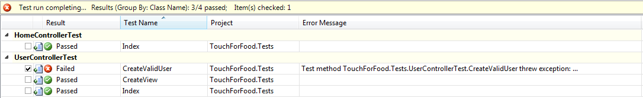

Figure 2‑1 Iteration 2 Unit Test Results

### Unit Test Coverage

**Project Coverage:** 6.10%

**Controller Layer Coverage:** 5.5%

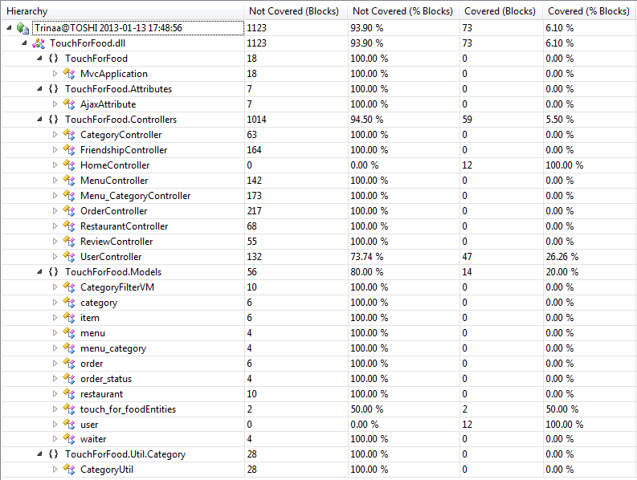

Figure 2‑2 Iteration 2 Unit Test Coverage Results

## Defects

Table 2‑1 Iteration 2 List of Defects

|  |  |  |  |  |  |  |  |  |  |  |  |
| --- | --- | --- | --- | --- | --- | --- | --- | --- | --- | --- | --- |
| **Key** | **Issue Type** | **Status** | **Priority** | **Resolution** | **Assignee** | **Reporter** | **Created** | **Resolved** | **Affects Sprint** | **Fix Sprint** | **Time Spent (hours)** |
| CAP-45 | Bug | Resolved | Major | Fixed | Josh Hum | Cristian Asenjo | 10/20/2012 12:20 | 11/5/2012 11:26 | Sprint 2 | Sprint 2 | 2.33 |
| CAP-53 | Bug | Resolved | Major | Fixed | Mikhail Levkovsky | Mikhail Levkovsky | 10/20/2012 18:50 | 10/26/2012 14:28 | Sprint 2 | Sprint 2 | 2.00 |
| CAP-54 | Bug | Open | Minor | *Unresolved* | Christian Daher | Cristian Asenjo | 10/25/2012 22:20 |  | Sprint 2 | Sprint 3 |  |
| CAP-55 | Bug | Open | Minor | *Unresolved* | Christian Daher | Cristian Asenjo | 10/25/2012 22:36 |  | Sprint 2 | Sprint 3 |  |
| CAP-77 | Bug | Resolved | Major | Fixed | Mikhail Levkovsky | Mikhail Levkovsky | 11/6/2012 12:13 | 11/6/2012 14:18 | Sprint 2 | Sprint 2 | 0.50 |
| CAP-82 | Bug | Resolved | Major | Fixed | Cristian Asenjo | Cristian Asenjo | 11/10/2012 11:22 | 11/10/2012 15:01 | Sprint 2 | Sprint 2 | 3.00 |
| CAP-83 | Bug | Resolved | Major | Fixed | Cristian Asenjo | Cristian Asenjo | 11/10/2012 15:02 | 11/10/2012 18:36 | Sprint 2 | Sprint 2 | 2.00 |
| CAP-85 | Bug | Open | Critical | *Unresolved* | Ryan Nasr | Cristian Asenjo | 11/14/2012 22:09 |  | Sprint 2 | Sprint 3 |  |
| CAP-86 | Bug | Open | Minor | *Unresolved* | Ryan Nasr | Cristian Asenjo | 11/14/2012 22:10 |  | Sprint 2 | Sprint 3 |  |
| CAP-88 | Bug | Open | Major | *Unresolved* | Patrick Modafferi | Patrick Modafferi | 11/19/2012 20:53 |  | Sprint 2 | Sprint 3 |  |
| CAP-91 | Bug | Open | Trivial | *Unresolved* | Cristian Asenjo | Patrick Modafferi | 11/19/2012 20:55 |  | Sprint 2 | Sprint 3 |  |
| CAP-92 | Bug | Open | Trivial | *Unresolved* | Patrick Modafferi | Patrick Modafferi | 11/19/2012 20:55 |  | Sprint 2 | Sprint 3 |  |
| CAP-93 | Bug | Open | Trivial | *Unresolved* | Cristian Asenjo | Patrick Modafferi | 11/19/2012 20:56 |  | Sprint 2 | Sprint 3 |  |
| CAP-94 | Bug | Open | Trivial | *Unresolved* | Patrick Modafferi | Patrick Modafferi | 11/19/2012 20:56 |  | Sprint 2 | Sprint 3 |  |
| CAP-95 | Bug | Open | Trivial | *Unresolved* | Patrick Modafferi | Patrick Modafferi | 11/19/2012 20:58 |  | Sprint 2 | Sprint 3 |  |
| CAP-96 | Bug | Open | Trivial | *Unresolved* | Cynthia Donato | Patrick Modafferi | 11/19/2012 20:58 |  | Sprint 2 | Sprint 3 |  |
| CAP-97 | Bug | Open | Trivial | *Unresolved* | Mikhail Levkovsky | Patrick Modafferi | 11/19/2012 21:00 |  | Sprint 2 | Sprint 3 |  |
| CAP-98 | Bug | Open | Trivial | *Unresolved* | Josh Hum | Patrick Modafferi | 11/19/2012 21:00 |  | Sprint 2 | Sprint 3 |  |
| CAP-99 | Bug | Open | Trivial | *Unresolved* | Cristian Asenjo | Patrick Modafferi | 11/19/2012 21:16 |  | Sprint 2 | Sprint 3 |  |
| CAP-100 | Bug | Open | Minor | *Unresolved* | Katrina Anderson | Patrick Modafferi | 11/19/2012 21:28 |  | Sprint 2 | Sprint 3 |  |

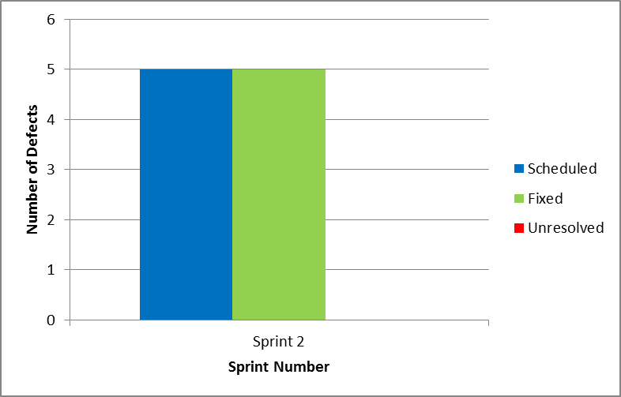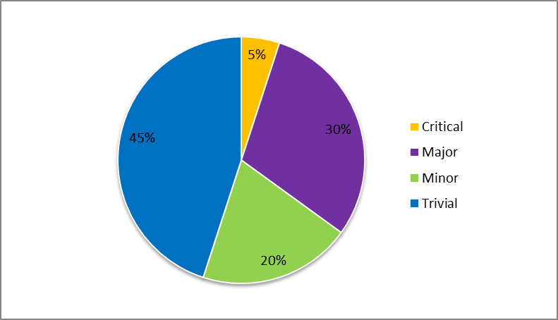

Figure 2‑3 Iteration 2 Defect Breakdown vs. Sprint & Number of Defects vs. Criticality

# Iteration 3 Test Results

## Unit Tests

### Unit Test Table & Status

**Number of Unit Tests:** 4

**Number of Passed Unit Tests:** 3

**Number of Failed Unit Tests:** 1

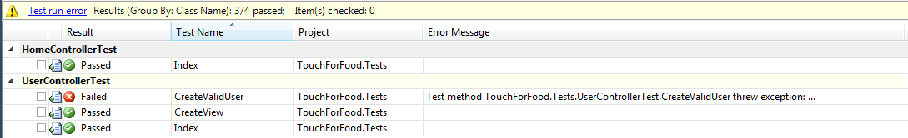

Figure 3‑1 Iteration 3 Unit Test Results

### Unit Test Coverage

**Project Coverage:** 5.38%

**Controller Layer Coverage:** 4.78%

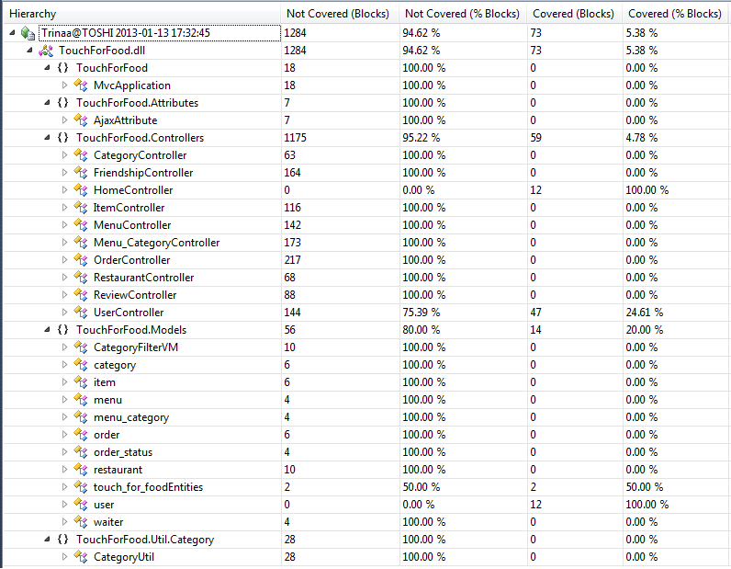

Figure 3‑2 Iteration 3 Unit Test Coverage Results

## Defects

Table 3‑1 Iteration 3 List of Defects

|  |  |  |  |  |  |  |  |  |  |  |  |
| --- | --- | --- | --- | --- | --- | --- | --- | --- | --- | --- | --- |
| **Key** | **Issue Type** | **Status** | **Priority** | **Resolution** | **Assignee** | **Reporter** | **Created** | **Resolved** | **Affects Sprint** | **Fix Sprint** | **Time Spent (hours)** |
| [CAP-45](http://ryanweb.dyndns.info:8080/browse/CAP-45) | Bug | Resolved | Major | Fixed | Josh Hum | Cristian Asenjo | 10/20/2012 12:20 | 11/5/2012 11:26 | Sprint 2 | Sprint 2 | 2.33 |
| [CAP-53](http://ryanweb.dyndns.info:8080/browse/CAP-53) | Bug | Resolved | Major | Fixed | Mikhail Levkovsky | Mikhail Levkovsky | 10/20/2012 18:50 | 10/26/2012 14:28 | Sprint 2 | Sprint 2 | 2.00 |
| [CAP-54](http://ryanweb.dyndns.info:8080/browse/CAP-54) | Bug | Resolved | Minor | Fixed | Christian Daher | Cristian Asenjo | 10/25/2012 22:20 | 12/17/2012 16:02 | Sprint 2 | Sprint 3 | 0.17 |
| [CAP-55](http://ryanweb.dyndns.info:8080/browse/CAP-55) | Bug | Resolved | Minor | Fixed | Christian Daher | Cristian Asenjo | 10/25/2012 22:36 | 12/17/2012 16:00 | Sprint 2 | Sprint 3 | 0.08 |
| [CAP-77](http://ryanweb.dyndns.info:8080/browse/CAP-77) | Bug | Resolved | Major | Fixed | Mikhail Levkovsky | Mikhail Levkovsky | 11/6/2012 12:13 | 11/6/2012 14:18 | Sprint 2 | Sprint 2 | 0.50 |
| [CAP-82](http://ryanweb.dyndns.info:8080/browse/CAP-82) | Bug | Resolved | Major | Fixed | Cristian Asenjo | Cristian Asenjo | 11/10/2012 11:22 | 11/10/2012 15:01 | Sprint 2 | Sprint 2 | 3.00 |
| [CAP-83](http://ryanweb.dyndns.info:8080/browse/CAP-83) | Bug | Resolved | Major | Fixed | Cristian Asenjo | Cristian Asenjo | 11/10/2012 15:02 | 11/10/2012 18:36 | Sprint 2 | Sprint 2 | 2.00 |
| [CAP-85](http://ryanweb.dyndns.info:8080/browse/CAP-85) | Bug | Open | Critical | *Unresolved* | Ryan Nasr | Cristian Asenjo | 11/14/2012 22:09 |  | Sprint 2 | Sprint 3 |  |
| [CAP-86](http://ryanweb.dyndns.info:8080/browse/CAP-86) | Bug | Resolved | Minor | Fixed | Ryan Nasr | Cristian Asenjo | 11/14/2012 22:10 | 12/17/2012 15:52 | Sprint 2 | Sprint 3 | 1.00 |
| [CAP-88](http://ryanweb.dyndns.info:8080/browse/CAP-88) | Bug | Resolved | Major | Fixed | Patrick Modafferi | Patrick Modafferi | 11/19/2012 20:53 | 12/17/2012 16:03 | Sprint 2 | Sprint 3 | 1.00 |
| [CAP-91](http://ryanweb.dyndns.info:8080/browse/CAP-91) | Bug | Resolved | Trivial | Fixed | Cristian Asenjo | Patrick Modafferi | 11/19/2012 20:55 | 12/17/2012 15:33 | Sprint 2 | Sprint 3 | 1.00 |
| [CAP-92](http://ryanweb.dyndns.info:8080/browse/CAP-92) | Bug | Resolved | Trivial | Fixed | Patrick Modafferi | Patrick Modafferi | 11/19/2012 20:55 | 12/11/2012 17:00 | Sprint 2 | Sprint 3 | 0.50 |
| [CAP-93](http://ryanweb.dyndns.info:8080/browse/CAP-93) | Bug | Resolved | Trivial | Fixed | Cristian Asenjo | Patrick Modafferi | 11/19/2012 20:56 | 12/16/2012 23:12 | Sprint 2 | Sprint 3 | 1.25 |
| [CAP-94](http://ryanweb.dyndns.info:8080/browse/CAP-94) | Bug | Resolved | Trivial | Fixed | Patrick Modafferi | Patrick Modafferi | 11/19/2012 20:56 | 12/16/2012 19:25 | Sprint 2 | Sprint 3 | 0.50 |
| [CAP-95](http://ryanweb.dyndns.info:8080/browse/CAP-95) | Bug | Resolved | Trivial | Fixed | Patrick Modafferi | Patrick Modafferi | 11/19/2012 20:58 | 12/17/2012 17:58 | Sprint 2 | Sprint 3 | 1.00 |
| [CAP-96](http://ryanweb.dyndns.info:8080/browse/CAP-96) | Bug | Resolved | Trivial | Fixed | Cynthia Donato | Patrick Modafferi | 11/19/2012 20:58 | 12/17/2012 15:33 | Sprint 2 | Sprint 3 | 3.52 |
| [CAP-97](http://ryanweb.dyndns.info:8080/browse/CAP-97) | Bug | Resolved | Trivial | Fixed | Mikhail Levkovsky | Patrick Modafferi | 11/19/2012 21:00 | 12/16/2012 17:20 | Sprint 2 | Sprint 3 | 0.50 |
| [CAP-98](http://ryanweb.dyndns.info:8080/browse/CAP-98) | Bug | Open | Trivial | *Unresolved* | Josh Hum | Patrick Modafferi | 11/19/2012 21:00 |  | Sprint 2 | Sprint 3 |  |
| [CAP-99](http://ryanweb.dyndns.info:8080/browse/CAP-99) | Bug | Resolved | Trivial | Fixed | Cristian Asenjo | Patrick Modafferi | 11/19/2012 21:16 | 12/16/2012 23:11 | Sprint 2 | Sprint 3 | 0.33 |
| [CAP-100](http://ryanweb.dyndns.info:8080/browse/CAP-100) | Bug | Open | Minor | *Unresolved* | Katrina Anderson | Patrick Modafferi | 11/19/2012 21:28 |  | Sprint 2 | Sprint 3 |  |
| [CAP-101](http://ryanweb.dyndns.info:8080/browse/CAP-101) | Bug | Open | Minor | *Unresolved* | Christian Daher | Katrina Anderson | 12/16/2012 22:12 |  | Sprint 3 | Sprint 4 |  |
| [CAP-102](http://ryanweb.dyndns.info:8080/browse/CAP-102) | Bug | Resolved | Minor | Fixed | Katrina Anderson | Katrina Anderson | 12/17/2012 0:09 | 12/17/2012 15:44 | Sprint 3 | Sprint 3 | 0.50 |
| [CAP-108](http://ryanweb.dyndns.info:8080/browse/CAP-108) | Bug | Open | Minor | *Unresolved* | Christian Daher | Christian Daher | 12/17/2012 16:19 |  | Sprint 3 | Sprint 4 |  |
| [CAP-109](http://ryanweb.dyndns.info:8080/browse/CAP-109) | Bug | Open | Major | *Unresolved* | Mikhail Levkovsky | Christian Daher | 12/17/2012 17:46 |  | Sprint 3 | Sprint 4 |  |

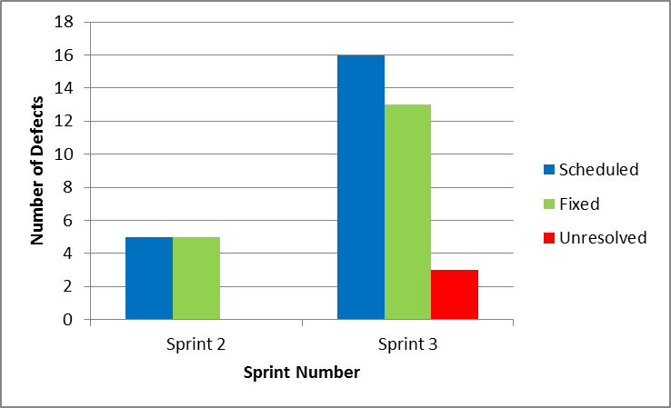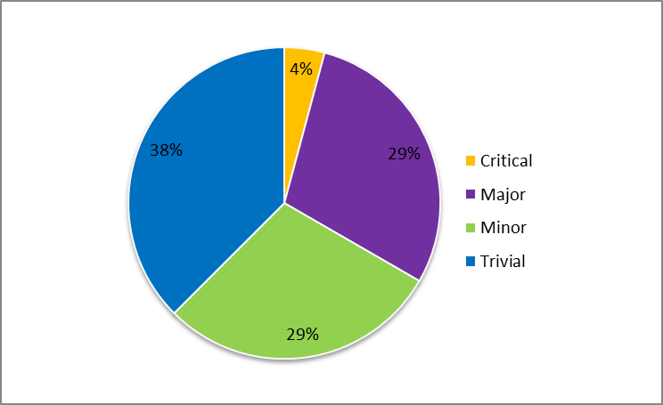

Figure 3‑3 Iteration 3 Defect Breakdown vs. Sprint & Number of Defects vs. Criticality

# Iteration 4 Test Results

## Unit Tests

### Unit Test Table & Status

**Number of Unit Tests:** 11

**Number of Passed Unit Tests:** 4

**Number of Failed Unit Tests:** 7

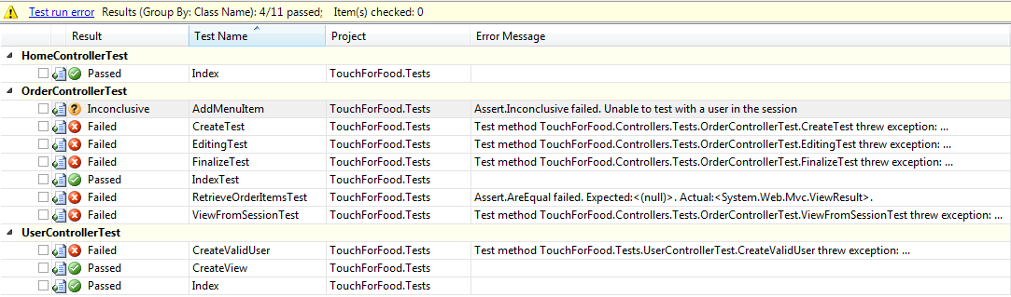

Figure 4‑1 Iteration 4 Unit Test Results

### Unit Test Coverage

**Project Coverage:** 8.43%

**Controller Layer Coverage:** 7.93%

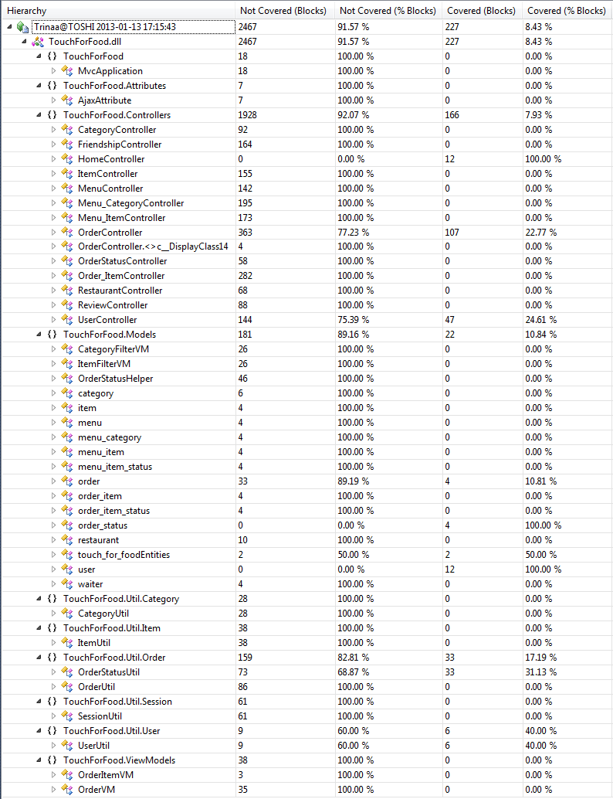

Figure 4‑2 Iteration 4 Code Coverage Results

## Defects

Table 4‑1 Iteration 4 List of Defects

|  |  |  |  |  |  |  |  |  |  |  |  |
| --- | --- | --- | --- | --- | --- | --- | --- | --- | --- | --- | --- |
| **Key** | **Issue Type** | **Status** | **Priority** | **Resolution** | **Assignee** | **Reporter** | **Created** | **Resolved** | **Affects Sprint** | **Fix Sprint** | **Time Spent (hours)** |
| [CAP-45](http://ryanweb.dyndns.info:8080/browse/CAP-45) | Bug | Resolved | Major | Fixed | Josh Hum | Cristian Asenjo | 10/20/2012 12:20 | 11/5/2012 11:26 | Sprint 2 | Sprint 2 | 2.33 |
| [CAP-53](http://ryanweb.dyndns.info:8080/browse/CAP-53) | Bug | Resolved | Major | Fixed | Mikhail Levkovsky | Mikhail Levkovsky | 10/20/2012 18:50 | 10/26/2012 14:28 | Sprint 2 | Sprint 2 | 2.00 |
| [CAP-54](http://ryanweb.dyndns.info:8080/browse/CAP-54) | Bug | Resolved | Minor | Fixed | Christian Daher | Cristian Asenjo | 10/25/2012 22:20 | 12/17/2012 16:02 | Sprint 2 | Sprint 3 | 0.17 |
| [CAP-55](http://ryanweb.dyndns.info:8080/browse/CAP-55) | Bug | Resolved | Minor | Fixed | Christian Daher | Cristian Asenjo | 10/25/2012 22:36 | 12/17/2012 16:00 | Sprint 2 | Sprint 3 | 0.08 |
| [CAP-77](http://ryanweb.dyndns.info:8080/browse/CAP-77) | Bug | Resolved | Major | Fixed | Mikhail Levkovsky | Mikhail Levkovsky | 11/6/2012 12:13 | 11/6/2012 14:18 | Sprint 2 | Sprint 2 | 0.50 |
| [CAP-82](http://ryanweb.dyndns.info:8080/browse/CAP-82) | Bug | Resolved | Major | Fixed | Cristian Asenjo | Cristian Asenjo | 11/10/2012 11:22 | 11/10/2012 15:01 | Sprint 2 | Sprint 2 | 3.00 |
| [CAP-83](http://ryanweb.dyndns.info:8080/browse/CAP-83) | Bug | Resolved | Major | Fixed | Cristian Asenjo | Cristian Asenjo | 11/10/2012 15:02 | 11/10/2012 18:36 | Sprint 2 | Sprint 2 | 2.00 |
| [CAP-85](http://ryanweb.dyndns.info:8080/browse/CAP-85) | Bug | Open | Critical | *Unresolved* | Ryan Nasr | Cristian Asenjo | 11/14/2012 22:09 |  | Sprint 2 | Sprint 5 |  |
| [CAP-86](http://ryanweb.dyndns.info:8080/browse/CAP-86) | Bug | Resolved | Minor | Fixed | Ryan Nasr | Cristian Asenjo | 11/14/2012 22:10 | 12/17/2012 15:52 | Sprint 2 | Sprint 3 | 1.00 |
| [CAP-88](http://ryanweb.dyndns.info:8080/browse/CAP-88) | Bug | Resolved | Major | Fixed | Patrick Modafferi | Patrick Modafferi | 11/19/2012 20:53 | 12/17/2012 16:03 | Sprint 2 | Sprint 3 | 1.00 |
| [CAP-91](http://ryanweb.dyndns.info:8080/browse/CAP-91) | Bug | Resolved | Trivial | Fixed | Cristian Asenjo | Patrick Modafferi | 11/19/2012 20:55 | 12/17/2012 15:33 | Sprint 2 | Sprint 3 | 1.00 |
| [CAP-92](http://ryanweb.dyndns.info:8080/browse/CAP-92) | Bug | Resolved | Trivial | Fixed | Patrick Modafferi | Patrick Modafferi | 11/19/2012 20:55 | 12/11/2012 17:00 | Sprint 2 | Sprint 3 | 0.50 |
| [CAP-93](http://ryanweb.dyndns.info:8080/browse/CAP-93) | Bug | Resolved | Trivial | Fixed | Cristian Asenjo | Patrick Modafferi | 11/19/2012 20:56 | 12/16/2012 23:12 | Sprint 2 | Sprint 3 | 1.25 |
| [CAP-94](http://ryanweb.dyndns.info:8080/browse/CAP-94) | Bug | Resolved | Trivial | Fixed | Patrick Modafferi | Patrick Modafferi | 11/19/2012 20:56 | 12/16/2012 19:25 | Sprint 2 | Sprint 3 | 0.50 |
| [CAP-95](http://ryanweb.dyndns.info:8080/browse/CAP-95) | Bug | Resolved | Trivial | Fixed | Patrick Modafferi | Patrick Modafferi | 11/19/2012 20:58 | 12/17/2012 17:58 | Sprint 2 | Sprint 3 | 1.00 |
| [CAP-96](http://ryanweb.dyndns.info:8080/browse/CAP-96) | Bug | Resolved | Trivial | Fixed | Cynthia Donato | Patrick Modafferi | 11/19/2012 20:58 | 12/17/2012 15:33 | Sprint 2 | Sprint 3 | 3.52 |
| [CAP-97](http://ryanweb.dyndns.info:8080/browse/CAP-97) | Bug | Resolved | Trivial | Fixed | Mikhail Levkovsky | Patrick Modafferi | 11/19/2012 21:00 | 12/16/2012 17:20 | Sprint 2 | Sprint 3 | 0.50 |
| [CAP-98](http://ryanweb.dyndns.info:8080/browse/CAP-98) | Bug | Resolved | Trivial | Fixed | Josh Hum | Patrick Modafferi | 11/19/2012 21:00 | 1/2/2013 11:14 | Sprint 2 | Sprint 4 | 0.52 |
| [CAP-99](http://ryanweb.dyndns.info:8080/browse/CAP-99) | Bug | Resolved | Trivial | Fixed | Cristian Asenjo | Patrick Modafferi | 11/19/2012 21:16 | 12/16/2012 23:11 | Sprint 2 | Sprint 3 | 0.33 |
| [CAP-100](http://ryanweb.dyndns.info:8080/browse/CAP-100) | Bug | Resolved | Minor | Fixed | Katrina Anderson | Patrick Modafferi | 11/19/2012 21:28 | 12/30/2012 13:35 | Sprint 2 | Sprint 4 | 13.33 |
| [CAP-101](http://ryanweb.dyndns.info:8080/browse/CAP-101) | Bug | Resolved | Minor | Fixed | Christian Daher | Katrina Anderson | 12/16/2012 22:12 | 12/17/2012 23:01 | Sprint 3 | Sprint 4 | 0.25 |
| [CAP-102](http://ryanweb.dyndns.info:8080/browse/CAP-102) | Bug | Resolved | Minor | Fixed | Katrina Anderson | Katrina Anderson | 12/17/2012 0:09 | 12/17/2012 15:44 | Sprint 3 | Sprint 3 | 0.50 |
| [CAP-108](http://ryanweb.dyndns.info:8080/browse/CAP-108) | Bug | Open | Minor | *Unresolved* | Christian Daher | Christian Daher | 12/17/2012 16:19 |  | Sprint 3 | Sprint 4 |  |
| [CAP-109](http://ryanweb.dyndns.info:8080/browse/CAP-109) | Bug | Open | Major | *Unresolved* | Mikhail Levkovsky | Christian Daher | 12/17/2012 17:46 |  | Sprint 3 | Sprint 4 |  |
| [CAP-111](http://ryanweb.dyndns.info:8080/browse/CAP-111) | Bug | Resolved | Major | Fixed | Patrick Modafferi | Patrick Modafferi | 12/18/2012 11:20 | 12/19/2012 17:00 | Sprint 4 | Sprint 4 | 8.50 |
| [CAP-125](http://ryanweb.dyndns.info:8080/browse/CAP-125) | Bug | Resolved | Major | Fixed | Mikhail Levkovsky | Mikhail Levkovsky | 12/18/2012 17:09 | 12/18/2012 20:44 | Sprint 4 | Sprint 4 | 6.00 |
| [CAP-128](http://ryanweb.dyndns.info:8080/browse/CAP-128) | Bug | Open | Trivial | *Unresolved* | Mikhail Levkovsky | Patrick Modafferi | 12/18/2012 17:14 |  | Sprint 4 | Sprint 5 |  |
| [CAP-156](http://ryanweb.dyndns.info:8080/browse/CAP-156) | Bug | Resolved | Blocker | Fixed | Mikhail Levkovsky | Mikhail Levkovsky | 12/19/2012 15:08 | 12/19/2012 15:12 | Sprint 4 | Sprint 4 | 0.27 |
| [CAP-158](http://ryanweb.dyndns.info:8080/browse/CAP-158) | Bug | Open | Minor | *Unresolved* | Mikhail Levkovsky | Katrina Anderson | 12/21/2012 15:02 |  | Sprint 4 | Sprint 5 |  |
| [CAP-159](http://ryanweb.dyndns.info:8080/browse/CAP-159) | Bug | Open | Major | *Unresolved* | Ryan Nasr | Matthew Tam | 12/21/2012 17:27 |  | Sprint 4 | Sprint 5 |  |
| [CAP-160](http://ryanweb.dyndns.info:8080/browse/CAP-160) | Bug | Resolved | Critical | Fixed | Patrick Modafferi | Mikhail Levkovsky | 12/21/2012 19:19 | 12/21/2012 19:33 | Sprint 4 | Sprint 4 | 4.00 |
| [CAP-161](http://ryanweb.dyndns.info:8080/browse/CAP-161) | Bug | Open | Critical | *Unresolved* | Patrick Modafferi | Cynthia Donato | 12/24/2012 13:05 |  | Sprint 4 | Sprint 5 |  |
| [CAP-168](http://ryanweb.dyndns.info:8080/browse/CAP-168) | Bug | Closed | Blocker | Fixed | Christian Daher | Katrina Anderson | 12/30/2012 22:14 | 1/2/2013 12:18 | Sprint 4 | Sprint 4 | 0.25 |
| [CAP-169](http://ryanweb.dyndns.info:8080/browse/CAP-169) | Bug | Open | Major | *Unresolved* | Cynthia Donato | Katrina Anderson | 1/1/2013 17:42 |  | Sprint 4 | Sprint 5 |  |
| [CAP-170](http://ryanweb.dyndns.info:8080/browse/CAP-170) | Bug | Open | Trivial | *Unresolved* | Katrina Anderson | Katrina Anderson | 1/2/2013 10:49 |  | Sprint 4 | Sprint 5 |  |
| [CAP-190](http://ryanweb.dyndns.info:8080/browse/CAP-190) | Bug | Open | Major | *Unresolved* | Ryan Nasr | Patrick Modafferi | 1/2/2013 12:29 |  | Sprint 4 | Sprint 5 |  |
| [CAP-191](http://ryanweb.dyndns.info:8080/browse/CAP-191) | Bug | Open | Minor | *Unresolved* | Cristian Asenjo | Cristian Asenjo | 1/2/2013 12:29 |  | Sprint 4 | Sprint 5 |  |
| [CAP-193](http://ryanweb.dyndns.info:8080/browse/CAP-193) | Bug | Open | Minor | *Unresolved* | Patrick Modafferi | Patrick Modafferi | 1/2/2013 13:25 |  | Sprint 4 | Sprint 5 |  |

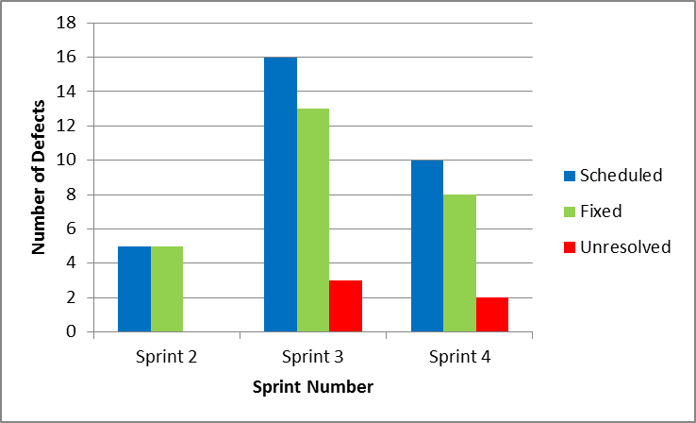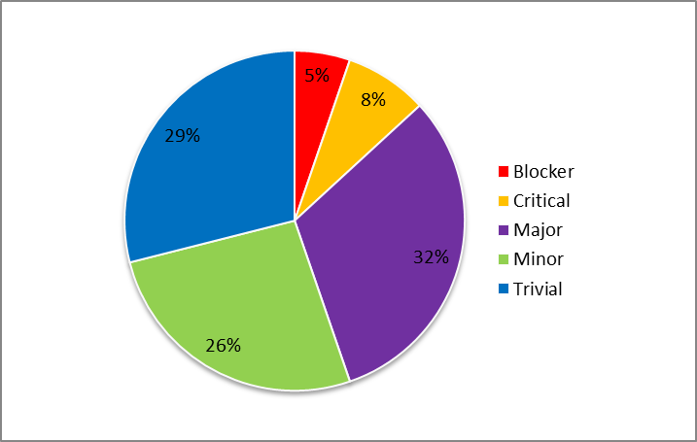

Figure 4‑3 Iteration 4 Defect Breakdown vs. Sprint & Number of Defects vs. Criticality

# Iteration 5 Test Results

## Unit Tests

### Unit Test Table & Status

**Number of Unit Tests:** 34

**Number of Passed Unit Tests:** 29

**Number of Failed Unit Tests:** 5

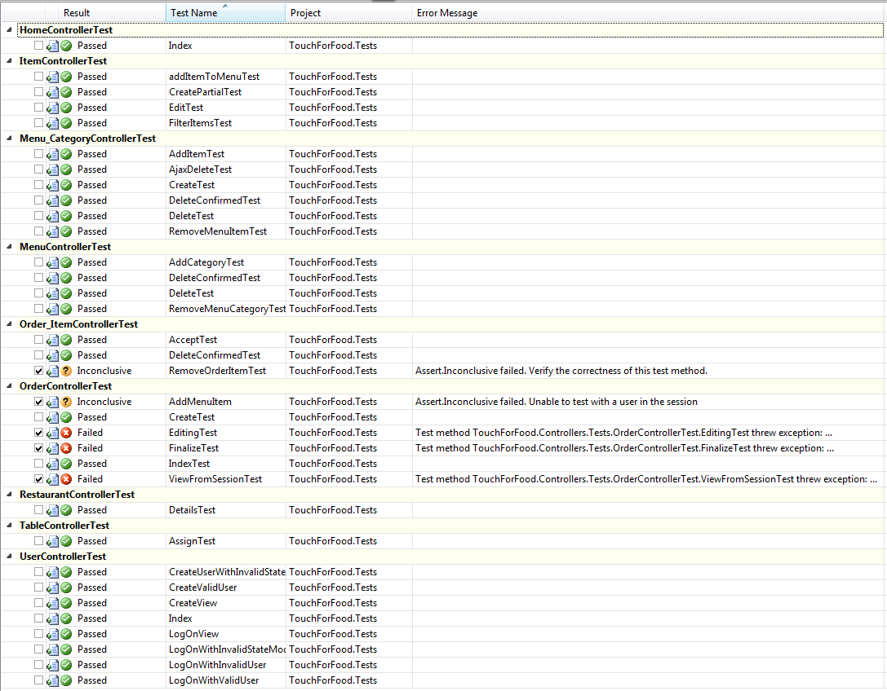

Figure 5‑1 Iteration 5 Unit Test Results

### Unit Test Coverage

**Project Coverage:** 38.23%

**Controller Layer Coverage:** 21.56%

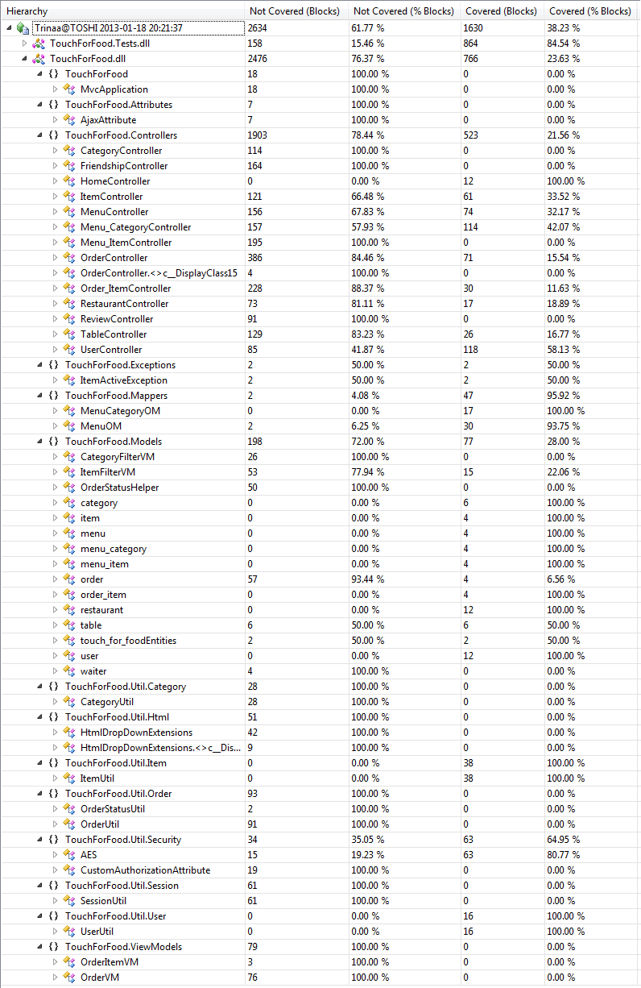

Figure 5‑2 Iteration 5 Code Coverage Results

## Defects

Table 5‑1 Iteration 5 List of Defects

|  |  |  |  |  |  |  |  |  |  |  |  |
| --- | --- | --- | --- | --- | --- | --- | --- | --- | --- | --- | --- |
| **Key** | **Issue Type** | **Status** | **Priority** | **Resolution** | **Assignee** | **Reporter** | **Created** | **Resolved** | **Affects Sprint** | **Fix Sprint** | **Time Spent (hours)** |
| [CAP-108](http://ryanweb.dyndns.info:8080/browse/CAP-108) | Bug | Closed | Minor | Fixed | Christian Daher | Christian Daher | 12/17/2012 16:19 | 1/14/2013 13:24 | Sprint 3 | Sprint 5 | 2.50 |
| [CAP-109](http://ryanweb.dyndns.info:8080/browse/CAP-109) | Bug | Resolved | Major | Fixed | Mikhail Levkovsky | Christian Daher | 12/17/2012 17:46 | 1/15/2013 1:36 | Sprint 3 | Sprint 5 | 4.93 |
| [CAP-111](http://ryanweb.dyndns.info:8080/browse/CAP-111) | Bug | Resolved | Major | Fixed | Patrick Modafferi | Patrick Modafferi | 12/18/2012 11:20 | 12/19/2012 17:00 | Sprint 4 | Sprint 4 | 8.50 |
| [CAP-125](http://ryanweb.dyndns.info:8080/browse/CAP-125) | Bug | Resolved | Major | Fixed | Mikhail Levkovsky | Mikhail Levkovsky | 12/18/2012 17:09 | 12/18/2012 20:44 | Sprint 4 | Sprint 4 | 6.00 |
| [CAP-128](http://ryanweb.dyndns.info:8080/browse/CAP-128) | Bug | Open | Trivial | *Unresolved* | Christian Daher | Patrick Modafferi | 12/18/2012 17:14 |  | Sprint 4 | Sprint 5 |  |
| [CAP-156](http://ryanweb.dyndns.info:8080/browse/CAP-156) | Bug | Resolved | Blocker | Fixed | Mikhail Levkovsky | Mikhail Levkovsky | 12/19/2012 15:08 | 12/19/2012 15:12 | Sprint 4 | Sprint 4 | 0.27 |
| [CAP-158](http://ryanweb.dyndns.info:8080/browse/CAP-158) | Bug | Resolved | Minor | Fixed | Mikhail Levkovsky | Katrina Anderson | 12/21/2012 15:02 | 1/5/2013 14:42 | Sprint 4 | Sprint 5 | 2.00 |
| [CAP-159](http://ryanweb.dyndns.info:8080/browse/CAP-159) | Bug | Resolved | Major | Fixed | Ryan Nasr | Matthew Tam | 12/21/2012 17:27 | 1/4/2013 14:38 | Sprint 4 | Sprint 5 | 0.50 |
| [CAP-160](http://ryanweb.dyndns.info:8080/browse/CAP-160) | Bug | Resolved | Critical | Fixed | Patrick Modafferi | Mikhail Levkovsky | 12/21/2012 19:19 | 12/21/2012 19:33 | Sprint 4 | Sprint 4 | 4.00 |
| [CAP-161](http://ryanweb.dyndns.info:8080/browse/CAP-161) | Bug | Resolved | Critical | Fixed | Patrick Modafferi | Cynthia Donato | 12/24/2012 13:05 | 1/13/2013 11:24 | Sprint 4 | Sprint 5 | 0.83 |
| [CAP-168](http://ryanweb.dyndns.info:8080/browse/CAP-168) | Bug | Closed | Blocker | Fixed | Christian Daher | Katrina Anderson | 12/30/2012 22:14 | 1/2/2013 12:18 | Sprint 4 | Sprint 4 | 0.25 |
| [CAP-169](http://ryanweb.dyndns.info:8080/browse/CAP-169) | Bug | Open | Major | *Unresolved* | Cynthia Donato | Katrina Anderson | 1/1/2013 17:42 |  | Sprint 4 | Sprint 5 |  |
| [CAP-170](http://ryanweb.dyndns.info:8080/browse/CAP-170) | Bug | Resolved | Trivial | Fixed | Katrina Anderson | Katrina Anderson | 1/2/2013 10:49 | 1/6/2013 19:03 | Sprint 4 | Sprint 5 | 0.42 |
| [CAP-190](http://ryanweb.dyndns.info:8080/browse/CAP-190) | Bug | Resolved | Major | Fixed | Ryan Nasr | Patrick Modafferi | 1/2/2013 12:29 | 1/4/2013 14:05 | Sprint 4 | Sprint 5 | 4.02 |
| [CAP-191](http://ryanweb.dyndns.info:8080/browse/CAP-191) | Bug | Resolved | Minor | Fixed | Cristian Asenjo | Cristian Asenjo | 1/2/2013 12:29 | 1/13/2013 18:52 | Sprint 4 | Sprint 5 | 1.03 |
| [CAP-193](http://ryanweb.dyndns.info:8080/browse/CAP-193) | Bug | Resolved | Minor | Fixed | Patrick Modafferi | Patrick Modafferi | 1/2/2013 13:25 | 1/5/2013 23:00 | Sprint 4 | Sprint 5 | 6.50 |
| [CAP-229](http://ryanweb.dyndns.info:8080/browse/CAP-229) | Bug | Resolved | Minor | Fixed | Mikhail Levkovsky | Patrick Modafferi | 1/6/2013 14:57 | 1/12/2013 13:13 | Sprint 5 | Sprint 5 | 2.52 |
| [CAP-235](http://ryanweb.dyndns.info:8080/browse/CAP-235) | Bug | Open | Critical | *Unresolved* | Christian Daher | Cynthia Donato | 1/8/2013 15:54 |  | Sprint 5 | Sprint 6 |  |
| [CAP-236](http://ryanweb.dyndns.info:8080/browse/CAP-236) | Bug | Open | Critical | *Unresolved* | Christian Daher | Cynthia Donato | 1/8/2013 15:56 |  | Sprint 5 | Sprint 6 |  |
| [CAP-237](http://ryanweb.dyndns.info:8080/browse/CAP-237) | Bug | Open | Critical | *Unresolved* | Christian Daher | Mikhail Levkovsky | 1/8/2013 15:58 |  | Sprint 5 | Sprint 6 |  |
| [CAP-238](http://ryanweb.dyndns.info:8080/browse/CAP-238) | Bug | Open | Critical | *Unresolved* | Christian Daher | Cynthia Donato | 1/8/2013 15:58 |  | Sprint 5 | Sprint 6 |  |
| [CAP-239](http://ryanweb.dyndns.info:8080/browse/CAP-239) | Bug | Open | Critical | *Unresolved* | Christian Daher | Mikhail Levkovsky | 1/8/2013 16:00 |  | Sprint 5 | Sprint 6 |  |
| [CAP-240](http://ryanweb.dyndns.info:8080/browse/CAP-240) | Bug | Open | Critical | *Unresolved* | Christian Daher | Mikhail Levkovsky | 1/8/2013 16:02 |  | Sprint 5 | Sprint 6 |  |
| [CAP-241](http://ryanweb.dyndns.info:8080/browse/CAP-241) | Bug | Open | Critical | *Unresolved* | Christian Daher | Mikhail Levkovsky | 1/8/2013 16:04 |  | Sprint 5 | Sprint 6 |  |
| [CAP-242](http://ryanweb.dyndns.info:8080/browse/CAP-242) | Bug | Open | Critical | *Unresolved* | Christian Daher | Cynthia Donato | 1/8/2013 16:04 |  | Sprint 5 | Sprint 6 |  |
| [CAP-243](http://ryanweb.dyndns.info:8080/browse/CAP-243) | Bug | Open | Critical | *Unresolved* | Christian Daher | Mikhail Levkovsky | 1/8/2013 16:06 |  | Sprint 5 | Sprint 6 |  |
| [CAP-246](http://ryanweb.dyndns.info:8080/browse/CAP-246) | Bug | Open | Critical | *Unresolved* | Christian Daher | Mikhail Levkovsky | 1/8/2013 20:29 |  | Sprint 5 | Sprint 6 |  |
| [CAP-250](http://ryanweb.dyndns.info:8080/browse/CAP-250) | Bug | Open | Minor | *Unresolved* | Christian Daher | Cynthia Donato | 1/8/2013 21:30 |  | Sprint 5 | Sprint 6 |  |
| [CAP-252](http://ryanweb.dyndns.info:8080/browse/CAP-252) | Bug | Resolved | Blocker | Fixed | Ryan Nasr | Mikhail Levkovsky | 1/10/2013 14:36 | 1/11/2013 15:27 | Sprint 5 | Sprint 5 | 0.52 |
| [CAP-253](http://ryanweb.dyndns.info:8080/browse/CAP-253) | Bug | Resolved | Blocker | Fixed | Ryan Nasr | Cynthia Donato | 1/10/2013 15:20 | 1/14/2013 20:45 | Sprint 5 | Sprint 5 | 1.00 |
| [CAP-259](http://ryanweb.dyndns.info:8080/browse/CAP-259) | Bug | Closed | Blocker | Fixed | Patrick Modafferi | Matthew Tam | 1/11/2013 18:25 | 1/14/2013 13:52 | Sprint 5 | Sprint 5 | 0.17 |
| [CAP-262](http://ryanweb.dyndns.info:8080/browse/CAP-262) | Bug | Resolved | Blocker | Fixed | Cristian Asenjo | Cynthia Donato | 1/13/2013 20:51 | 1/15/2013 22:38 | Sprint 5 | Sprint 5 | 2.60 |
| [CAP-274](http://ryanweb.dyndns.info:8080/browse/CAP-274) | Bug | Open | Major | *Unresolved* | Ryan Nasr | Ryan Nasr | 1/14/2013 21:39 |  | Sprint 5 | Sprint 6 |  |
| CAP-275 | Bug | Resolved | Blocker | Fixed | Cynthia Donato | Cynthia Donato | 1/15/2013 14:02 | 1/15/2013 21:54 | Sprint 5 | Sprint 5 | 0.25 |
| CAP-276 | Bug | Open | Minor | *Unresolved* | Cristian Asenjo | Cristian Asenjo | 1/15/2013 14:03 |  | Sprint 5 | Sprint 6 |  |
| CAP-277 | Bug | Open | Critical | *Unresolved* | Christian Daher | Cynthia Donato | 1/15/2013 14:06 |  | Sprint 5 | Sprint 6 |  |

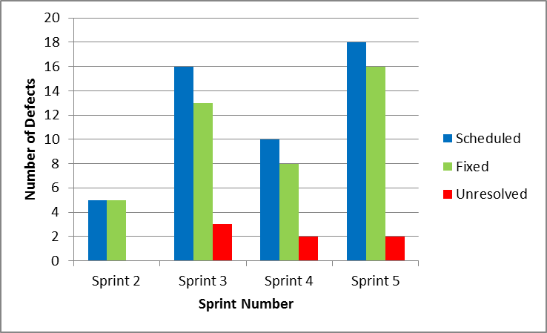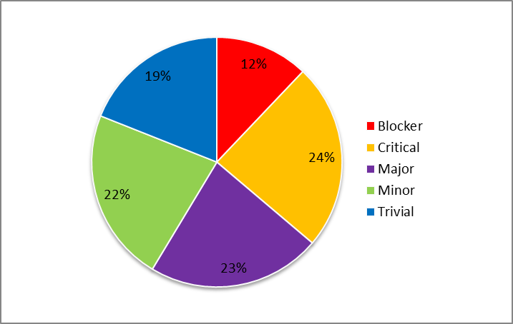

Figure 5‑3Iteration 5 Defect Breakdown vs. Sprint & Number of Defects vs. Criticality

# Iteration 6 Test Results

## Units Tests

### Unit Test Table & Status

**Number of Unit Tests:** 46

**Number of Passed Unit Tests:** 26

**Number of Failed Unit Tests:** 20

It is important to note that some of the unit tests are failing due to badly written test methods and not necessarily to the code they are testing. We are aware that there are issues with the tests and will take the appropriate measures to fix them as soon as possible.

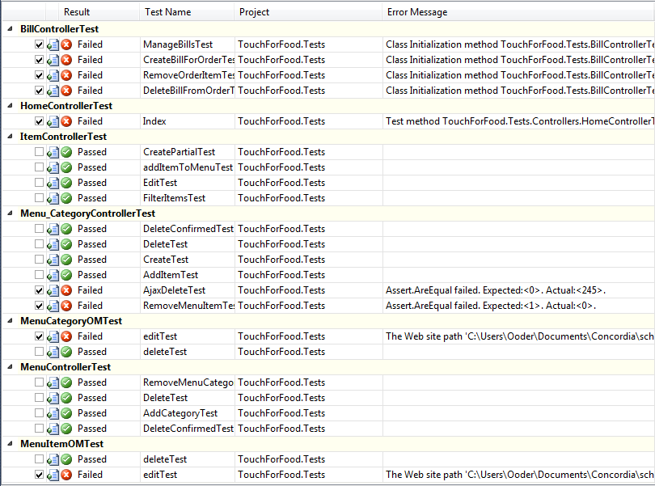

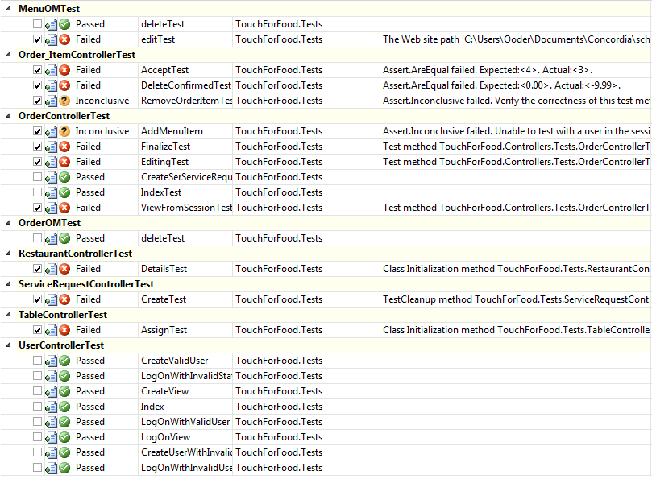

Figure 6‑1 Iteration 6 Unit Test Results

### Unit Test Coverage

**Project Coverage:** 14.34%

**Controller Layer Coverage:** 13.95%

**MapperLayerCoverage:** 16.90%

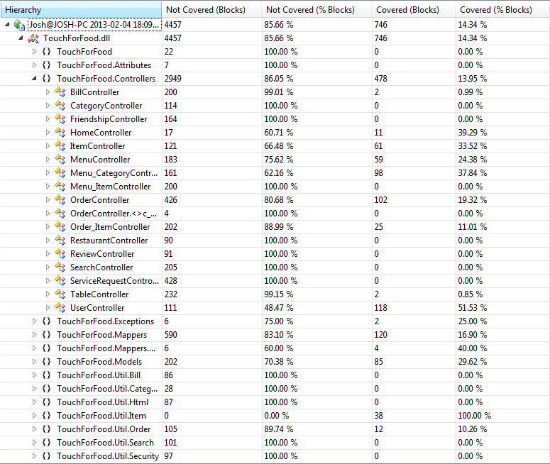

Figure 6‑2 Iteration 6 Code Coverage Results

## Defects

The following table of defects list the defects affecting Iteration 6 and/or to be fixed in Iteration 6.

Table 6‑1 Iteration 6 List of Defects

|  |  |  |  |  |  |  |  |  |  |  |  |
| --- | --- | --- | --- | --- | --- | --- | --- | --- | --- | --- | --- |
| **Key** | **Issue Type** | **Status** | **Priority** | **Resolution** | **Assignee** | **Reporter** | **Created** | **Resolved** | **Affects Sprint** | **Fix Sprint** | **Time Spent (hours)** |
| CAP-128 | Bug | Reopened | Trivial | Unresolved | Mikhail Levkovsky | Patrick Modafferi | 18/12/2012 17:14 |  | Sprint 4 | Sprint 6, Sprint 7 | 0 |
| CAP-274 | Bug | Reopened | Trivial | Unresolved | Mikhail Levkovsky | Ryan Nasr | 14/01/2013 21:39 |  | Sprint 5 | Sprint 6 | 0 |
| CAP-251 | Bug | Resolved | Minor | Duplicate | Unassigned | Josh Hum | 09/01/2013 16:23 | 15/01/2013 14:28 | Sprint 5 | Sprint 6 | 0 |
| CAP-276 | Bug | Resolved | Minor | Fixed | Cristian Asenjo | Cristian Asenjo | 15/01/2013 14:03 | 27/01/2013 12:21 |  | Sprint 6 | 0.16667 |
| CAP-169 | Bug | Reopened | Major | Unresolved | Cynthia Donato | Katrina Anderson | 01/01/2013 17:42 |  | Sprint 4 | Sprint 5, Sprint 6, Sprint 7 | 7.58333 |
| CAP-261 | Bug | Resolved | Major | Won't Fix | Ryan Nasr | Ryan Nasr | 13/01/2013 17:26 | 17/01/2013 19:19 | Sprint 5 | Sprint 6 | 1 |
| CAP-308 | Bug | Closed | Major | Fixed | Ryan Nasr | Ryan Nasr | 17/01/2013 19:23 | 29/01/2013 0:24 |  | Sprint 6 | 0.08333 |
| CAP-235 | Bug | Resolved | Critical | Fixed | Christian Daher | Cynthia Donato | 08/01/2013 15:54 | 29/01/2013 19:15 | Sprint 5 | Sprint 6 | 0.01667 |
| CAP-236 | Bug | Resolved | Critical | Duplicate | Christian Daher | Cynthia Donato | 08/01/2013 15:56 | 29/01/2013 19:15 | Sprint 5 | Sprint 6 | 0.01667 |
| CAP-237 | Bug | Resolved | Critical | Duplicate | Christian Daher | Mikhail Levkovsky | 08/01/2013 15:58 | 29/01/2013 19:14 | Sprint 5 | Sprint 6 | 0.01667 |
| CAP-238 | Bug | Resolved | Critical | Duplicate | Christian Daher | Cynthia Donato | 08/01/2013 15:58 | 29/01/2013 19:14 | Sprint 5 | Sprint 6 | 0.01667 |
| CAP-239 | Bug | Resolved | Critical | Duplicate | Christian Daher | Mikhail Levkovsky | 08/01/2013 16:00 | 29/01/2013 19:14 | Sprint 5 | Sprint 6 | 0.01667 |
| CAP-240 | Bug | Resolved | Critical | Duplicate | Christian Daher | Mikhail Levkovsky | 08/01/2013 16:02 | 29/01/2013 19:15 | Sprint 5 | Sprint 6 | 0.01667 |
| CAP-241 | Bug | Resolved | Critical | Duplicate | Christian Daher | Mikhail Levkovsky | 08/01/2013 16:04 | 29/01/2013 19:14 | Sprint 5 | Sprint 6 | 0.01667 |
| CAP-242 | Bug | Resolved | Critical | Duplicate | Christian Daher | Cynthia Donato | 08/01/2013 16:04 | 29/01/2013 19:14 | Sprint 5 | Sprint 6 | 0.01667 |
| CAP-243 | Bug | Resolved | Critical | Duplicate | Christian Daher | Mikhail Levkovsky | 08/01/2013 16:06 | 29/01/2013 19:15 | Sprint 5 | Sprint 6 | 0.01667 |
| CAP-246 | Bug | Resolved | Critical | Fixed | Christian Daher | Mikhail Levkovsky | 08/01/2013 20:29 | 29/01/2013 18:43 | Sprint 5 | Sprint 6 | 1 |
| CAP-277 | Bug | Resolved | Critical | Fixed | Christian Daher | Cynthia Donato | 15/01/2013 14:06 | 29/01/2013 18:44 | Sprint 5 | Sprint 6 | 0.5 |
| CAP-319 | Bug | Resolved | Blocker | Fixed | Unassigned | Cynthia Donato | 26/01/2013 13:17 | 29/01/2013 14:57 | Sprint 6 | Sprint 6 | 0.16667 |

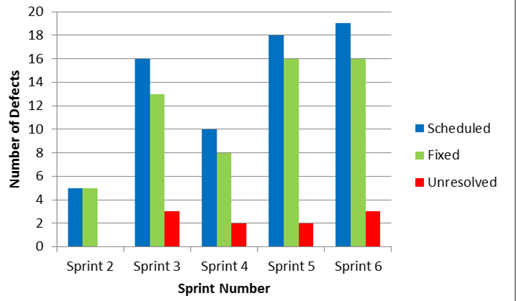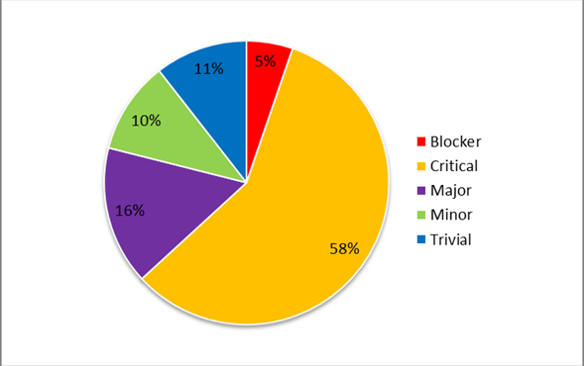

Figure 6‑3 Iteration 6 Defect Breakdown vs. Sprint & Number of Defects vs. Criticality

## User Interface Tests & Results

The test cases detailed in Section 1.1 are executed by hand to verify that the system has a functional user interface and that it meets the required standards of TFF. Here are the results:

Table 6‑2 Iteration 6 UI Test Results

|  |  |  |  |  |  |  |
| --- | --- | --- | --- | --- | --- | --- |
| **Test ID** | **Title** | **Environment** | **Sprint** | **Test Date** | **Status** | **Notes** |
| TC025.1 | Test Create Order | Google Chrome 24.0.1312.57 m | 6 | 1/27/2013 | FAIL | - Doesn't work for a regular user, don't know if this was intended |
| TC026.1 | Test View Menu (Customer) | Google Chrome 24.0.1312.57 m | 6 | 1/27/2013 | FAIL | - Can't finalize the order, unless that's expected |
| TC026.2 | Test View Menu (Restaurant) | Google Chrome 24.0.1312.57 m | 6 | 1/27/2013 | FAIL | - The user should not be able to see the remove buttons. |
| TC026.3 | Test View Menu (Administrator) | Google Chrome 24.0.1312.57 m | 6 | 1/27/2013 | PASS |  |
| TC027.1 | Test Menu Editor Main Page | Google Chrome 24.0.1312.57 m | 6 | 1/28/2013 | PASS |  |
| TC027.2 | Test Category Management Page | Google Chrome 24.0.1312.57 m | 6 | 1/28/2013 | PASS | - On site, it's + New Category. In test case, it specifies "Create New Category" |
| TC027.3 | Test Item Management Page | Google Chrome 24.0.1312.57 m | 6 | 1/28/2013 | PASS |  |
| TC027.4 | Test Menu Edit | Google Chrome 24.0.1312.57 m | 6 | 1/28/2013 | FAIL | - Can't remove a category |
| TC027.5 | Test Create Menu | Google Chrome 24.0.1312.57 m | 6 | 1/28/2013 | PASS |  |
| TC029.1 | Test Cancel Order | Google Chrome 24.0.1312.57 m | 6 | 1/28/2013 | FAIL | - Can't view orders |
| TC029.2 | Test Decline Order Item | Google Chrome 24.0.1312.57 m | 6 | 1/28/2013 | FAIL | - Can't view orders |
| TC029.3 | Test Accept Order Item | Google Chrome 24.0.1312.57 m | 6 | 1/28/2013 | FAIL | - Can't view orders |
| TC040.1 | Test Login With Non-Existent User | Google Chrome 24.0.1312.57 m | 6 | 1/27/2013 | PASS |  |
| TC040.2 | Test Create New User | Google Chrome 24.0.1312.57 m | 6 | 1/27/2013 | PASS |  |
| TC040.3 | Test Login With Existent User | Google Chrome 24.0.1312.57 m | 6 | 1/27/2013 | FAIL | - Not case sensitive for user name or for password i.e. can write testinguser / testing |
| TC040.4 | Test Logout | Google Chrome 24.0.1312.57 m | 6 | 1/27/2013 | PASS |  |
| TC192.1 | Test Create Table Page | Google Chrome 24.0.1312.57 m | 6 | 1/28/2013 | PASS |  |
| TC192.2 | Test Creating Incorrect Table Page | Google Chrome 24.0.1312.57 m | 6 | 1/28/2013 | FAIL | - Can create a table with no information, no error message |
| TC192.3 | Test Edit Table Page | Google Chrome 24.0.1312.57 m | 6 | 1/28/2013 | PASS |  |
| TC192.4 | Test Incorrect Edit Table Page | Google Chrome 24.0.1312.57 m | 6 | 1/28/2013 | FAIL | - Can create a table with no name, no error message appears |
| TC192.5 | Test NFC Link Page | Google Chrome 24.0.1312.57 m | 6 | 1/28/2013 | FAIL | - Can click on NFC link to tables that are not linked to a restaurant, which results in an error |
| TC192.6 | Test Table Details Page | Google Chrome 24.0.1312.57 m | 6 | 1/28/2013 | PASS |  |
| TC192.7 | Test Delete Table Page | Google Chrome 24.0.1312.57 m | 6 | 1/28/2013 | PASS |  |

# Iteration 7 Test Results

## Units Tests

### Unit Test Table & Status

**Number of Unit Tests:** 68

**Number of Passed Unit Tests:** 40

**Number of Failed Unit Tests:** 28

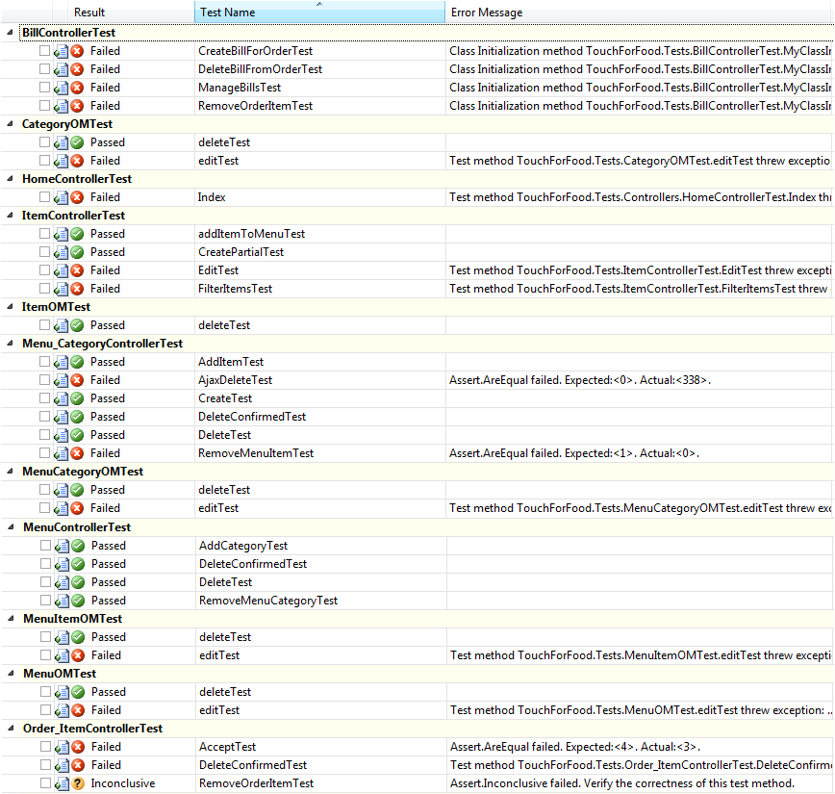

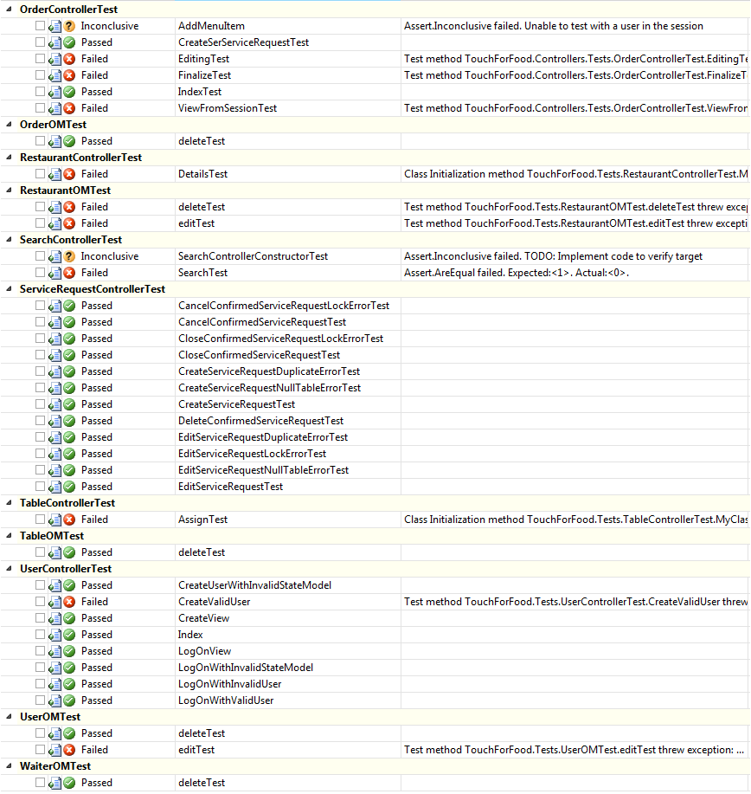

Figure 7‑1 Iteration 7 Unit Test Results

### Unit Test Coverage

**Project Coverage:** 28.00%

**Controller Layer Coverage:** 21.48%

**MapperLayerCoverage:** 47.12%

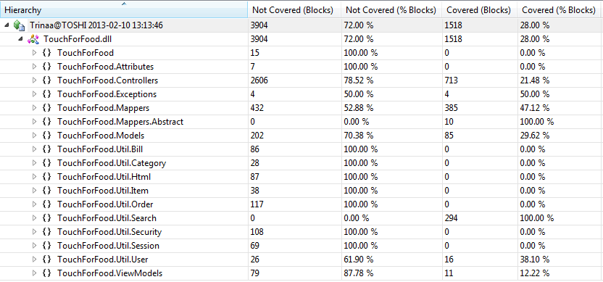

Figure 7‑2 Iteration 7 Code Coverage Results

## Defects

Table 7‑1 Iteration 7 List of Defects

|  |  |  |  |  |  |  |  |  |  |  |  |
| --- | --- | --- | --- | --- | --- | --- | --- | --- | --- | --- | --- |
| **Key** | **Issue Type** | **Status** | **Priority** | **Resolution** | **Assignee** | **Reporter** | **Created** | **Resolved** | **Affects Sprint** | **Fix Sprint** | **Time Spent (hours)** |
| CAP-250 | Bug | Open | Trivial | *Unresolved* | Mikhail Levkovsky | Cynthia Donato | 08/01/2013 21:30 |  | Sprint 5 | Sprint 7 | 0.00 |
| CAP-251 | Bug | Resolved | Minor | Duplicate | *Unassigned* | Josh Hum | 09/01/2013 16:23 | 15/01/2013 14:28 | Sprint 5 | Sprint 6 | 0.00 |
| CAP-252 | Bug | Resolved | Blocker | Fixed | Ryan Nasr | Mikhail Levkovsky | 10/01/2013 14:36 | 11/01/2013 15:27 | Sprint 5 | Sprint 5 | 0.52 |
| CAP-253 | Bug | Resolved | Blocker | Fixed | Ryan Nasr | Cynthia Donato | 10/01/2013 15:20 | 14/01/2013 20:45 | Sprint 5 | Sprint 5 | 1.00 |
| CAP-254 | Bug | Resolved | Critical | Duplicate | *Unassigned* | Matthew Tam | 11/01/2013 14:15 | 11/01/2013 14:30 | Sprint 5 | Sprint 5 | 0.00 |
| CAP-259 | Bug | Closed | Blocker | Fixed | Patrick Modafferi | Matthew Tam | 11/01/2013 18:25 | 14/01/2013 13:52 | Sprint 5 | Sprint 5 | 0.17 |
| CAP-260 | Bug | Closed | Blocker | Duplicate | *Unassigned* | Matthew Tam | 11/01/2013 18:48 | 14/01/2013 13:45 |  |  | 0.00 |
| CAP-261 | Bug | Resolved | Major | Won't Fix | Ryan Nasr | Ryan Nasr | 13/01/2013 17:26 | 17/01/2013 19:19 | Sprint 5 | Sprint 6 | 1.00 |
| CAP-262 | Bug | Resolved | Blocker | Fixed | Cristian Asenjo | Cynthia Donato | 13/01/2013 20:51 | 15/01/2013 22:38 | Sprint 5 | Sprint 5 | 2.60 |
| CAP-274 | Bug | Reopened | Trivial | *Unresolved* | Mikhail Levkovsky | Ryan Nasr | 14/01/2013 21:39 |  | Sprint 5 | Sprint 6 | 0.00 |
| CAP-275 | Bug | Resolved | Blocker | Fixed | Cynthia Donato | Cynthia Donato | 15/01/2013 14:02 | 15/01/2013 21:54 | Sprint 5 | Sprint 5 | 0.25 |
| CAP-276 | Bug | Resolved | Minor | Fixed | Cristian Asenjo | Cristian Asenjo | 15/01/2013 14:03 | 27/01/2013 12:21 | Sprint 5 | Sprint 6 | 0.17 |
| CAP-277 | Bug | Resolved | Critical | Fixed | Christian Daher | Cynthia Donato | 15/01/2013 14:06 | 29/01/2013 18:44 | Sprint 5 | Sprint 6 | 0.50 |
| CAP-308 | Bug | Closed | Major | Fixed | Ryan Nasr | Ryan Nasr | 17/01/2013 19:23 | 29/01/2013 0:24 | Sprint 5 | Sprint 6 | 0.08 |
| CAP-313 | Bug | Resolved | Critical | Fixed | Mikhail Levkovsky | Ryan Nasr | 19/01/2013 17:00 | 08/02/2013 13:33 | Sprint 7 | Sprint 7 | 1.02 |
| CAP-315 | Bug | Resolved | Major | Fixed | Cristian Asenjo | Mikhail Levkovsky | 25/01/2013 14:35 | 27/01/2013 13:18 | Sprint 6 | Sprint 6 | 0.80 |
| CAP-316 | Bug | Resolved | Major | Fixed | Mikhail Levkovsky | Ryan Nasr | 26/01/2013 12:43 | 08/02/2013 13:32 | Sprint 7 | Sprint 7 | 0.52 |
| [CAP-317](http://ryanweb.dyndns.info:8080/browse/CAP-45) | Bug | Resolved | Major | Fixed | Mikhail Levkovsky | Ryan Nasr | 26/01/2013 12:47 | 08/02/2013 18:02 | Sprint 6 | Sprint 7 | 0.02 |
| [CAP-319](http://ryanweb.dyndns.info:8080/browse/CAP-53) | Bug | Resolved | Blocker | Fixed | *Unassigned* | Cynthia Donato | 26/01/2013 13:17 | 29/01/2013 14:57 | Sprint 6 | Sprint 6 | 0.17 |
| [CAP-321](http://ryanweb.dyndns.info:8080/browse/CAP-54) | Bug | Open | Major | *Unresolved* | Cristian Asenjo | Cristian Asenjo | 28/01/2013 15:42 |  | Sprint 6 | Sprint 7 | 0.00 |
| [CAP-322](http://ryanweb.dyndns.info:8080/browse/CAP-55) | Bug | Open | Major | *Unresolved* | Cristian Asenjo | Cristian Asenjo | 28/01/2013 20:00 |  | Sprint 6 | Sprint 7 | 0.00 |
| [CAP-323](http://ryanweb.dyndns.info:8080/browse/CAP-77) | Bug | Open | Minor | *Unresolved* | Cristian Asenjo | Cristian Asenjo | 28/01/2013 20:01 |  | Sprint 6 | Sprint 7 | 0.00 |
| [CAP-324](http://ryanweb.dyndns.info:8080/browse/CAP-82) | Bug | Open | Minor | *Unresolved* | Cristian Asenjo | Cristian Asenjo | 28/01/2013 20:02 |  | Sprint 7 | Sprint 7 | 0.00 |
| [CAP-325](http://ryanweb.dyndns.info:8080/browse/CAP-83) | Bug | Open | Trivial | *Unresolved* | Mikhail Levkovsky | Josh Hum | 28/01/2013 23:50 |  | Sprint 6 | Sprint 8 | 0.00 |
| [CAP-386](http://ryanweb.dyndns.info:8080/browse/CAP-85) | Bug | Open | Minor | *Unresolved* | *Unassigned* | Patrick Modafferi | 01/02/2013 23:27 |  | Sprint 7 | Sprint 8 | 0.00 |
| [CAP-387](http://ryanweb.dyndns.info:8080/browse/CAP-86) | Bug | Open | Major | *Unresolved* | *Unassigned* | Katrina Anderson | 04/02/2013 20:57 |  | Sprint 7 | Sprint 8 | 0.00 |
| [CAP-388](http://ryanweb.dyndns.info:8080/browse/CAP-88) | Bug | Resolved | Critical | Fixed | Katrina Anderson | Katrina Anderson | 05/02/2013 11:16 | 07/02/2013 2:28 | Sprint 7 | Sprint 7 | 1.90 |
| [CAP-390](http://ryanweb.dyndns.info:8080/browse/CAP-91) | Bug | Open | Trivial | *Unresolved* | *Unassigned* | Katrina Anderson | 06/02/2013 23:07 |  | Sprint 7 | Sprint 8 | 0.00 |
| [CAP-391](http://ryanweb.dyndns.info:8080/browse/CAP-92) | Bug | Open | Minor | *Unresolved* | *Unassigned* | Katrina Anderson | 06/02/2013 23:19 |  | Sprint 7 | Sprint 8 | 0.00 |
| [CAP-392](http://ryanweb.dyndns.info:8080/browse/CAP-93) | Bug | Open | Minor | *Unresolved* | *Unassigned* | Katrina Anderson | 06/02/2013 23:30 |  | Sprint 7 | Sprint 8 | 0.00 |
| [CAP-393](http://ryanweb.dyndns.info:8080/browse/CAP-94) | Bug | Open | Minor | *Unresolved* | *Unassigned* | Katrina Anderson | 06/02/2013 23:31 |  | Sprint 7 | Sprint 8 | 0.00 |
| [CAP-394](http://ryanweb.dyndns.info:8080/browse/CAP-95) | Bug | Open | Trivial | *Unresolved* | *Unassigned* | Cynthia Donato | 07/02/2013 14:17 |  | Sprint 7 | Sprint 8 | 0.00 |
| [CAP-400](http://ryanweb.dyndns.info:8080/browse/CAP-96) | Bug | Open | Trivial | *Unresolved* | *Unassigned* | Cynthia Donato | 07/02/2013 14:28 |  | Sprint 7 | Sprint 8 | 0.00 |
| [CAP-402](http://ryanweb.dyndns.info:8080/browse/CAP-97) | Bug | Open | Major | *Unresolved* | *Unassigned* | Cynthia Donato | 09/02/2013 9:25 |  | Sprint 7 | Sprint 8 | 0.00 |
| [CAP-403](http://ryanweb.dyndns.info:8080/browse/CAP-98) | Bug | Open | Major | *Unresolved* | *Unassigned* | Cynthia Donato | 09/02/2013 9:26 |  | Sprint 7 | Sprint 8 | 0.00 |
| [CAP-404](http://ryanweb.dyndns.info:8080/browse/CAP-99) | Bug | Open | Major | *Unresolved* | *Unassigned* | Cynthia Donato | 09/02/2013 14:55 |  | Sprint 7 | Sprint 8 | 0.00 |

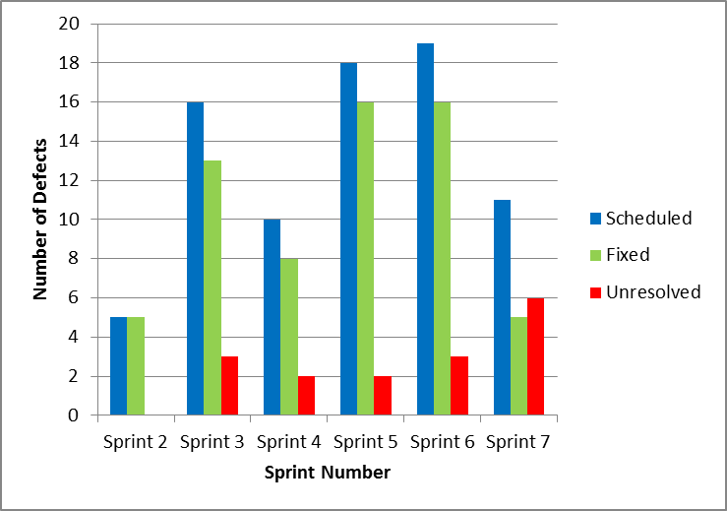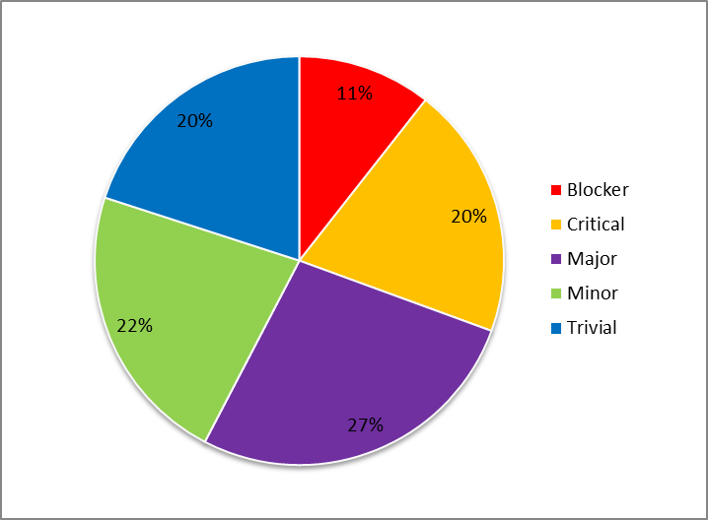

Figure 7‑3 Iteration 7 Defect Breakdown vs. Sprint & Number of Defects vs. Criticality

## User Interface Tests & Results

**Number of UI Tests:** 34

**Number of Passed UI Tests:** 22

**Number of Failed UI Tests:** 12

Table 7‑2 Iteration 7 UI Test Results

|  |  |  |  |  |  |  |
| --- | --- | --- | --- | --- | --- | --- |
| **Test ID** | **Title** | **Environment** | **Sprint** | **Test Date** | **Status** | **Notes** |
| TC025.1 | Test Create Order | Google Chrome 24.0.1312.57 m | 6 | 10/02/2013 | FAIL | - Doesn't work for a user with role customer. |
| TC026.1 | Test View Menu (Customer) | Google Chrome 24.0.1312.57 m | 6 | 10/02/2013 | FAIL | - Menu list is not exclusive to the restaurant where the user is signed in.  - Intervention in the database is required to make menus categories and items visible. |
| TC026.2 | Test View Menu (Restaurant) | Google Chrome 24.0.1312.57 m | 6 | 10/02/2013 | FAIL | - Menu list is not exclusive to the restaurants associated to the user.  - The option to order food should not be available to restaurant users. |
| TC026.3 | Test View Menu (Administrator) | Google Chrome 24.0.1312.57 m | 6 | 10/02/2013 | PASS |  |
| TC027.1 | Test Menu Editor Main Page | Google Chrome 24.0.1312.57 m | 6 | 10/02/2013 | FAIL | - All the current menus are not displayed. |
| TC027.2 | Test Category Management Page | Google Chrome 24.0.1312.57 m | 6 | 10/02/2013 | PASS |  |
| TC027.3 | Test Item Management Page | Google Chrome 24.0.1312.57 m | 6 | 10/02/2013 | FAIL | - Option to edit an item is unavailable. |
| TC027.4 | Test Menu Edit | Google Chrome 24.0.1312.57 m | 6 | 10/02/2013 | FAIL | - Category cannot be removed. |
| TC027.5 | Test Create Menu | Google Chrome 24.0.1312.57 m | 6 | 10/02/2013 | PASS |  |
| TC029.1 | Test Cancel Order | Google Chrome 24.0.1312.57 m | 6 | 10/02/2013 | FAIL | - Option to cancel order is not visible |
| TC029.2 | Test Decline Order Item | Google Chrome 24.0.1312.57 m | 6 | 10/02/2013 | PASS |  |
| TC029.3 | Test Accept Order Item | Google Chrome 24.0.1312.57 m | 6 | 10/02/2013 | FAIL | - Order item status not visible  - No indication that the order was successfully accepted provided. |
| TC034.1 | Test Create Service Request (Administrator) | Google Chrome 24.0.1312.57 m | 7 | 10/02/2013 | PASS |  |
| TC034.2 | Test Create Service Request (Restaurant) | Google Chrome 24.0.1312.57 m | 7 | 10/02/2013 | PASS |  |
| TC034.3 | Test Call Waiter (Customer) | Google Chrome 24.0.1312.57 m | 7 | 10/02/2013 | PASS |  |
| TC034.4 | Test Edit Service Request (Restaurant) | Google Chrome 24.0.1312.57 m | 7 | 10/02/2013 | PASS |  |
| TC034.5 | Test Edit Service Request (Administrator) | Google Chrome 24.0.1312.57 m | 7 | 10/02/2013 | PASS |  |
| TC034.6 | Test Cancel Service Request | Google Chrome 24.0.1312.57 m | 7 | 10/02/2013 | PASS |  |
| TC034.7 | Test Close Service Request | Google Chrome 24.0.1312.57 m | 7 | 10/02/2013 | PASS |  |
| TC040.1 | Test Login With Non-Existent User | Google Chrome 24.0.1312.57 m | 6 | 10/02/2013 | PASS |  |
| TC040.2 | Test Create New User | Google Chrome 24.0.1312.57 m | 6 | 10/02/2013 | PASS |  |
| TC040.3 | Test Login With Existent User | Google Chrome 24.0.1312.57 m | 6 | 10/02/2013 | FAIL | - Password is not case sensitive |
| TC040.4 | Test Logout | Google Chrome 24.0.1312.57 m | 6 | 10/02/2013 | PASS |  |
| TC42.1 | Test Create Bill (Restaurant) | Google Chrome 24.0.1312.57 m | 7 | 10/02/2013 | PASS |  |
| TC42.2 | Test Add Item to Bill (Restaurant) | Google Chrome 24.0.1312.57 m | 7 | 10/02/2013 | PASS |  |
| TC42.3 | Test Remove Item from Bill (Restaurant) | Google Chrome 24.0.1312.57 m | 7 | 10/02/2013 | PASS |  |
| TC42.4 | Test Delete Bill (Restaurant) | Google Chrome 24.0.1312.57 m | 7 | 10/02/2013 | PASS |  |
| TC192.1 | Test Create Table Page | Google Chrome 24.0.1312.57 m | 6 | 10/02/2013 | PASS |  |
| TC192.2 | Test Creating Incorrect Table Page | Google Chrome 24.0.1312.57 m | 6 | 10/02/2013 | FAIL | - No error message is displayed. |
| TC192.3 | Test Edit Table Page | Google Chrome 24.0.1312.57 m | 6 | 10/02/2013 | PASS |  |
| TC192.4 | Test Incorrect Edit Table Page | Google Chrome 24.0.1312.57 m | 6 | 10/02/2013 | FAIL | - No error message is displayed. |
| TC192.5 | Test NFC Link Page | Google Chrome 24.0.1312.57 m | 6 | 10/02/2013 | FAIL | - Error is thrown when table isn’t associated to a restaurant |
| TC192.6 | Test Table Details Page | Google Chrome 24.0.1312.57 m | 6 | 10/02/2013 | PASS |  |
| TC192.7 | Test Delete Table Page | Google Chrome 24.0.1312.57 m | 6 | 10/02/2013 | PASS |  |

# Iteration 8 Test Results

## Units Tests

### Unit Test Table & Status

**Number of Unit Tests:** 78

**Number of Passed Unit Tests:** 64

**Number of Failed Unit Tests:** 14

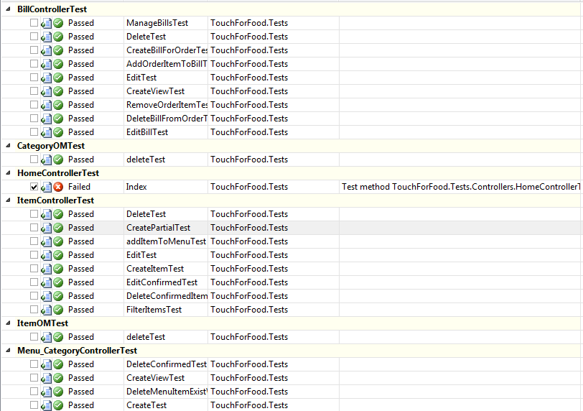

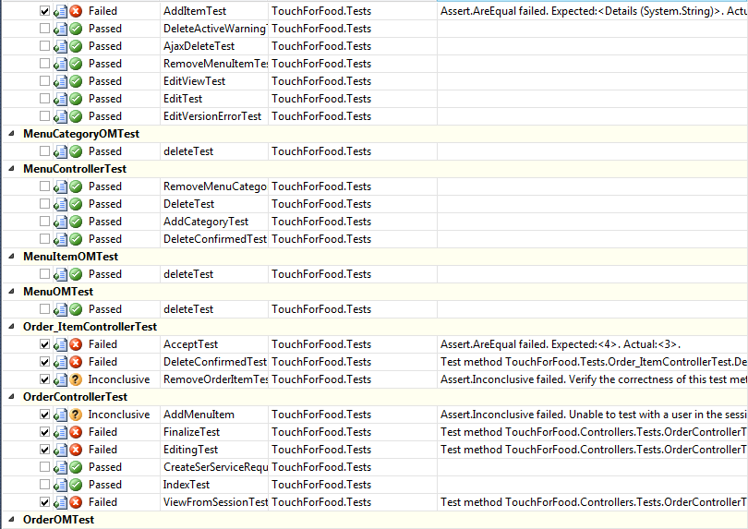

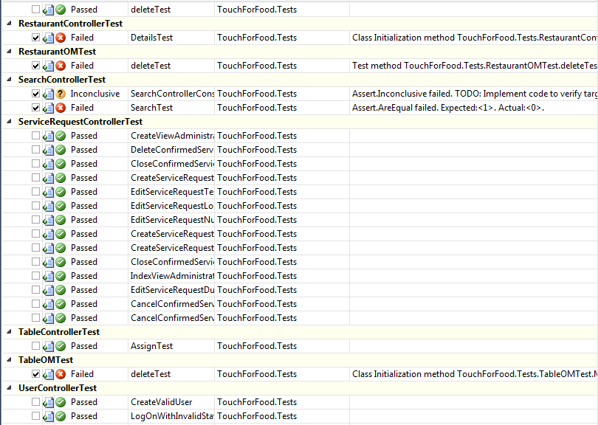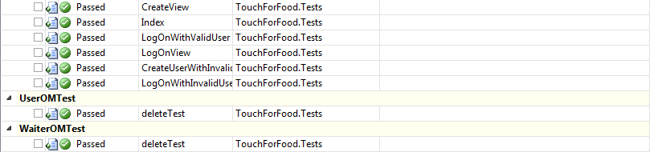

Figure 8‑1 Iteration 8 Unit Test Results

### Unit Test Coverage

**Project Coverage:** 37.86%

**Controller Layer Coverage:** 31.66%

**MapperLayerCoverage:** 49.89%

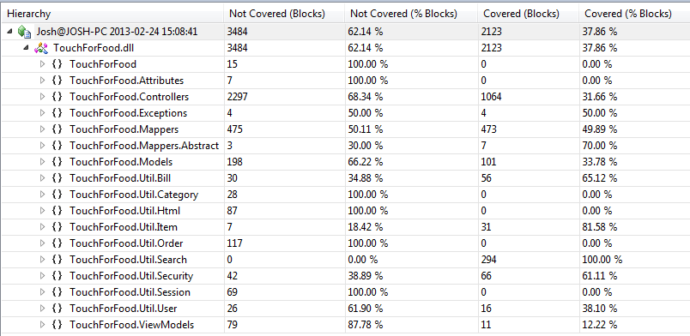

Figure 8‑2 Iteration 8 Code Coverage Results

## Defects

Table 8‑1 Iteration 8 List of Defects

|  |  |  |  |  |  |  |  |  |  |  |  |
| --- | --- | --- | --- | --- | --- | --- | --- | --- | --- | --- | --- |
| **Key** | **Issue Type** | **Status** | **Priority** | **Resolution** | **Assignee** | **Reporter** | **Created** | **Resolved** | **Affects Sprint** | **Fix Sprint** | **Time Spent (hours)** |
| CAP-386 | Bug | Closed | Minor | Fixed | Unassigned | Patrick Modafferi | 01/02/2013 | 12/02/2013 | Sprint 7 | Sprint 8 | 0.00 |
| CAP-390 | Bug | Open | Trivial | Unresolved | Ryan Nasr | Katrina Anderson | 06/02/2013 |  | Sprint 7 | Sprint 8 | 0.00 |
| CAP-387 | Bug | In Progress | Major | Unresolved | Ryan Nasr | Katrina Anderson | 04/02/2013 |  | Sprint 7 | Sprint 8 | 1.50 |
| CAP-393 | Bug | Resolved | Minor | Duplicate | Josh Hum | Katrina Anderson | 06/02/2013 | 21/02/2013 | Sprint 7 | Sprint 8 | 0.17 |
| CAP-392 | Bug | Resolved | Minor | Duplicate | Josh Hum | Katrina Anderson | 06/02/2013 | 21/02/2013 | Sprint 7 | Sprint 8 | 0.17 |
| CAP-403 | Bug | In Progress | Major | Unresolved | Ryan Nasr | Cynthia Donato | 09/02/2013 |  | Sprint 7 | Sprint 8 | 2.00 |
| CAP-404 | Bug | In Progress | Major | Unresolved | Ryan Nasr | Cynthia Donato | 09/02/2013 |  | Sprint 7 | Sprint 8 | 1.00 |
| CAP-414 | Bug | In Progress | Minor | Unresolved | Ryan Nasr | Cristian Asenjo | 12/02/2013 |  | Sprint 7 | Sprint 8 | 1.00 |
| CAP-391 | Bug | In Progress | Minor | Unresolved | Ryan Nasr | Katrina Anderson | 06/02/2013 |  | Sprint 7 | Sprint 8 | 0.50 |
| CAP-415 | Bug | In Progress | Major | Unresolved | Ryan Nasr | Mikhail Levkovsky | 12/02/2013 |  | Sprint 8 | Sprint 8 | 2.00 |
| CAP-402 | Bug | Open | Major | Unresolved | Ryan Nasr | Cynthia Donato | 09/02/2013 |  | Sprint 7 | Sprint 8 | 0.00 |
| CAP-413 | Bug | Open | Major | Unresolved | Ryan Nasr | Christian Daher | 12/02/2013 |  |  | Sprint 8 | 0.00 |
| CAP-464 | Bug | Resolved | Critical | Fixed | Patrick Modafferi | Katrina Anderson | 19/02/2013 | 24/02/2013 | Sprint 8 | Sprint 8 | 0.27 |
| CAP-484 | Bug | Resolved | Major | Fixed | Unassigned | Patrick Modafferi | 23/02/2013 | 24/02/2013 | Sprint 8 | Sprint 9 | 0.00 |
| CAP-487 | Bug | Open | Minor | Unresolved | Unassigned | Katrina Anderson | 23/02/2013 |  | Sprint 9 | Sprint 9 | 0 |
| CAP-486 | Bug | Open | Trivial | Unresolved | Unassigned | Katrina Anderson | 23/02/2013 |  | Sprint 9 | Sprint 9 | 0 |
| CAP-489 | Bug | Open | Minor | Unresolved | Unassigned | Katrina Anderson | 23/02/2013 |  | Sprint 9 | Sprint 9 | 0 |
| CAP-488 | Bug | Open | Trivial | Unresolved | Unassigned | Katrina Anderson | 23/02/2013 |  | Sprint 9 | Sprint 9 | 0 |
| CAP-480 | Bug | Open | Major | Unresolved | Ryan Nasr | Mikhail Levkovsky | 20/02/2013 |  | Sprint 9 | Sprint 9 | 0 |
| CAP-481 | Bug | Open | Minor | Unresolved | Unassigned | Mikhail Levkovsky | 20/02/2013 |  | Sprint 9 | Sprint 9 | 0 |
| CAP-459 | Bug | Open | Major | Unresolved | Ryan Nasr | Mikhail Levkovsky | 19/02/2013 |  | Sprint 9 | Sprint 9 | 0 |
| CAP-460 | Bug | Open | Minor | Unresolved | Ryan Nasr | Mikhail Levkovsky | 19/02/2013 |  | Sprint 9 | Sprint 9 | 0 |
| CAP-461 | Bug | Open | Major | Unresolved | Ryan Nasr | Mikhail Levkovsky | 19/02/2013 |  | Sprint 9 | Sprint 9 | 0 |
| CAP-463 | Bug | Open | Major | Unresolved | Ryan Nasr | Mikhail Levkovsky | 19/02/2013 |  | Sprint 9 | Sprint 9 | 0 |
| CAP-462 | Bug | Open | Minor | Unresolved | Ryan Nasr | Mikhail Levkovsky | 19/02/2013 |  | Sprint 9 | Sprint 9 | 0 |
| CAP-490 | Bug | Open | Minor | Unresolved | Unassigned | Josh Hum | 24/02/2013 |  | Sprint 9 | Sprint 9 | 0 |
| CAP-491 | Bug | Open | Trivial | Unresolved | Unassigned | Josh Hum | 24/02/2013 |  | Sprint 9 | Sprint 9 | 0 |
| CAP-495 | Bug | Open | Major | Unresolved | Unassigned | Josh Hum | 24/02/2013 |  | Sprint 9 | Sprint 9 | 0 |
| CAP-493 | Bug | Open | Minor | Unresolved | Unassigned | Josh Hum | 24/02/2013 |  | Sprint 9 | Sprint 9 | 0 |
| CAP-494 | Bug | Open | Major | Unresolved | Unassigned | Josh Hum | 24/02/2013 |  | Sprint 9 | Sprint 9 | 0 |
| CAP-500 | Bug | Open | Major | Unresolved | Unassigned | Josh Hum | 24/02/2013 |  | Sprint 9 | Sprint 9 | 0 |
| CAP-498 | Bug | Open | Major | Unresolved | Unassigned | Josh Hum | 24/02/2013 |  | Sprint 9 | Sprint 9 | 0 |
| CAP-492 | Bug | Open | Minor | Unresolved | Unassigned | Josh Hum | 24/02/2013 |  | Sprint 9 | Sprint 9 | 0 |
| CAP-496 | Bug | Open | Major | Unresolved | Unassigned | Josh Hum | 24/02/2013 |  | Sprint 9 | Sprint 9 | 0 |
| CAP-497 | Bug | Open | Major | Unresolved | Unassigned | Josh Hum | 24/02/2013 |  | Sprint 9 | Sprint 9 | 0 |
| CAP-499 | Bug | Open | Major | Unresolved | Unassigned | Josh Hum | 24/02/2013 |  | Sprint 9 | Sprint 9 | 0 |
| CAP-507 | Bug | Open | Major | Unresolved | Unassigned | Josh Hum | 24/02/2013 |  | Sprint 9 | Sprint 9 | 0 |
| CAP-504 | Bug | Open | Major | Unresolved | Unassigned | Josh Hum | 24/02/2013 |  | Sprint 9 | Sprint 9 | 0 |
| CAP-502 | Bug | Open | Major | Unresolved | Unassigned | Josh Hum | 24/02/2013 |  | Sprint 9 | Sprint 9 | 0 |
| CAP-503 | Bug | Open | Major | Unresolved | Unassigned | Josh Hum | 24/02/2013 |  | Sprint 9 | Sprint 9 | 0 |
| CAP-501 | Bug | Open | Major | Unresolved | Unassigned | Josh Hum | 24/02/2013 |  | Sprint 9 | Sprint 9 | 0 |
| CAP-506 | Bug | Open | Major | Unresolved | Unassigned | Josh Hum | 24/02/2013 |  | Sprint 9 | Sprint 9 | 0 |
| CAP-509 | Bug | Open | Minor | Unresolved | Unassigned | Josh Hum | 24/02/2013 |  | Sprint 9 | Sprint 9 | 0 |
| CAP-508 | Bug | Open | Trivial | Unresolved | Unassigned | Josh Hum | 24/02/2013 |  | Sprint 9 | Sprint 9 | 0 |
| CAP-505 | Bug | Open | Major | Unresolved | Unassigned | Josh Hum | 24/02/2013 |  | Sprint 9 | Sprint 9 | 0 |
| CAP-260 | Bug | Closed | Blocker | Duplicate | Unassigned | Matthew Tam | 11/01/2013 | 14/01/2013 |  |  | 0 |
| CAP-250 | Bug | Resolved | Trivial | Incomplete | Mikhail Levkovsky | Cynthia Donato | 08/01/2013 | 12/02/2013 | Sprint 7 |  | 0 |
| CAP-325 | Bug | Resolved | Trivial | Incomplete | Mikhail Levkovsky | Josh Hum | 28/01/2013 | 12/02/2013 | Sprint 6 |  | 0 |

Figure 8‑3 Iteration 8 Defect Breakdown vs. Sprint

Figure 8‑4 Number of Defects vs. Criticality

## User Interface Tests & Results

**Number of UI Tests:** 45

**Number of Passed UI Tests:** 25

**Number of Failed UI Tests:** 20

Table 8‑2 Iteration 8 UI Test Results

|  |  |  |  |  |  |  |
| --- | --- | --- | --- | --- | --- | --- |
| **Test ID** | **Title** | **Environment** | **Sprint** | **Test Date** | **Status** | **Notes** |
| TC025.1 | Test Create Order | Google Chrome 24.0.1312.57 m | 6 | 24/02/2013 | PASS |  |
| TC026.1 | Test View Menu (Customer) | Google Chrome 24.0.1312.57 m | 6 | 24/02/2013 | PASS |  |
| TC026.2 | Test View Menu (Restaurant) | Google Chrome 24.0.1312.57 m | 6 | 24/02/2013 | FAIL | Displays administrative view instead of user menu view |
| TC026.3 | Test View Menu (Administrator) | Google Chrome 24.0.1312.57 m | 6 | 24/02/2013 | FAIL | Does not have capability to view menus as an administrator |
| TC026.4 | Test Search Menu (Customer) | Google Chrome 24.0.1312.57 m | 8 | 24/02/2013 | PASS |  |
| TC026.5 | Test Search Menu (Restaurant) | Google Chrome 24.0.1312.57 m | 8 | 24/02/2013 | FAIL | Restaurant search fails because they have not tapped into a table |
| TC026.6 | Test Search Menu (Administrator) | Google Chrome 24.0.1312.57 m | 8 | 24/02/2013 | FAIL | Fails due to not having tapped into a table |
| TC027.1 | Test Menu Editor Main Page | Google Chrome 24.0.1312.57 m | 6 | 24/02/2013 | PASS |  |
| TC027.2 | Test Category Management Page | Google Chrome 24.0.1312.57 m | 6 | 24/02/2013 | PASS |  |
| TC027.3 | Test Item Management Page | Google Chrome 24.0.1312.57 m | 6 | 24/02/2013 | FAIL | Cannot edit items from their list in categories |
| TC027.4 | Test Menu Edit | Google Chrome 24.0.1312.57 m | 6 | 24/02/2013 | FAIL | Cannot remove categories from the menu |
| TC027.5 | Test Create Menu | Google Chrome 24.0.1312.57 m | 6 | 24/02/2013 | PASS |  |
| TC029.1 | Test Cancel Order | Google Chrome 24.0.1312.57 m | 6 | 24/02/2013 | PASS |  |
| TC029.2 | Test Decline Order Item | Google Chrome 24.0.1312.57 m | 6 | 24/02/2013 | PASS |  |
| TC029.3 | Test Accept Order Item | Google Chrome 24.0.1312.57 m | 6 | 24/02/2013 | PASS |  |
| TC034.1 | Test Create Service Request (Administrator) | Google Chrome 24.0.1312.57 m | 7 | 24/02/2013 | PASS |  |
| TC034.2 | Test Create Service Request (Restaurant) | Google Chrome 24.0.1312.57 m | 7 | 24/02/2013 | PASS |  |
| TC034.3 | Test Call Waiter (Customer) | Google Chrome 24.0.1312.57 m | 7 | 24/02/2013 | FAIL | Service request action happens as expected except that user is prompted for login. This should not happen. |
| TC034.4 | Test Edit Service Request (Restaurant) | Google Chrome 24.0.1312.57 m | 7 | 24/02/2013 | PASS |  |
| TC034.5 | Test Edit Service Request (Administrator) | Google Chrome 24.0.1312.57 m | 7 | 24/02/2013 | FAIL | Service requests are not visible to admin |
| TC034.6 | Test Cancel Service Request | Google Chrome 24.0.1312.57 m | 7 | 24/02/2013 | PASS |  |
| TC034.7 | Test Close Service Request | Google Chrome 24.0.1312.57 m | 7 | 24/02/2013 | PASS |  |
| TC039.1 | Test Leave Review | Google Chrome 24.0.1312.57 m | 8 | 24/02/2013 | FAIL | Code not merged in yet. Cannot test. |
| TC039.2 | Test View Review | Google Chrome 24.0.1312.57 m | 8 | 24/02/2013 | FAIL | Code not merged in yet. Cannot test. |
| TC040.1 | Test Login With Non-Existent User | Google Chrome 24.0.1312.57 m | 6 | 24/02/2013 | PASS |  |
| TC040.2 | Test Create New User | Google Chrome 24.0.1312.57 m | 6 | 24/02/2013 | PASS |  |
| TC040.3 | Test Login With Existent User | Google Chrome 24.0.1312.57 m | 6 | 24/02/2013 | FAIL | Password should be case sensitive. Logs user in with incorrect password. |
| TC040.4 | Test Logout | Google Chrome 24.0.1312.57 m | 6 | 24/02/2013 | PASS |  |
| TC41.1 | Test Create Bill (Customer) | Google Chrome 24.0.1312.57 m | 8 | 24/02/2013 | FAIL | Fails at step 3. No bill is displayed. |
| TC41.2 | Test Add Item to Bill (Customer) | Google Chrome 24.0.1312.57 m | 8 | 24/02/2013 | FAIL | Precondition of TC41.1 fails |
| TC42.3 | Test Remove Item from Bill (Customer) | Google Chrome 24.0.1312.57 m | 8 | 24/02/2013 | FAIL | Precondition of TC41.2 fails |
| TC42.4 | Test Delete Bill (Customer) | Google Chrome 24.0.1312.57 m | 8 | 24/02/2013 | FAIL | Precondition of TC41.2 fails |
| TC42.1 | Test Create Bill (Restaurant) | Google Chrome 24.0.1312.57 m | 7 | 24/02/2013 | PASS |  |
| TC42.2 | Test Add Item to Bill (Restaurant) | Google Chrome 24.0.1312.57 m | 7 | 24/02/2013 | PASS |  |
| TC42.3 | Test Remove Item from Bill (Restaurant) | Google Chrome 24.0.1312.57 m | 7 | 24/02/2013 | PASS |  |
| TC42.4 | Test Delete Bill (Restaurant) | Google Chrome 24.0.1312.57 m | 7 | 24/02/2013 | PASS |  |
| TC192.1 | Test Create Table Page | Google Chrome 24.0.1312.57 m | 6 | 24/02/2013 | PASS |  |
| TC192.2 | Test Creating Incorrect Table Page | Google Chrome 24.0.1312.57 m | 6 | 24/02/2013 | FAIL | System crashes instead of displaying error message |
| TC192.3 | Test Edit Table Page | Google Chrome 24.0.1312.57 m | 6 | 24/02/2013 | PASS |  |
| TC192.4 | Test Incorrect Edit Table Page | Google Chrome 24.0.1312.57 m | 6 | 24/02/2013 | FAIL | Saves even without a name. Should have a name. |
| TC192.5 | Test NFC Link Page | Google Chrome 24.0.1312.57 m | 6 | 24/02/2013 | PASS |  |
| TC192.6 | Test Table Details Page | Google Chrome 24.0.1312.57 m | 6 | 24/02/2013 | PASS |  |
| TC192.7 | Test Delete Table Page | Google Chrome 24.0.1312.57 m | 6 | 24/02/2013 | FAIL | Table is still shown on the list. |
| TC279.1 | Test View Past Orders | Google Chrome 24.0.1312.57 m | 8 | 24/02/2013 | FAIL | Code not merged in yet. Cannot test. |
| TC279.2 | Test Suggest an Order | Google Chrome 24.0.1312.57 m | 8 | 24/02/2013 | FAIL | Code not merged in yet. Cannot test. |

# Iteration 9 Test Results

## Unit Tests

### Unit Test Table & Status

**Number of Unit Tests:** 213

**Number of Passed Unit Tests:** 206

**Number of Failed Unit Tests:** 7

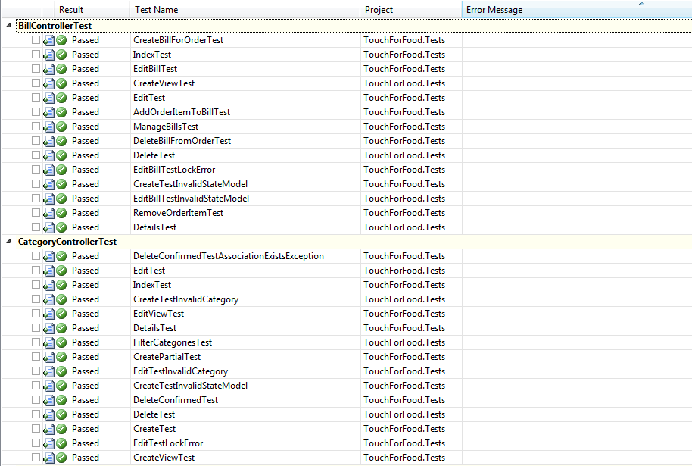

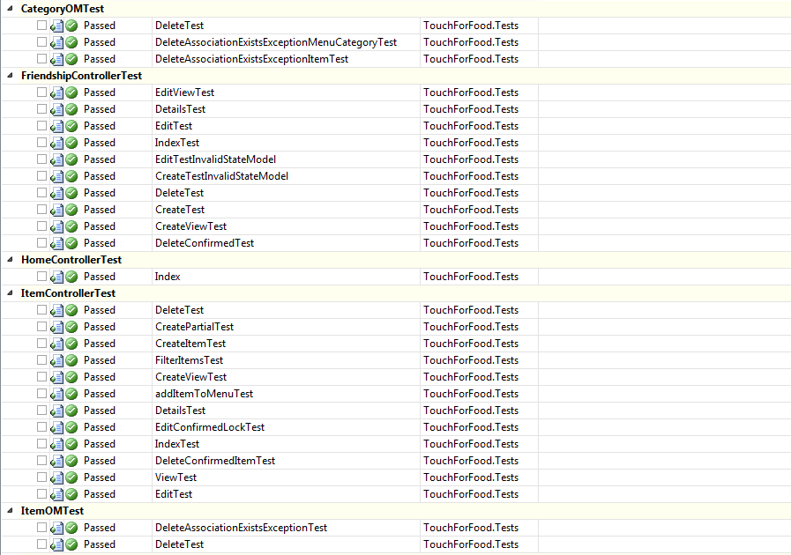

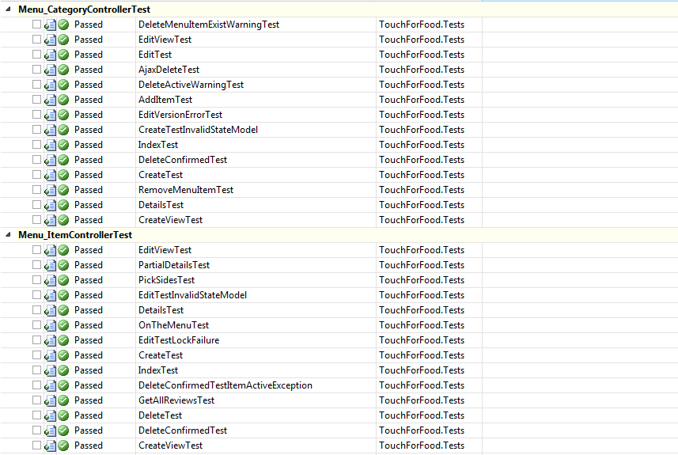

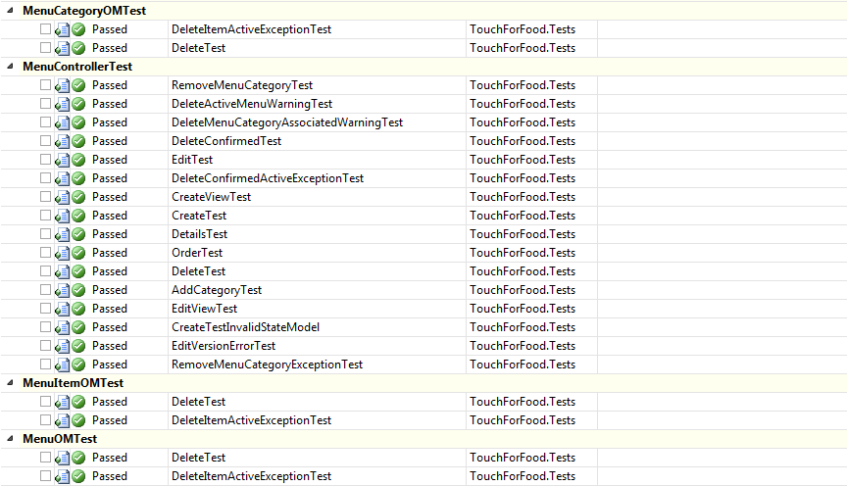

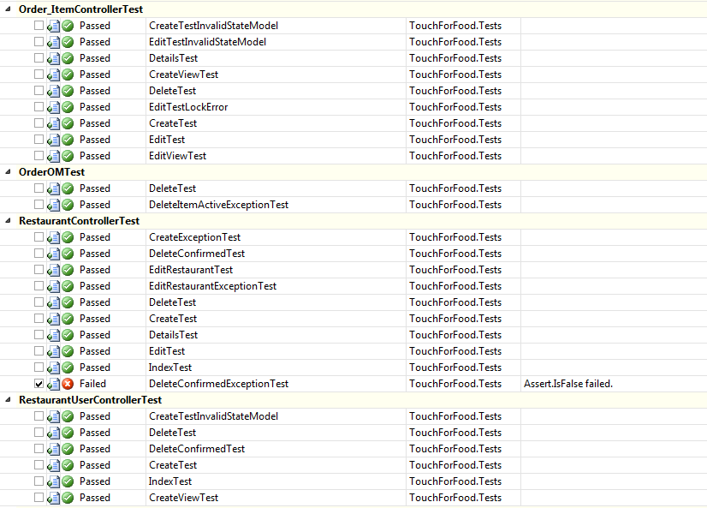

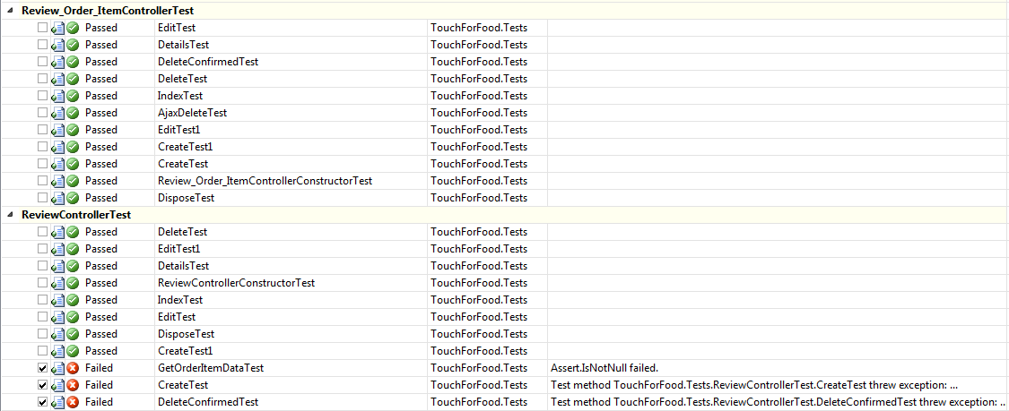

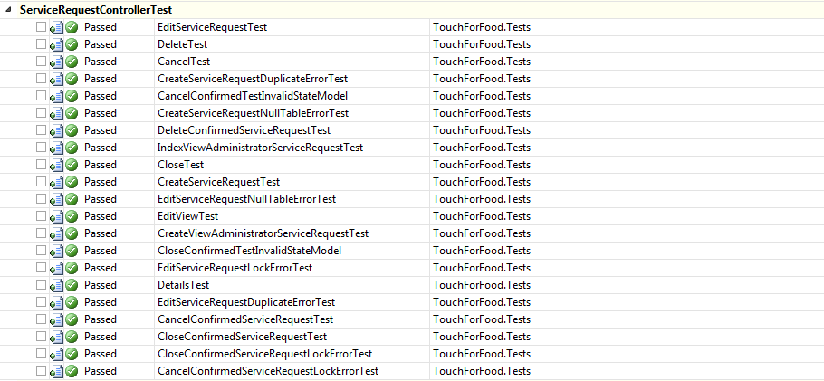

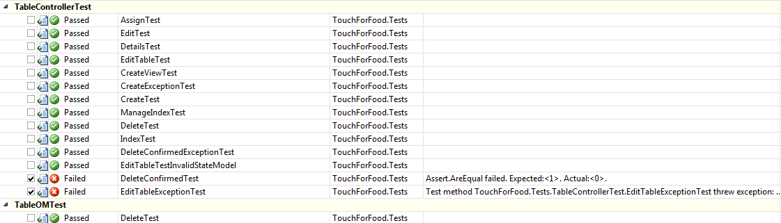

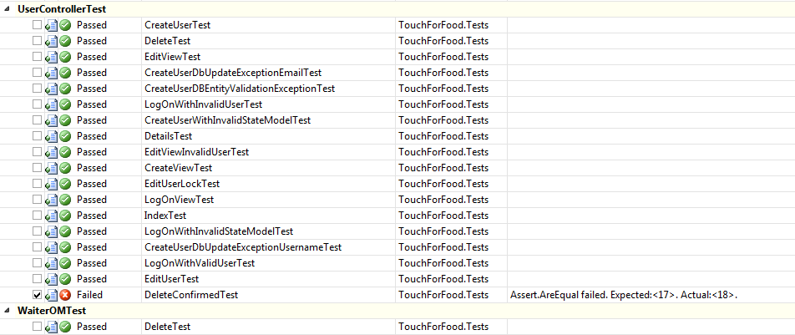

### Unit Test Coverage

**Project Coverage:** 51.78%

**Controller Layer Coverage:** 58.41%

**MapperLayerCoverage:** 70.19%

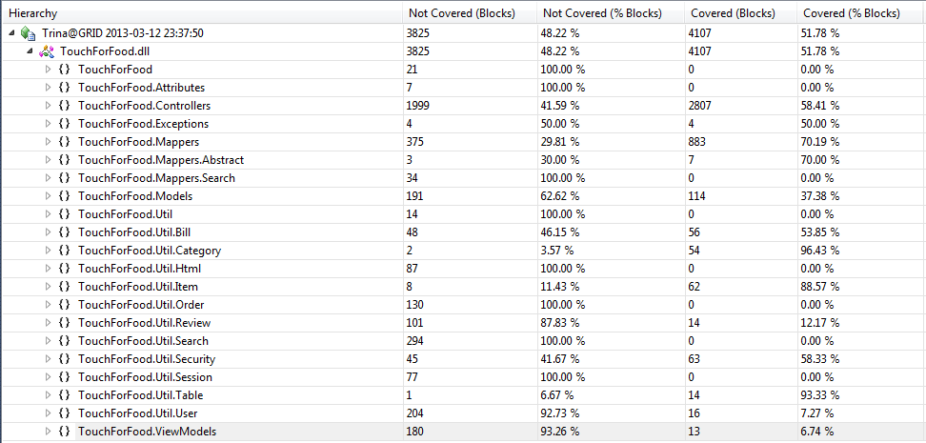

## Defects

|  |  |  |  |  |  |  |
| --- | --- | --- | --- | --- | --- | --- |
| **Assignee** | **Reporter** | **Created** | **Resolved** | **Affects Sprint** | **Fix Sprint** | **Time Spent (hours)** |
| Josh Hum | Cristian Asenjo | 20/10/2012 12:20 | 05/11/2012 11:26 | Sprint 2 | Sprint 2 | 2.33 |
| Mikhail Levkovsky | Mikhail Levkovsky | 20/10/2012 18:50 | 26/10/2012 14:28 | Sprint 2 | Sprint 2 | 2.00 |
| Christian Daher | Cristian Asenjo | 25/10/2012 22:20 | 17/12/2012 16:02 | Sprint 2 | Sprint 3 | 0.17 |
| Christian Daher | Cristian Asenjo | 25/10/2012 22:36 | 17/12/2012 16:00 | Sprint 2 | Sprint 3 | 0.08 |
| Mikhail Levkovsky | Mikhail Levkovsky | 06/11/2012 12:13 | 06/11/2012 14:18 | Sprint 2 | Sprint 2 | 0.50 |
| Cristian Asenjo | Cristian Asenjo | 10/11/2012 11:22 | 10/11/2012 15:01 | Sprint 2 | Sprint 2 | 3.00 |
| Cristian Asenjo | Cristian Asenjo | 10/11/2012 15:02 | 10/11/2012 18:36 | Sprint 2 | Sprint 2 | 2.00 |
| Ryan Nasr | Cristian Asenjo | 14/11/2012 22:09 | 14/01/2013 21:38 | Sprint 2 | Sprint 5 | 0.83 |
| Ryan Nasr | Cristian Asenjo | 14/11/2012 22:10 | 17/12/2012 15:52 | Sprint 2 | Sprint 3 | 1.00 |
| *Unassigned* | Patrick Modafferi | 19/11/2012 20:53 | 14/01/2013 13:16 | Sprint 2 | Sprint 3 | 1.00 |
| Cristian Asenjo | Patrick Modafferi | 19/11/2012 20:55 | 17/12/2012 15:33 | Sprint 2 | Sprint 3 | 1.00 |
| Patrick Modafferi | Patrick Modafferi | 19/11/2012 20:55 | 11/12/2012 17:00 | Sprint 2 | Sprint 3 | 0.50 |
| Cristian Asenjo | Patrick Modafferi | 19/11/2012 20:56 | 16/12/2012 23:12 | Sprint 2 | Sprint 3 | 1.25 |
| Patrick Modafferi | Patrick Modafferi | 19/11/2012 20:56 | 16/12/2012 19:25 | Sprint 2 | Sprint 3 | 0.50 |
| Patrick Modafferi | Patrick Modafferi | 19/11/2012 20:58 | 17/12/2012 17:58 | Sprint 2 | Sprint 3 | 1.00 |
| Cynthia Donato | Patrick Modafferi | 19/11/2012 20:58 | 17/12/2012 15:33 | Sprint 2 | Sprint 3 | 3.52 |
| Mikhail Levkovsky | Patrick Modafferi | 19/11/2012 21:00 | 16/12/2012 17:20 | Sprint 2 | Sprint 3 | 0.50 |
| Josh Hum | Patrick Modafferi | 19/11/2012 21:00 | 02/01/2013 11:14 | Sprint 2 | Sprint 3, Sprint 4 | 0.52 |
| Cristian Asenjo | Patrick Modafferi | 19/11/2012 21:16 | 16/12/2012 23:11 | Sprint 2 | Sprint 3 | 0.33 |
| Katrina Anderson | Patrick Modafferi | 19/11/2012 21:28 | 30/12/2012 13:35 | Sprint 2 | Sprint 3, Sprint 4 | 0.08 |
| Christian Daher | Katrina Anderson | 16/12/2012 22:12 | 17/12/2012 23:01 | Sprint 3 | Sprint 4 | 0.25 |
| Katrina Anderson | Katrina Anderson | 17/12/2012 0:09 | 14/01/2013 13:22 | Sprint 3 | Sprint 3 | 0.50 |
| Christian Daher | Christian Daher | 17/12/2012 16:19 | 14/01/2013 13:24 | Sprint 3 | Sprint 5 | 2.50 |
| Mikhail Levkovsky | Christian Daher | 17/12/2012 17:46 | 15/01/2013 1:36 | Sprint 3 | Sprint 5 | 4.93 |
| Patrick Modafferi | Patrick Modafferi | 18/12/2012 11:20 | 19/12/2012 17:00 | Sprint 4 | Sprint 4 | 8.50 |
| Mikhail Levkovsky | Mikhail Levkovsky | 18/12/2012 17:09 | 18/12/2012 20:44 | Sprint 4 | Sprint 4 | 6.00 |
| Patrick Modafferi | Patrick Modafferi | 18/12/2012 17:14 | 07/02/2013 12:18 | Sprint 4 | Sprint 6, Sprint 7 | 0.58 |
| Mikhail Levkovsky | Mikhail Levkovsky | 19/12/2012 15:08 | 19/12/2012 15:12 | Sprint 4 | Sprint 4 | 0.27 |
| Mikhail Levkovsky | Katrina Anderson | 21/12/2012 15:02 | 05/01/2013 14:42 | Sprint 4 | Sprint 5 | 2.00 |
| Ryan Nasr | Matthew Tam | 21/12/2012 17:27 | 04/01/2013 14:38 | Sprint 4 | Sprint 5 | 0.50 |
| Patrick Modafferi | Mikhail Levkovsky | 21/12/2012 19:19 | 21/12/2012 19:33 | Sprint 4 | Sprint 4 | 4.00 |
| Patrick Modafferi | Cynthia Donato | 24/12/2012 13:05 | 13/01/2013 11:24 | Sprint 4 | Sprint 5 | 0.83 |
| Christian Daher | Katrina Anderson | 30/12/2012 22:14 | 02/01/2013 12:18 | Sprint 4 | Sprint 4 | 0.25 |
| Cynthia Donato | Katrina Anderson | 01/01/2013 17:42 | 21/02/2013 21:17 | Sprint 4 | Sprint 5, Sprint 6, Sprint 7, Sprint 8 | 9.25 |
| Katrina Anderson | Katrina Anderson | 02/01/2013 10:49 | 06/01/2013 19:03 | Sprint 4 | Sprint 5 | 0.42 |
| Ryan Nasr | Patrick Modafferi | 02/01/2013 12:29 | 04/01/2013 14:05 | Sprint 4 | Sprint 5 | 4.02 |
| Cristian Asenjo | Cristian Asenjo | 02/01/2013 12:29 | 13/01/2013 18:52 | Sprint 4 | Sprint 5 | 1.03 |
| Patrick Modafferi | Patrick Modafferi | 02/01/2013 13:25 | 05/01/2013 23:00 | Sprint 4 | Sprint 5 | 6.50 |
| Mikhail Levkovsky | Patrick Modafferi | 06/01/2013 14:57 | 12/01/2013 13:13 | Sprint 5 | Sprint 5 | 2.52 |
| Christian Daher | Cynthia Donato | 08/01/2013 15:54 | 29/01/2013 19:15 | Sprint 5 | Sprint 6 | 0.02 |
| Christian Daher | Cynthia Donato | 08/01/2013 15:56 | 29/01/2013 19:15 | Sprint 5 | Sprint 6 | 0.02 |
| Christian Daher | Mikhail Levkovsky | 08/01/2013 15:58 | 29/01/2013 19:14 | Sprint 5 | Sprint 6 | 0.02 |
| Christian Daher | Cynthia Donato | 08/01/2013 15:58 | 29/01/2013 19:14 | Sprint 5 | Sprint 6 | 0.02 |
| Christian Daher | Mikhail Levkovsky | 08/01/2013 16:00 | 29/01/2013 19:14 | Sprint 5 | Sprint 6 | 0.02 |
| Christian Daher | Mikhail Levkovsky | 08/01/2013 16:02 | 29/01/2013 19:15 | Sprint 5 | Sprint 6 | 0.02 |
| Christian Daher | Mikhail Levkovsky | 08/01/2013 16:04 | 29/01/2013 19:14 | Sprint 5 | Sprint 6 | 0.02 |
| Christian Daher | Cynthia Donato | 08/01/2013 16:04 | 29/01/2013 19:14 | Sprint 5 | Sprint 6 | 0.02 |
| Christian Daher | Mikhail Levkovsky | 08/01/2013 16:06 | 29/01/2013 19:15 | Sprint 5 | Sprint 6 | 0.02 |
| Christian Daher | Mikhail Levkovsky | 08/01/2013 20:29 | 29/01/2013 18:43 | Sprint 5 | Sprint 6 | 1.00 |
| Mikhail Levkovsky | Cynthia Donato | 08/01/2013 21:30 | 12/02/2013 21:23 | Sprint 5, Sprint 6, Sprint 7 |  | 0.00 |
| Unassigned | Josh Hum | 09/01/2013 16:23 | 15/01/2013 14:28 | Sprint 5 | Sprint 6 | 0.00 |
| Ryan Nasr | Mikhail Levkovsky | 10/01/2013 14:36 | 11/01/2013 15:27 | Sprint 5 | Sprint 5 | 0.52 |
| Ryan Nasr | Cynthia Donato | 10/01/2013 15:20 | 14/01/2013 20:45 | Sprint 5 | Sprint 5 | 1.00 |
| Unassigned | Matthew Tam | 11/01/2013 14:15 | 11/01/2013 14:30 | Sprint 5 | Sprint 5 | 0.00 |
| Patrick Modafferi | Matthew Tam | 11/01/2013 18:25 | 14/01/2013 13:52 | Sprint 5 | Sprint 5 | 0.17 |
| Unassigned | Matthew Tam | 11/01/2013 18:48 | 14/01/2013 13:45 |  |  | 0.00 |
| Ryan Nasr | Ryan Nasr | 13/01/2013 17:26 | 17/01/2013 19:19 | Sprint 5 | Sprint 6 | 1.00 |
| Cristian Asenjo | Cynthia Donato | 13/01/2013 20:51 | 15/01/2013 22:38 | Sprint 5 | Sprint 5 | 2.60 |
| Mikhail Levkovsky | Ryan Nasr | 14/01/2013 21:39 | 12/02/2013 21:22 | Sprint 5 | Sprint 6 | 0.00 |
| Cynthia Donato | Cynthia Donato | 15/01/2013 14:02 | 15/01/2013 21:54 | Sprint 5 | Sprint 5 | 0.25 |
| Cristian Asenjo | Cristian Asenjo | 15/01/2013 14:03 | 27/01/2013 12:21 |  | Sprint 6 | 0.17 |
| Christian Daher | Cynthia Donato | 15/01/2013 14:06 | 29/01/2013 18:44 | Sprint 5 | Sprint 6 | 0.50 |
| Ryan Nasr | Ryan Nasr | 17/01/2013 19:23 | 29/01/2013 0:24 |  | Sprint 6 | 0.08 |
| Mikhail Levkovsky | Ryan Nasr | 19/01/2013 17:00 | 08/02/2013 13:33 | Sprint 7 | Sprint 7 | 1.02 |
| Cristian Asenjo | Mikhail Levkovsky | 25/01/2013 14:35 | 27/01/2013 13:18 | Sprint 6 | Sprint 6 | 0.80 |
| Mikhail Levkovsky | Ryan Nasr | 26/01/2013 12:43 | 08/02/2013 13:32 | Sprint 7 | Sprint 7 | 0.52 |
| Mikhail Levkovsky | Ryan Nasr | 26/01/2013 12:47 | 08/02/2013 18:02 | Sprint 6 | Sprint 7 | 0.02 |
| Unassigned | Cynthia Donato | 26/01/2013 13:17 | 29/01/2013 14:57 | Sprint 6 | Sprint 6 | 0.17 |
| Cristian Asenjo | Cristian Asenjo | 28/01/2013 15:42 | 12/02/2013 21:47 | Sprint 6 | Sprint 7 | 0.38 |
| Cristian Asenjo | Cristian Asenjo | 28/01/2013 20:00 | 12/02/2013 14:30 | Sprint 6 | Sprint 7 | 0.02 |
| Cristian Asenjo | Cristian Asenjo | 28/01/2013 20:01 | 12/02/2013 14:30 | Sprint 6 | Sprint 7 | 0.02 |
| Cristian Asenjo | Cristian Asenjo | 28/01/2013 20:02 | 12/02/2013 14:30 | Sprint 7 | Sprint 7 | 0.02 |
| Mikhail Levkovsky | Josh Hum | 28/01/2013 23:50 | 12/02/2013 21:22 | Sprint 6 |  | 0.00 |
| Unassigned | Patrick Modafferi | 01/02/2013 23:27 | 12/02/2013 14:07 | Sprint 7 | Sprint 8 | 0.00 |
| Ryan Nasr | Katrina Anderson | 04/02/2013 20:57 | 25/02/2013 21:03 | Sprint 7 | Sprint 8 | 1.52 |
| Katrina Anderson | Katrina Anderson | 05/02/2013 11:16 | 07/02/2013 2:28 | Sprint 7 | Sprint 7 | 1.90 |
| Ryan Nasr | Katrina Anderson | 06/02/2013 23:07 | 08/03/2013 17:55 | Sprint 7 | Sprint 8, Sprint 9 | 1.00 |
| Ryan Nasr | Katrina Anderson | 06/02/2013 23:19 | 25/02/2013 21:03 | Sprint 7 | Sprint 8 | 0.52 |
| Josh Hum | Katrina Anderson | 06/02/2013 23:30 | 21/02/2013 16:53 | Sprint 7 | Sprint 8 | 0.17 |
| Josh Hum | Katrina Anderson | 06/02/2013 23:31 | 21/02/2013 16:53 | Sprint 7 | Sprint 8 | 0.17 |
| Mikhail Levkovsky | Cynthia Donato | 09/02/2013 9:25 | 10/03/2013 15:50 | Sprint 7 | Sprint 8, Sprint 9 | 1.00 |
| Ryan Nasr | Cynthia Donato | 09/02/2013 9:26 | 25/02/2013 21:03 | Sprint 7 | Sprint 8 | 2.02 |
| Ryan Nasr | Cynthia Donato | 09/02/2013 14:55 | 25/02/2013 21:03 | Sprint 7 | Sprint 8 | 1.02 |
| Mikhail Levkovsky | Christian Daher | 12/02/2013 18:13 | 28/02/2013 15:03 |  | Sprint 8, Sprint 9 | 1.25 |
| Ryan Nasr | Cristian Asenjo | 12/02/2013 19:53 | 25/02/2013 21:03 | Sprint 7 | Sprint 8 | 1.02 |
| Ryan Nasr | Mikhail Levkovsky | 12/02/2013 20:02 | 25/02/2013 21:04 | Sprint 8 | Sprint 8 | 2.02 |
| Ryan Nasr | Mikhail Levkovsky | 19/02/2013 0:52 |  | Sprint 9 | Sprint 9 | 0.00 |
| Ryan Nasr | Mikhail Levkovsky | 19/02/2013 0:52 | 06/03/2013 12:43 | Sprint 9 | Sprint 9 | 1.00 |
| Patrick Modafferi | Mikhail Levkovsky | 19/02/2013 0:53 | 06/03/2013 14:22 | Sprint 9 | Sprint 9 | 1.75 |
| Ryan Nasr | Mikhail Levkovsky | 19/02/2013 0:53 | 06/03/2013 12:33 | Sprint 9 | Sprint 9 | 1.00 |
| Patrick Modafferi | Mikhail Levkovsky | 19/02/2013 0:54 | 27/02/2013 12:22 | Sprint 9 | Sprint 9 | 0.25 |
| Patrick Modafferi | Katrina Anderson | 19/02/2013 12:24 | 24/02/2013 14:01 | Sprint 8 | Sprint 8 | 0.27 |
| Ryan Nasr | Mikhail Levkovsky | 20/02/2013 17:52 | 08/03/2013 17:22 | Sprint 9 | Sprint 9 | 3.00 |
| Mikhail Levkovsky | Mikhail Levkovsky | 20/02/2013 21:15 | 10/03/2013 14:03 | Sprint 9 | Sprint 9 | 0.00 |
| Unassigned | Patrick Modafferi | 23/02/2013 12:48 |  | Sprint 8 | Sprint 9 | 0.00 |
| Josh Hum | Katrina Anderson | 23/02/2013 14:04 | 08/03/2013 15:54 | Sprint 9 | Sprint 9 | 0.08 |
| Ryan Nasr | Katrina Anderson | 23/02/2013 15:50 | 08/03/2013 17:42 | Sprint 9 | Sprint 9 | 1.00 |
| Mikhail Levkovsky | Katrina Anderson | 23/02/2013 16:10 | 02/03/2013 17:08 | Sprint 9 | Sprint 9 | 0.17 |
| Mikhail Levkovsky | Katrina Anderson | 23/02/2013 16:44 | 28/02/2013 16:49 | Sprint 9 | Sprint 9 | 0.08 |
| Cristian Asenjo | Josh Hum | 24/02/2013 15:44 | 08/03/2013 14:11 | Sprint 9 | Sprint 9 | 0.08 |
| Cristian Asenjo | Josh Hum | 24/02/2013 15:45 | 11/03/2013 22:16 | Sprint 9 | Sprint 9 | 1.72 |
| Josh Hum | Josh Hum | 24/02/2013 22:04 | 27/02/2013 10:25 | Sprint 9 | Sprint 9 | 0.00 |
| Josh Hum | Josh Hum | 24/02/2013 22:07 | 07/03/2013 22:58 | Sprint 9 | Sprint 9 | 0.08 |
| Patrick Modafferi | Josh Hum | 24/02/2013 22:11 | 06/03/2013 14:23 | Sprint 9 | Sprint 9 | 0.50 |
| Josh Hum | Josh Hum | 24/02/2013 22:12 | 07/03/2013 18:59 | Sprint 9 | Sprint 9 | 1.17 |
| Josh Hum | Josh Hum | 24/02/2013 22:17 | 08/03/2013 14:07 | Sprint 9 | Sprint 9 | 0.08 |
| Patrick Modafferi | Josh Hum | 24/02/2013 22:19 | 08/03/2013 0:34 | Sprint 9 | Sprint 9 | 3.00 |
| Josh Hum | Josh Hum | 24/02/2013 22:24 | 08/03/2013 15:29 | Sprint 9 | Sprint 9 | 1.67 |
| Josh Hum | Josh Hum | 24/02/2013 22:32 | 13/03/2013 0:05 | Sprint 9 | Sprint 9 | 0.02 |
| Patrick Modafferi | Josh Hum | 24/02/2013 22:34 | 06/03/2013 1:31 | Sprint 9 | Sprint 9 | 2.75 |
| Josh Hum | Josh Hum | 24/02/2013 22:46 | 08/03/2013 15:31 | Sprint 9 | Sprint 9 | 7.08 |
| Ryan Nasr | Josh Hum | 24/02/2013 22:55 | 08/03/2013 17:38 | Sprint 9 | Sprint 9 | 2.00 |
| Christian Daher | Josh Hum | 24/02/2013 23:01 | 09/03/2013 1:45 | Sprint 9 | Sprint 9 | 3.00 |
| Cristian Asenjo | Josh Hum | 24/02/2013 23:12 | 11/03/2013 22:42 | Sprint 9 | Sprint 9 | 0.02 |
| Cristian Asenjo | Josh Hum | 24/02/2013 23:28 | 11/03/2013 22:16 | Sprint 9 | Sprint 9 | 1.72 |
| Christian Daher | Josh Hum | 24/02/2013 23:38 | 05/03/2013 20:39 | Sprint 9 | Sprint 9 | 2.00 |
| Christian Daher | Josh Hum | 24/02/2013 23:40 | 06/03/2013 20:17 | Sprint 9 | Sprint 9 | 2.00 |
| Christian Daher | Josh Hum | 24/02/2013 23:45 | 06/03/2013 20:17 | Sprint 9 | Sprint 9 | 1.00 |
| Josh Hum | Josh Hum | 24/02/2013 23:47 | 08/03/2013 15:38 | Sprint 9 | Sprint 9 | 0.17 |
| Mikhail Levkovsky | Patrick Modafferi | 25/02/2013 21:49 | 25/02/2013 22:55 | Sprint 8 | Sprint 9 | 0.50 |
| Mikhail Levkovsky | Patrick Modafferi | 26/02/2013 14:19 | 28/02/2013 16:40 | Sprint 9 | Sprint 9 | 0.50 |
| Cristian Asenjo | Cristian Asenjo | 26/02/2013 14:20 | 09/03/2013 12:33 | Sprint 8 | Sprint 9 | 1.50 |
| Cristian Asenjo | Cristian Asenjo | 26/02/2013 14:28 | 10/03/2013 19:49 | Sprint 8 | Sprint 9 | 1.02 |
| Mikhail Levkovsky | Patrick Modafferi | 26/02/2013 15:03 | 13/03/2013 0:05 | Sprint 9 | Sprint 9 | 0.67 |
| Christian Daher | Patrick Modafferi | 26/02/2013 16:37 | 05/03/2013 0:40 | Sprint 9 | Sprint 9 | 3.00 |
| Christian Daher | Patrick Modafferi | 26/02/2013 16:40 | 05/03/2013 13:08 | Sprint 9 | Sprint 9 | 3.00 |
| Katrina Anderson | Katrina Anderson | 27/02/2013 14:40 | 05/03/2013 10:27 | Sprint 9 | Sprint 9 | 0.42 |
| Patrick Modafferi | Katrina Anderson | 28/02/2013 11:50 |  | Sprint10 | Sprint10 | 0.67 |
| Cristian Asenjo | Katrina Anderson | 28/02/2013 13:36 | 11/03/2013 23:15 | Sprint 9 | Sprint 9 | 1.02 |
| Ryan Nasr | Katrina Anderson | 28/02/2013 14:45 | 08/03/2013 18:10 | Sprint10 | Sprint 9 | 1.00 |
| Ryan Nasr | Katrina Anderson | 28/02/2013 16:40 | 08/03/2013 18:11 | Sprint10 | Sprint 9 | 0.50 |
| Cynthia Donato | Katrina Anderson | 28/02/2013 17:27 |  | Sprint 9 | Sprint10 | 0.00 |
| Ryan Nasr | Katrina Anderson | 28/02/2013 19:26 | 08/03/2013 18:16 | Sprint10 | Sprint 9 | 0.50 |
| Cynthia Donato | Katrina Anderson | 28/02/2013 19:51 |  | Sprint10 | Sprint10 | 0.00 |
| Ryan Nasr | Katrina Anderson | 28/02/2013 22:07 | 08/03/2013 18:17 | Sprint10 | Sprint 9 | 0.50 |
| Patrick Modafferi | Mikhail Levkovsky | 02/03/2013 17:12 | 06/03/2013 13:43 | Sprint10 | Sprint 9 | 0.17 |
| Mikhail Levkovsky | Mikhail Levkovsky | 04/03/2013 16:26 | 04/03/2013 23:52 | Sprint 9 | Sprint 9 | 0.50 |
| Ryan Nasr | Katrina Anderson | 04/03/2013 17:56 | 08/03/2013 18:37 | Sprint10 | Sprint 9 | 1.00 |
| Ryan Nasr | Katrina Anderson | 04/03/2013 20:01 | 08/03/2013 18:41 | Sprint10 | Sprint 9 | 0.50 |
| Ryan Nasr | Katrina Anderson | 04/03/2013 21:00 | 08/03/2013 18:42 | Sprint10 | Sprint 9 | 0.33 |
| Cynthia Donato | Katrina Anderson | 04/03/2013 21:49 |  | Sprint10 | Sprint10 | 0.00 |
| Cristian Asenjo | Mikhail Levkovsky | 04/03/2013 23:51 |  | Sprint10 | Sprint10 | 0.00 |
| Katrina Anderson | Katrina Anderson | 05/03/2013 11:12 | 05/03/2013 20:11 | Sprint 9 | Sprint 9 | 1.75 |
| Unassigned | Patrick Modafferi | 06/03/2013 0:27 |  | Sprint 9 |  | 0.00 |
| Mikhail Levkovsky | Patrick Modafferi | 06/03/2013 13:50 | 08/03/2013 11:32 | Sprint 9 | Sprint10 | 1.50 |
| Ryan Nasr | Patrick Modafferi | 06/03/2013 14:42 | 08/03/2013 19:24 | Sprint 9 | Sprint 9 | 1.00 |
| Unassigned | Katrina Anderson | 06/03/2013 16:41 | 12/03/2013 14:19 | Sprint10 | Sprint10 | 0.02 |
| Unassigned | Katrina Anderson | 06/03/2013 17:11 | 08/03/2013 14:15 | Sprint10 | Sprint10 | 0.08 |
| Josh Hum | Patrick Modafferi | 06/03/2013 23:16 |  | Sprint 9 | Sprint10 | 0.33 |
| Unassigned | Katrina Anderson | 08/03/2013 12:09 |  | Sprint10 | Sprint10 | 0.00 |
| Mikhail Levkovsky | Mikhail Levkovsky | 08/03/2013 12:38 | 08/03/2013 12:57 | Sprint 9 | Sprint 9 | 0.25 |
| Ryan Nasr | Katrina Anderson | 08/03/2013 12:43 |  | Sprint10 | Sprint10 | 0.00 |
| Mikhail Levkovsky | Katrina Anderson | 08/03/2013 15:38 | 08/03/2013 16:44 | Sprint10 | Sprint 9 | 0.00 |
| Katrina Anderson | Katrina Anderson | 08/03/2013 16:50 | 08/03/2013 17:48 | Sprint 9 | Sprint 9 | 0.50 |
| Unassigned | Ryan Nasr | 09/03/2013 16:48 | 12/03/2013 13:48 |  |  | 0.00 |
| Unassigned | Katrina Anderson | 09/03/2013 19:25 |  | Sprint10 | Sprint10 | 0.00 |
| Unassigned | Katrina Anderson | 09/03/2013 22:07 |  | Sprint10 | Sprint10 | 0.00 |
| Unassigned | Cynthia Donato | 10/03/2013 10:55 | 12/03/2013 14:15 | Sprint 9 | Sprint10 | 0.00 |
| Cynthia Donato | Cynthia Donato | 10/03/2013 10:59 |  | Sprint 9 | Sprint10 | 0.00 |
| Unassigned | Cynthia Donato | 10/03/2013 11:02 | 12/03/2013 14:21 | Sprint 9 | Sprint10 | 0.02 |
| Unassigned | Cynthia Donato | 10/03/2013 11:10 |  | Sprint 9 | Sprint10 | 0.00 |
| Unassigned | Cynthia Donato | 10/03/2013 11:16 | 12/03/2013 14:34 | Sprint 9 | Sprint10 | 0.02 |
| Unassigned | Cynthia Donato | 10/03/2013 11:19 | 10/03/2013 16:04 | Sprint 9 | Sprint10 | 0.02 |
| Unassigned | Cynthia Donato | 10/03/2013 11:34 |  | Sprint 9 | Sprint10 | 0.00 |
| Unassigned | Cynthia Donato | 10/03/2013 11:40 | 12/03/2013 14:32 | Sprint 9 | Sprint10 | 0.02 |
| Unassigned | Cynthia Donato | 10/03/2013 12:00 | 12/03/2013 14:10 | Sprint 9 | Sprint10 | 0.02 |
| Unassigned | Cynthia Donato | 10/03/2013 12:02 |  | Sprint 9 | Sprint10 | 0.00 |
| Unassigned | Cynthia Donato | 10/03/2013 12:10 |  | Sprint 9 | Sprint10 | 0.00 |
| Unassigned | Cynthia Donato | 10/03/2013 12:50 |  | Sprint 9 | Sprint10 | 0.00 |
| Unassigned | Cynthia Donato | 10/03/2013 13:04 |  | Sprint 9 | Sprint10 | 0.00 |
| Matthew Tam | Cynthia Donato | 10/03/2013 13:06 |  | Sprint 9 | Sprint10 | 0.00 |
| Christian Daher | Cynthia Donato | 10/03/2013 13:21 |  | Sprint 9 | Sprint10 | 0.00 |
| Unassigned | Cynthia Donato | 10/03/2013 13:39 |  | Sprint 9 | Sprint10 | 0.00 |
| Christian Daher | Mikhail Levkovsky | 11/03/2013 14:13 |  | Sprint10 | Sprint10 | 0.00 |
| Unassigned | Cynthia Donato | 11/03/2013 19:41 | 12/03/2013 13:43 | Sprint 9 | Sprint10 | 0.02 |
| Unassigned | Cynthia Donato | 11/03/2013 19:55 | 11/03/2013 20:05 | Sprint 9 | Sprint10 | 0.00 |
| Unassigned | Cynthia Donato | 11/03/2013 19:58 |  | Sprint 9 | Sprint10 | 0.00 |
| Unassigned | Cynthia Donato | 11/03/2013 20:10 |  | Sprint 9 | Sprint10 | 0.00 |
| Ryan Nasr | Cynthia Donato | 11/03/2013 20:17 |  | Sprint 9 | Sprint10 | 0.00 |
| Unassigned | Cynthia Donato | 11/03/2013 20:25 | 12/03/2013 13:42 | Sprint 9 | Sprint10 | 0.17 |
| Cristian Asenjo | Josh Hum | 12/03/2013 8:51 |  | Sprint10 | Sprint10 | 0.00 |
| Josh Hum | Josh Hum | 12/03/2013 9:00 |  | Sprint10 | Sprint10 | 0.00 |
| Josh Hum | Josh Hum | 12/03/2013 9:54 |  | Sprint10 | Sprint10 | 0.00 |

Figure 9-3 Iteration 9 Defect Breakdown vs. Sprint

Figure 9‑9‑1 Number of Defects vs. Criticality

## User Interface Tests & Results

**Number of UI Tests:** 46

**Number of Passed UI Tests:** 24

**Number of Failed UI Tests:** 22

|  |  |  |  |  |  |  |
| --- | --- | --- | --- | --- | --- | --- |
| **Test ID** | **Title** | **Environment** | **Sprint** | **Test Date** | **Status** | **Notes** |
| TC025.1 | Test Create Order | Google Chrome 25.0.1364.160 m | 6 | 10/03/2013 | FAIL | The system displays "Pick a Side" with the option "None" selected. You also only have the option to "Place Order" or hit the X. Place order seems misleading, it implies you cannot continue adding food. Should read "Add to Order" |
| TC026.1 | Test View Menu (Customer) | Google Chrome 25.0.1364.160 m | 6 | 10/03/2013 | PASS |  |
| TC026.2 | Test View Menu (Restaurant) | Google Chrome 25.0.1364.160 m | 6 | 10/03/2013 | FAIL | The expected result in step 2 is not correct. This test case needs to be updated.  The restaurant sees a list of categories in the menu and possible new categories to add to the menu. |
| TC026.3 | Test View Menu (Administrator) | Google Chrome 25.0.1364.160 m | 6 | 10/03/2013 | FAIL | As discussed in the Sprint 9 meeting the admin user role should have the same rights as a developer. Need to updated system to reflect this. |
| TC026.4 | Test Search Menu (Customer) | Google Chrome 25.0.1364.160 m | 8 | 10/03/2013 | N/A | Cannot execute this test. These items are not in the DB. When you create them they still do not show up in the search, I would imagine this is because the indexer script needs to be run… Consider changing this TC to be more generic |
| TC026.5 | Test Search Menu (Restaurant) | Google Chrome 25.0.1364.160 m | 8 | 10/03/2013 | N/A | Cannot execute this test. These items are not in the DB. When you create them they still do not show up in the search, I would imagine this is because the indexer script needs to be run… Consider changing this TC to be more generic |
| TC026.6 | Test Search Menu (Administrator) | Google Chrome 25.0.1364.160 m | 8 | 10/03/2013 | N/A | Cannot execute this test. These items are not in the DB. When you create them they still do not show up in the search, I would imagine this is because the indexer script needs to be run… Consider changing this TC to be more generic |
| TC027.1 | Test Menu Editor Main Page | Google Chrome 25.0.1364.160 m | 6 | 10/03/2013 | PASS | Passes as a restaurant user. Do not see Menus list as Administrator unless admin is registered as a resto user which should not be necessary |
| TC027.2 | Test Category Management Page | Google Chrome 25.0.1364.160 m | 6 | 10/03/2013 | PASS | Passes as a restaurant user. Do not see Menus list as Administrator unless admin is registered as a resto user which should not be necessary |
| TC027.3 | Test Item Management Page | Google Chrome 25.0.1364.160 m | 6 | 10/03/2013 | FAIL | Cannot preform step 3. No way to edit this item using current flow described by test case. (Logged in as resto user) |
| TC027.4 | Test Menu Edit | Google Chrome 25.0.1364.160 m | 6 | 10/03/2013 | PASS | Passes as a restaurant user. Do not see Menus list as Administrator unless admin is registered as a resto user which should not be necessary |
| TC027.5 | Test Create Menu | Google Chrome 25.0.1364.160 m | 6 | 10/03/2013 | PASS | Passes as a restaurant user. Do not see Menus list as Administrator unless admin is registered as a resto user which should not be necessary |
| TC029.1 | Test Cancel Order | Google Chrome 25.0.1364.160 m | 6 | 10/03/2013 | FAIL | Expected result in step 3 does not happen. We no longer see the order in the list. Do not see Menus list as Administrator unless admin is registered as a resto user which should not be necessary |
| TC029.2 | Test Decline Order Item | Google Chrome 25.0.1364.160 m | 6 | 10/03/2013 | PASS | Do not see Menus list as Administrator unless admin is registered as a resto user which should not be necessary |
| TC029.3 | Test Accept Order Item | Google Chrome 25.0.1364.160 m | 6 | 10/03/2013 | FAIL | The order item for which you click "Accept" is set to Processing but all order items in the order are set to PENDING which should not happen. |
| TC034.1 | Test Create Service Request (Administrator) | Google Chrome 25.0.1364.160 m | 7 | 10/03/2013 | PASS | Do not see Menus list as Administrator unless admin is registered as a resto user which should not be necessary |
| TC034.2 | Test Create Service Request (Restaurant) | Google Chrome 25.0.1364.160 m | 7 | 10/03/2013 | PASS | Do not see Menus list as Administrator unless admin is registered as a resto user which should not be necessary |
| TC034.3 | Test Call Waiter (Customer) | Google Chrome 25.0.1364.160 m | 7 | 10/03/2013 | FAIL | Functionality works but expected result #2 does not occure instead we are displayed the login page |
| TC034.4 | Test Edit Service Request (Restaurant) | Google Chrome 25.0.1364.160 m | 7 | 10/03/2013 | PASS |  |
| TC034.5 | Test Edit Service Request (Administrator) | Google Chrome 25.0.1364.160 m | 7 | 10/03/2013 | FAIL | Status does not display words it displays the number. Setting status to 0 does not set the request to closed. Do not see Menus list as Administrator unless admin is registered as a resto user which should not be necessary |
| TC034.6 | Test Cancel Service Request | Google Chrome 25.0.1364.160 m | 7 | 10/03/2013 | PASS |  |
| TC034.7 | Test Complete Service Request | Google Chrome 25.0.1364.160 m | 7 | 10/03/2013 | PASS |  |
| TC035.3 | Test Update Customer Settings | Google Chrome 25.0.1364.160 m | 9 | 10/03/2013 | FAIL | Customer does not have the ability to see the User link. Tets case missing the name of the link. |
| TC039.1 | Test Leave Review | Google Chrome 25.0.1364.160 m | 8 | 10/03/2013 | FAIL | The user does not see the Profile link |
| TC039.2 | Test View Review | Google Chrome 25.0.1364.160 m | 8 | 10/03/2013 | PASS | hardcoded review in the db to be able to test this |
| TC040.1 | Test Login With Non-Existent User | Google Chrome 25.0.1364.160 m | 6 | 10/03/2013 | PASS |  |
| TC040.2 | Test Create New User | Google Chrome 25.0.1364.160 m | 6 | 10/03/2013 | PASS |  |
| TC040.3 | Test Login With Existent User | Google Chrome 25.0.1364.160 m | 6 | 10/03/2013 | FAIL | password should be case senstaive but it is not so the test fails at step 2 |
| TC040.4 | Test Logout | Google Chrome 25.0.1364.160 m | 6 | 10/03/2013 | PASS |  |
| TC41.1 | Test Create Bill (Customer) | Google Chrome 25.0.1364.160 m | 8 | 10/03/2013 | FAIL | user does not see manage bills link. |
| TC41.2 | Test Add Item to Bill (Customer) | Google Chrome 25.0.1364.160 m | 8 | 10/03/2013 | FAIL | cannot manage bills as a customer |
| TC41.3 | Test Remove Item From Bill (Customer) | Google Chrome 25.0.1364.160 m | 9 | 10/03/2013 | FAIL | cannot manage bills as a customer |
| TC41.4 | Test Delete Bill (Customer) | Google Chrome 25.0.1364.160 m | 9 | 10/03/2013 | FAIL | cannot manage bills as a customer |
| TC42.1 | Test Create Bill (Restaurant) | Google Chrome 25.0.1364.160 m | **7** | 10/03/2013 | PASS |  |
| TC42.2 | Test Add Item to Bill (Restaurant) | Google Chrome 25.0.1364.160 m | 7 | 10/03/2013 | PASS |  |
| TC42.3 | Test Remove Item from Bill (Restaurant) | Google Chrome 25.0.1364.160 m | 7 | 10/03/2013 | PASS |  |
| TC42.4 | Test Delete Bill (Restaurant) | Google Chrome 25.0.1364.160 m | 7 | 10/03/2013 | FAIL | there is no delete bill button displayed. |
| TC192.1 | Test Create Table Page | Google Chrome 25.0.1364.160 m | 6 | 10/03/2013 | PASS | Passes as a restaurant user. Do not see Menus list as Administrator unless admin is registered as a resto user which should not be necessary |
| TC192.2 | Test Creating Incorrect Table Page | Google Chrome 25.0.1364.160 m | 6 | 10/03/2013 | PASS | Passes as a restaurant user. Do not see Menus list as Administrator unless admin is registered as a resto user which should not be necessary |
| TC192.3 | Test Edit Table Page | Google Chrome 25.0.1364.160 m | 6 | 10/03/2013 | PASS | Passes as a restaurant user. Do not see Menus list as Administrator unless admin is registered as a resto user which should not be necessary |
| TC192.4 | Test Incorrect Edit Table Page | Google Chrome 25.0.1364.160 m | 6 | 10/03/2013 | PASS | Passes as a restaurant user. Do not see Menus list as Administrator unless admin is registered as a resto user which should not be necessary |
| TC192.5 | Test NFC Link Page | Google Chrome 25.0.1364.160 m | 6 | 10/03/2013 | PASS | Passes as a restaurant user. Do not see Menus list as Administrator unless admin is registered as a resto user which should not be necessary |
| TC192.6 | Test Table Details Page | Google Chrome 25.0.1364.160 m | 6 | 10/03/2013 | PASS | Passes as a restaurant user. Do not see Menus list as Administrator unless admin is registered as a resto user which should not be necessary |
| TC192.7 | Test Delete Table Page | Google Chrome 25.0.1364.160 m | 6 | 10/03/2013 | FAIL | internal server error occures as restaurant user and Admin user. |
| TC279.1 | Test View Past Orders | Google Chrome 25.0.1364.160 m | 8 | 10/03/2013 | FAIL | user cannot access profile page |
| TC279.2 | Test Suggest an Order | Google Chrome 25.0.1364.160 m | 8 | 10/03/2013 | FAIL | server error in application is displayed |

# Iteration 10 Test Results

There are no test results for iteration 10. Since there were still a few issues to handle in the code and sprint 11 was really only a half sprint, we decided to just run the tests in Iteration 11.

# Iteration 11 Test Results

## Unit Tests

### Unit Test Table & Status

**Number of Unit Tests:** 230

**Number of Passed Unit Tests:** 224

**Number of Failed Unit Tests:** 6

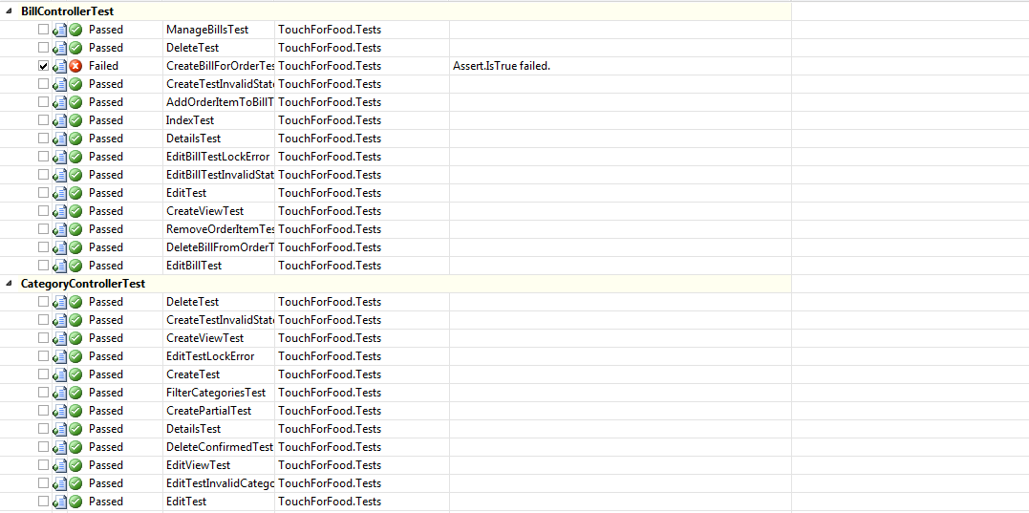

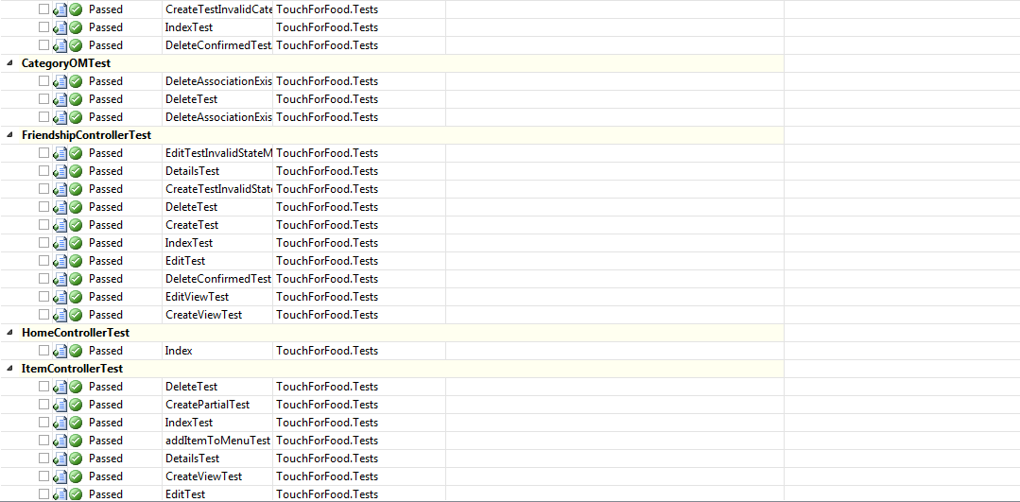

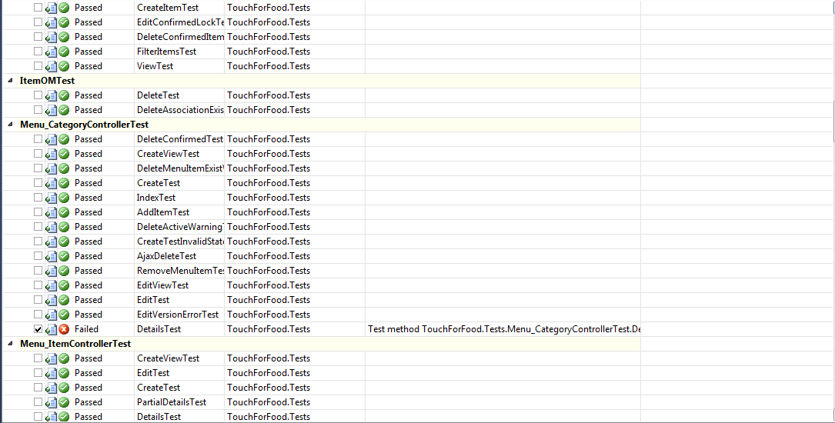

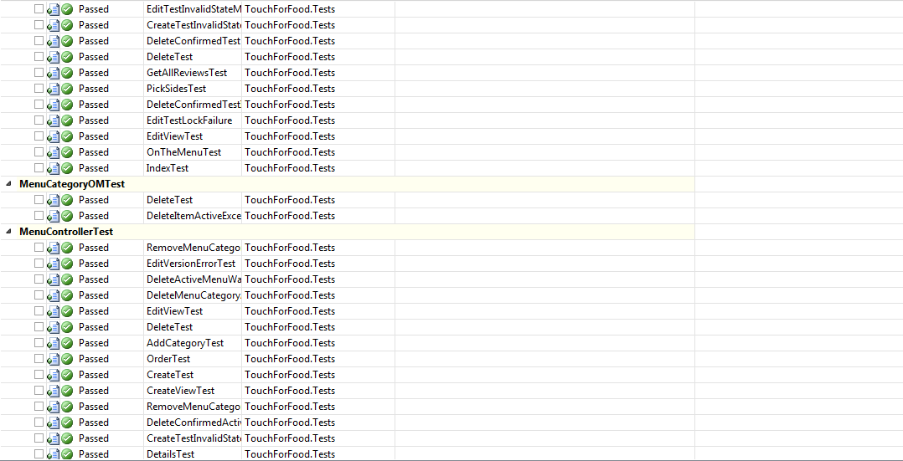

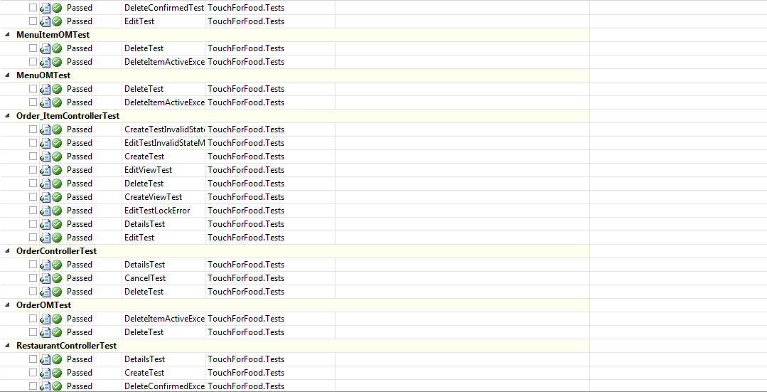

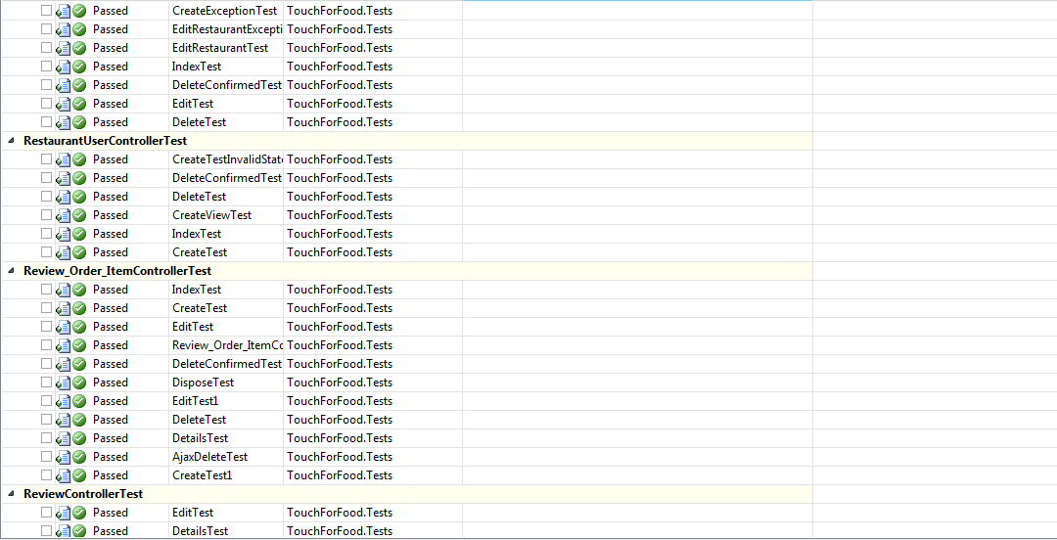

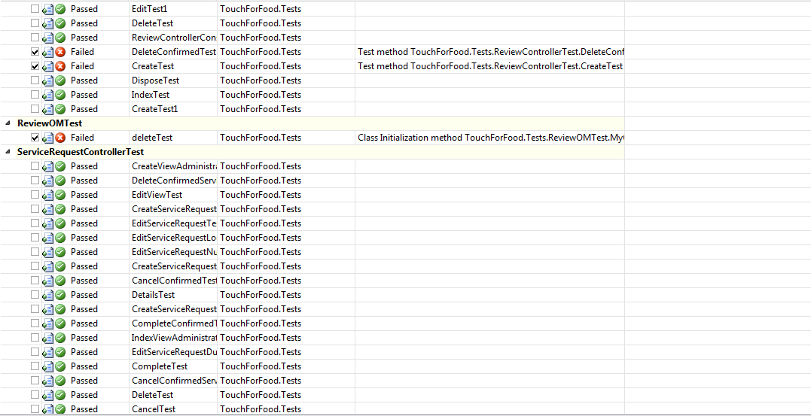

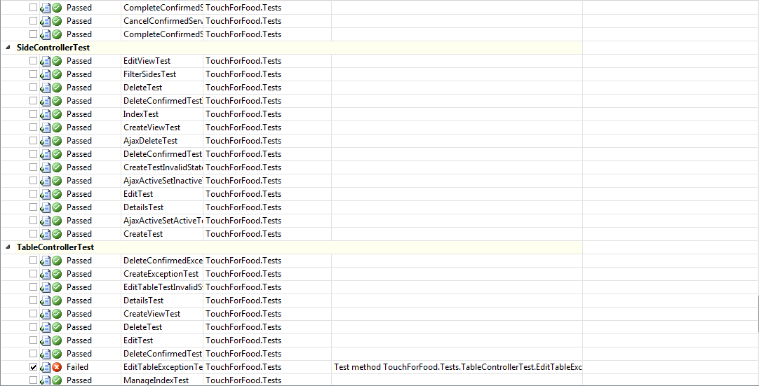

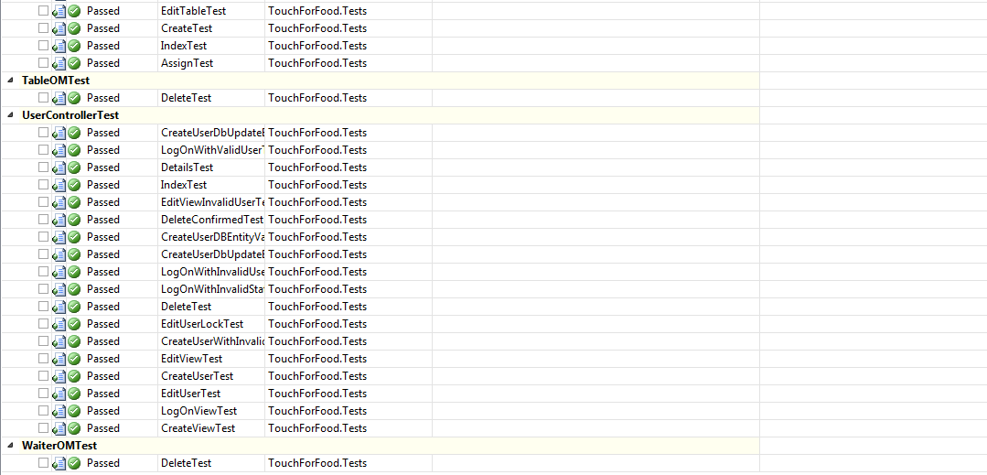

Figure 11‑1 Iteration 11 Unit Test Results

### Unit Test Coverage

**Project Coverage:** 51.44%

**Controller Layer Coverage:** 55.74%

**MapperLayerCoverage:** 73.36%

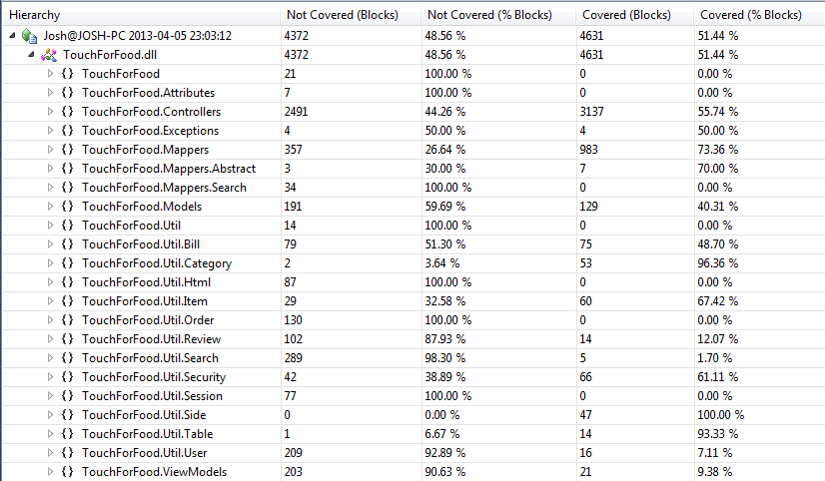

Figure 11‑2 Iteration 11 Code Coverage Results

## Defects

The following table shows all bugs that were scheduled to be fixed in sprints 10 and 11.

Table 11‑1 Iterations 10 and 11 List of Defects

|  |  |  |  |  |  |  |
| --- | --- | --- | --- | --- | --- | --- |
| **Assignee** | **Reporter** | **Created** | **Resolved** | **Affects Sprint** | **Fix Sprint** | **Time Spent (hours)** |
| Mikhail Levkovsky | Katrina Anderson | 08/03/2013 12:09 | 16/03/2013 15:04 | Sprint10 | Sprint10 | 0.116667 |
| Ryan Nasr | Katrina Anderson | 08/03/2013 12:43 | 24/03/2013 13:10 | Sprint10 | Sprint10 | 0.5 |
| Unassigned | Cynthia Donato | 10/03/2013 11:16 | 12/03/2013 14:34 | Sprint 9 | Sprint10 | 0.016667 |
| Unassigned | Cynthia Donato | 10/03/2013 11:40 | 12/03/2013 14:32 | Sprint 9 | Sprint10 | 0.016667 |
| Cynthia Donato | Katrina Anderson | 04/03/2013 21:49 | 01/04/2013 15:05 | Sprint10 | Sprint10 | 0.333333 |
| Mikhail Levkovsky | Patrick Modafferi | 06/03/2013 13:50 | 08/03/2013 11:32 | Sprint 9 | Sprint10 | 1.5 |
| Josh Hum | Cynthia Donato | 10/03/2013 11:10 | 30/03/2013 19:56 | Sprint 9 | Sprint11 | 0.333333 |
| Josh Hum | Cynthia Donato | 10/03/2013 11:34 | 30/03/2013 21:54 | Sprint 9 | Sprint11 | 0.166667 |
| Josh Hum | Cynthia Donato | 10/03/2013 12:02 | 30/03/2013 22:07 | Sprint 9 | Sprint11 | 0.25 |
| Josh Hum | Cynthia Donato | 10/03/2013 12:10 | 30/03/2013 22:09 | Sprint 9 | Sprint11 | 0.083333 |
| Unassigned | Cynthia Donato | 11/03/2013 19:41 | 12/03/2013 13:43 | Sprint 9 | Sprint10 | 0.016667 |
| Unassigned | Cynthia Donato | 11/03/2013 19:55 | 11/03/2013 20:05 | Sprint 9 | Sprint10 | 0 |
| Josh Hum | Cynthia Donato | 11/03/2013 19:58 | 30/03/2013 22:24 | Sprint 9 | Sprint11 | 0.083333 |
| Josh Hum | Cynthia Donato | 11/03/2013 20:10 | 30/03/2013 22:25 | Sprint 9 | Sprint10 | 0.016667 |
| Ryan Nasr | Cynthia Donato | 11/03/2013 20:17 | 24/03/2013 13:08 | Sprint 9 | Sprint10 | 1.5 |
| Cristian Asenjo | Josh Hum | 12/03/2013 8:51 | 21/03/2013 21:35 | Sprint10 | Sprint10 | 0.516667 |
| Christian Daher | Josh Hum | 16/03/2013 15:05 | 19/03/2013 13:58 |  | Sprint10 | 0.5 |
| Cristian Asenjo | Cynthia Donato | 18/03/2013 21:42 | 21/03/2013 22:42 | Sprint10 | Sprint10 | 0.05 |
| Patrick Modafferi | Katrina Anderson | 28/02/2013 11:50 | 16/03/2013 18:56 | Sprint10 | Sprint10 | 1.666667 |
| Cynthia Donato | Katrina Anderson | 28/02/2013 19:51 | 19/03/2013 0:29 | Sprint10 | Sprint10 | 0.083333 |
| Unassigned | Katrina Anderson | 06/03/2013 16:41 | 12/03/2013 14:19 | Sprint10 | Sprint10 | 0.016667 |
| Unassigned | Katrina Anderson | 06/03/2013 17:11 | 08/03/2013 14:15 | Sprint10 | Sprint10 | 0.083333 |
| Mikhail Levkovsky | Katrina Anderson | 09/03/2013 19:25 | 16/03/2013 14:24 | Sprint10 | Sprint10 | 0.25 |
| Mikhail Levkovsky | Katrina Anderson | 09/03/2013 22:07 | 16/03/2013 14:50 | Sprint10 | Sprint10 | 0.166667 |
| Unassigned | Cynthia Donato | 10/03/2013 10:55 | 12/03/2013 14:15 | Sprint 9 | Sprint10 | 0 |
| Cynthia Donato | Cynthia Donato | 10/03/2013 10:59 | 16/03/2013 21:10 | Sprint 9 | Sprint10 | 0.5 |
| Unassigned | Cynthia Donato | 10/03/2013 11:02 | 12/03/2013 14:21 | Sprint 9 | Sprint10 | 0.016667 |
| Unassigned | Cynthia Donato | 10/03/2013 11:19 | 10/03/2013 16:04 | Sprint 9 | Sprint10 | 0.016667 |
| Josh Hum | Cynthia Donato | 10/03/2013 12:50 | 17/03/2013 18:13 | Sprint 9 | Sprint10 | 0.666667 |
| Josh Hum | Cynthia Donato | 10/03/2013 13:04 | 30/03/2013 19:25 | Sprint 9 | Sprint11 | 0.083333 |
| Matthew Tam | Cynthia Donato | 10/03/2013 13:06 | 13/03/2013 0:46 | Sprint 9 | Sprint10 | 0.5 |
| Josh Hum | Cynthia Donato | 10/03/2013 13:39 | 18/03/2013 22:31 | Sprint 9 | Sprint10 | 0.116667 |
| Christian Daher | Mikhail Levkovsky | 11/03/2013 14:13 | 19/03/2013 13:00 | Sprint10 | Sprint10 | 1 |
| Patrick Modafferi | Josh Hum | 12/03/2013 9:00 | 16/03/2013 17:45 | Sprint10 | Sprint10 | 2.5 |
| Josh Hum | Josh Hum | 12/03/2013 9:54 | 16/03/2013 15:24 | Sprint10 | Sprint10 | 0.75 |
| Unassigned | Christian Daher | 13/03/2013 22:31 | 05/04/2013 18:33 |  | Sprint10 | 0.016667 |
| Christian Daher | Josh Hum | 16/03/2013 15:12 | 19/03/2013 13:55 |  | Sprint10 | 1 |
| Josh Hum | Josh Hum | 17/03/2013 17:58 | 17/03/2013 19:25 |  | Sprint10 | 1 |
| Mikhail Levkovsky | Josh Hum | 17/03/2013 20:00 | 18/03/2013 22:20 |  | Sprint10 | 1 |
| Christian Daher | Patrick Modafferi | 18/03/2013 19:53 | 23/03/2013 22:25 | Sprint10 | Sprint10 | 1 |
| Cynthia Donato | Patrick Modafferi | 19/03/2013 16:20 | 26/03/2013 14:16 | Sprint10 | Sprint10 | 4.5 |
| Christian Daher | Mikhail Levkovsky | 25/03/2013 14:14 | 30/03/2013 20:11 |  | Sprint11 | 2 |
| Cristian Asenjo | Mikhail Levkovsky | 25/03/2013 17:46 | 30/03/2013 16:48 |  | Sprint11 | 0.35 |
| Josh Hum | Josh Hum | 26/03/2013 15:17 | 31/03/2013 13:35 | Sprint11 | Sprint11 | 0.5 |
| Patrick Modafferi | Josh Hum | 26/03/2013 15:18 | 31/03/2013 18:29 | Sprint11 | Sprint11 | 1 |
| Mikhail Levkovsky | Mikhail Levkovsky | 03/04/2013 17:35 | 03/04/2013 17:35 | Sprint11 | Sprint11 | 0.416667 |
| Cynthia Donato | Katrina Anderson | 28/02/2013 17:27 | 30/03/2013 18:43 | Sprint 9 | Sprint10 | 5.5 |
| Cristian Asenjo | Mikhail Levkovsky | 04/03/2013 23:51 | 21/03/2013 22:36 | Sprint10 | Sprint10 | 2.516667 |
| Josh Hum | Patrick Modafferi | 06/03/2013 23:16 | 16/03/2013 17:14 | Sprint 9 | Sprint10 | 1.833333 |
| Unassigned | Cynthia Donato | 10/03/2013 12:00 | 12/03/2013 14:10 | Sprint 9 | Sprint10 | 0.016667 |
| Christian Daher | Cynthia Donato | 10/03/2013 13:21 | 17/03/2013 22:57 | Sprint 9 | Sprint10 | 1 |
| Unassigned | Cynthia Donato | 11/03/2013 20:25 | 12/03/2013 13:42 | Sprint 9 | Sprint10 | 0.166667 |
| Mikhail Levkovsky | Patrick Modafferi | 18/03/2013 19:45 | 21/03/2013 12:35 | Sprint10 | Sprint10 | 1.016667 |
| Christian Daher | Josh Hum | 24/03/2013 16:25 | 30/03/2013 20:10 | Sprint10 | Sprint10 | 1 |

Figure 11‑3 Iteration 10/11 Defect Breakdown vs. Sprint

Figure 11‑4 Number of Defects vs. Criticality

## User Interface Tests & Results

### Desktop

**Number of UI Tests:** 45

**Number of Passed UI Tests:** 45

**Number of Failed UI Tests:** 45

The following tests were executed on a laptop using Google Chrome.

Table 11‑2 Iteration 10/11 UI Test Results

|  |  |  |  |  |  |  |
| --- | --- | --- | --- | --- | --- | --- |
| **Test ID** | **Title** | **Environment** | **Sprint** | **Test Date** | **Status** | **Notes** |
| TC025.1 | Test Create Order | Google Chrome - 26.0.1410.43 m | 6 | 03/04/2013 | PASS |  |
| TC026.1 | Test View Menu (Customer) | Google Chrome - 26.0.1410.43 m | 6 | 03/04/2013 | PASS |  |
| TC026.2 | Test View Menu (Restaurant) | Google Chrome - 26.0.1410.43 m | 6 | 03/04/2013 | PASS |  |
| TC026.3 | Test View Menu (Administrator) | Google Chrome - 26.0.1410.43 m | 6 | 03/04/2013 | PASS |  |
| TC026.4 | Test Search Menu (Customer) | Google Chrome - 26.0.1410.43 m | 8 | 03/04/2013 | PASS |  |
| TC026.5 | Test Search Menu (Restaurant) | Google Chrome - 26.0.1410.43 m | 8 | 03/04/2013 | PASS |  |
| TC027.1 | Test Menu Editor Main Page | Google Chrome - 26.0.1410.43 m | 6 | 03/04/2013 | PASS |  |
| TC027.2 | Test Category Management Page | Google Chrome - 26.0.1410.43 m | 6 | 03/04/2013 | PASS |  |
| TC027.3 | Test Item Management Page | Google Chrome - 26.0.1410.43 m | 6 | 03/04/2013 | PASS |  |
| TC027.4 | Test Menu Edit | Google Chrome - 26.0.1410.43 m | 6 | 03/04/2013 | PASS |  |
| TC027.5 | Test Create Menu | Google Chrome - 26.0.1410.43 m | 6 | 03/04/2013 | PASS |  |
| TC029.1 | Test Cancel Order | Google Chrome - 26.0.1410.43 m | 6 | 03/04/2013 | PASS | After confirming the canceling of an order it redirects you the login page. |
| TC029.2 | Test Decline Order Item | Google Chrome - 26.0.1410.43 m | 6 | 03/04/2013 | PASS |  |
| TC029.3 | Test Accept Order Item | Google Chrome - 26.0.1410.43 m | 6 | 03/04/2013 | PASS |  |
| TC034.1 | Test Create Service Request (Administrator) | Google Chrome - 26.0.1410.43 m | 7 | 03/04/2013 | PASS |  |
| TC034.2 | Test Create Service Request (Restaurant) | Google Chrome - 26.0.1410.43 m | 7 | 03/04/2013 | PASS |  |
| TC034.3 | Test Call Waiter (Customer) | Google Chrome - 26.0.1410.43 m | 7 | 03/04/2013 | PASS |  |
| TC034.4 | Test Edit Service Request (Restaurant) | Google Chrome - 26.0.1410.43 m | 7 | 03/04/2013 | PASS | Shouldn't be able to edit after it has been completed. |
| TC034.5 | Test Edit Service Request (Administrator) | Google Chrome - 26.0.1410.43 m | 7 | 03/04/2013 | PASS |  |
| TC034.6 | Test Cancel Service Request | Google Chrome - 26.0.1410.43 m | 7 | 03/04/2013 | PASS |  |
| TC034.7 | Test Complete Service Request | Google Chrome - 26.0.1410.43 m | 7 | 03/04/2013 | PASS |  |
| TC035.3 | Test Update Customer Settings | Google Chrome - 26.0.1410.43 m | 9 | 03/04/2013 | PASS |  |
| TC039.1 | Test Leave Review | Google Chrome - 26.0.1410.43 m | 8 | 03/04/2013 | PASS |  |
| TC039.2 | Test View Review | Google Chrome - 26.0.1410.43 m | 8 | 03/04/2013 | PASS |  |
| TC040.1 | Test Login With Non-Existent User | Google Chrome - 26.0.1410.43 m | 6 | 03/04/2013 | PASS |  |
| TC040.2 | Test Create New User | Google Chrome - 26.0.1410.43 m | 6 | 03/04/2013 | PASS |  |
| TC040.3 | Test Login With Existent User | Google Chrome - 26.0.1410.43 m | 6 | 03/04/2013 | PASS |  |
| TC040.4 | Test Logout | Google Chrome - 26.0.1410.43 m | 6 | 03/04/2013 | PASS |  |
| TC41.1 | Test Create Bill (Customer) | Google Chrome - 26.0.1410.43 m | 8 | 03/04/2013 | PASS | You can create as many bills as you want as a user. |
| TC41.2 | Test Add Item to Bill (Customer) | Google Chrome - 26.0.1410.43 m | 8 | 03/04/2013 | PASS |  |
| TC41.3 | Test Remove Item From Bill (Customer) | Google Chrome - 26.0.1410.43 m | 9 | 03/04/2013 | PASS |  |
| TC41.4 | Test Delete Bill (Customer) | Google Chrome - 26.0.1410.43 m | 9 | 03/04/2013 | PASS |  |
| TC42.1 | Test Create Bill (Restaurant) | Google Chrome - 26.0.1410.43 m | **7** | 03/04/2013 | PASS |  |
| TC42.2 | Test Add Item to Bill (Restaurant) | Google Chrome - 26.0.1410.43 m | 7 | 03/04/2013 | PASS |  |
| TC42.3 | Test Remove Item from Bill (Restaurant) | Google Chrome - 26.0.1410.43 m | 7 | 03/04/2013 | PASS |  |
| TC42.4 | Test Delete Bill (Restaurant) | Google Chrome - 26.0.1410.43 m | 7 | 03/04/2013 | PASS |  |
| TC192.1 | Test Create Table Page | Google Chrome - 26.0.1410.43 m | 6 | 03/04/2013 | PASS |  |
| TC192.2 | Test Creating Incorrect Table Page | Google Chrome - 26.0.1410.43 m | 6 | 03/04/2013 | PASS |  |
| TC192.3 | Test Edit Table Page | Google Chrome - 26.0.1410.43 m | 6 | 03/04/2013 | PASS |  |
| TC192.4 | Test Incorrect Edit Table Page | Google Chrome - 26.0.1410.43 m | 6 | 03/04/2013 | PASS |  |
| TC192.5 | Test NFC Link Page | Google Chrome - 26.0.1410.43 m | 6 | 03/04/2013 | PASS |  |
| TC192.6 | Test Table Details Page | Google Chrome - 26.0.1410.43 m | 6 | 03/04/2013 | PASS |  |
| TC192.7 | Test Delete Table Page | Google Chrome - 26.0.1410.43 m | 6 | 03/04/2013 | PASS |  |
| TC279.1 | Test View Past Orders | Google Chrome - 26.0.1410.43 m | 8 | 03/04/2013 | PASS |  |
| TC279.2 | Test Suggest an Order | Google Chrome - 26.0.1410.43 m | 8 | 03/04/2013 | PASS |  |

### Mobile

**Number of UI Tests:** 18

**Number of Passed UI Tests:** 18

**Number of Failed UI Tests:** 18

The following tests were executed on an Android running the TFF app.

|  |  |  |  |  |  |  |
| --- | --- | --- | --- | --- | --- | --- |
| **Test ID** | **Title** | **Environment** | **Sprint** | **Test Date** | **Status** | **Notes** |
| TC025.1 | Test Create Order | Samsung S3 - Android 4.1.1 | 6 | 03/04/2013 | PASS |  |
| TC026.1 | Test View Menu (Customer) | Samsung S3 - Android 4.1.2 | 6 | 03/04/2013 | PASS |  |
| TC026.2 | Test View Menu (Restaurant) | Samsung S3 - Android 4.1.3 | 6 | 03/04/2013 | N/A |  |
| TC026.3 | Test View Menu (Administrator) | Samsung S3 - Android 4.1.4 | 6 | 03/04/2013 | N/A |  |
| TC026.4 | Test Search Menu (Customer) | Samsung S3 - Android 4.1.5 | 8 | 03/04/2013 | PASS |  |
| TC026.5 | Test Search Menu (Restaurant) | Samsung S3 - Android 4.1.6 | 8 | 03/04/2013 | N/A |  |
| TC027.1 | Test Menu Editor Main Page | Samsung S3 - Android 4.1.8 | 6 | 03/04/2013 | N/A |  |
| TC027.2 | Test Category Management Page | Samsung S3 - Android 4.1.9 | 6 | 03/04/2013 | N/A |  |
| TC027.3 | Test Item Management Page | Samsung S3 - Android 4.1.10 | 6 | 03/04/2013 | N/A |  |
| TC027.4 | Test Menu Edit | Samsung S3 - Android 4.1.11 | 6 | 03/04/2013 | N/A |  |
| TC027.5 | Test Create Menu | Samsung S3 - Android 4.1.12 | 6 | 03/04/2013 | N/A |  |
| TC029.1 | Test Cancel Order | Samsung S3 - Android 4.1.13 | 6 | 03/04/2013 | N/A |  |
| TC029.2 | Test Decline Order Item | Samsung S3 - Android 4.1.14 | 6 | 03/04/2013 | N/A |  |
| TC029.3 | Test Accept Order Item | Samsung S3 - Android 4.1.15 | 6 | 03/04/2013 | N/A |  |
| TC034.1 | Test Create Service Request (Administrator) | Samsung S3 - Android 4.1.16 | 7 | 03/04/2013 | N/A |  |
| TC034.2 | Test Create Service Request (Restaurant) | Samsung S3 - Android 4.1.17 | 7 | 03/04/2013 | N/A |  |
| TC034.3 | Test Call Waiter (Customer) | Samsung S3 - Android 4.1.18 | 7 | 03/04/2013 | PASS |  |
| TC034.4 | Test Edit Service Request (Restaurant) | Samsung S3 - Android 4.1.19 | 7 | 03/04/2013 | N/A |  |
| TC034.5 | Test Edit Service Request (Administrator) | Samsung S3 - Android 4.1.20 | 7 | 03/04/2013 | N/A |  |
| TC034.6 | Test Cancel Service Request | Samsung S3 - Android 4.1.21 | 7 | 03/04/2013 | N/A |  |
| TC034.7 | Test Complete Service Request | Samsung S3 - Android 4.1.22 | 7 | 03/04/2013 | N/A |  |
| TC035.3 | Test Update Customer Settings | Samsung S3 - Android 4.1.23 | 9 | 03/04/2013 | PASS |  |
| TC039.1 | Test Leave Review | Samsung S3 - Android 4.1.24 | 8 | 03/04/2013 | PASS |  |
| TC039.2 | Test View Review | Samsung S3 - Android 4.1.25 | 8 | 03/04/2013 | PASS |  |
| TC040.1 | Test Login With Non-Existent User | Samsung S3 - Android 4.1.26 | 6 | 03/04/2013 | PASS |  |
| TC040.2 | Test Create New User | Samsung S3 - Android 4.1.27 | 6 | 03/04/2013 | PASS |  |
| TC040.3 | Test Login With Existent User | Samsung S3 - Android 4.1.28 | 6 | 03/04/2013 | PASS |  |
| TC040.4 | Test Logout | Samsung S3 - Android 4.1.29 | 6 | 03/04/2013 | PASS |  |
| TC41.1 | Test Create Bill (Customer) | Samsung S3 - Android 4.1.30 | 8 | 03/04/2013 | PASS |  |
| TC41.2 | Test Add Item to Bill (Customer) | Samsung S3 - Android 4.1.31 | 8 | 03/04/2013 | PASS |  |
| TC41.3 | Test Remove Item From Bill (Customer) | Samsung S3 - Android 4.1.32 | 9 | 03/04/2013 | PASS |  |
| TC41.4 | Test Delete Bill (Customer) | Samsung S3 - Android 4.1.33 | 9 | 03/04/2013 | PASS |  |
| TC42.1 | Test Create Bill (Restaurant) | Samsung S3 - Android 4.1.34 | **7** | 03/04/2013 | N/A |  |
| TC42.2 | Test Add Item to Bill (Restaurant) | Samsung S3 - Android 4.1.35 | 7 | 03/04/2013 | N/A |  |
| TC42.3 | Test Remove Item from Bill (Restaurant) | Samsung S3 - Android 4.1.36 | 7 | 03/04/2013 | N/A |  |
| TC42.4 | Test Delete Bill (Restaurant) | Samsung S3 - Android 4.1.37 | 7 | 03/04/2013 | N/A |  |
| TC192.1 | Test Create Table Page | Samsung S3 - Android 4.1.38 | 6 | 03/04/2013 | N/A |  |
| TC192.2 | Test Creating Incorrect Table Page | Samsung S3 - Android 4.1.39 | 6 | 03/04/2013 | N/A |  |
| TC192.3 | Test Edit Table Page | Samsung S3 - Android 4.1.40 | 6 | 03/04/2013 | N/A |  |
| TC192.4 | Test Incorrect Edit Table Page | Samsung S3 - Android 4.1.41 | 6 | 03/04/2013 | N/A |  |
| TC192.5 | Test NFC Link Page | Samsung S3 - Android 4.1.42 | 6 | 03/04/2013 | N/A |  |
| TC192.6 | Test Table Details Page | Samsung S3 - Android 4.1.43 | 6 | 03/04/2013 | N/A |  |
| TC192.7 | Test Delete Table Page | Samsung S3 - Android 4.1.44 | 6 | 03/04/2013 | N/A |  |
| TC279.1 | Test View Past Orders | Samsung S3 - Android 4.1.45 | 8 | 03/04/2013 | PASS |  |
| TC279.2 | Test Suggest an Order | Samsung S3 - Android 4.1.46 | 8 | 03/04/2013 | PASS |  |

# ****Appendix A References****

# Appendix B Glossary

Refer to the SRS document - Appendix B Glossary and Appendix C Acronyms for a complete list of terms and definitions.